KS3 Artefact to Art
Session 2: Art and Power in Imperial Rome

Worksheet 1: Art and the First Emperor

1. The Prima Porta Statue

- How is Augustus standing? What is he wearing? What is he carrying?

- What do all these things tell us about the kind of image he wanted to represent?

- Did you know that Roman statues were painted with bright colours? (see inset image below) How would this have effected how people viewed the statue?
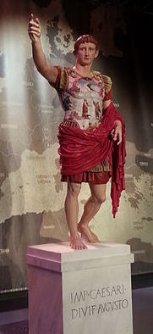
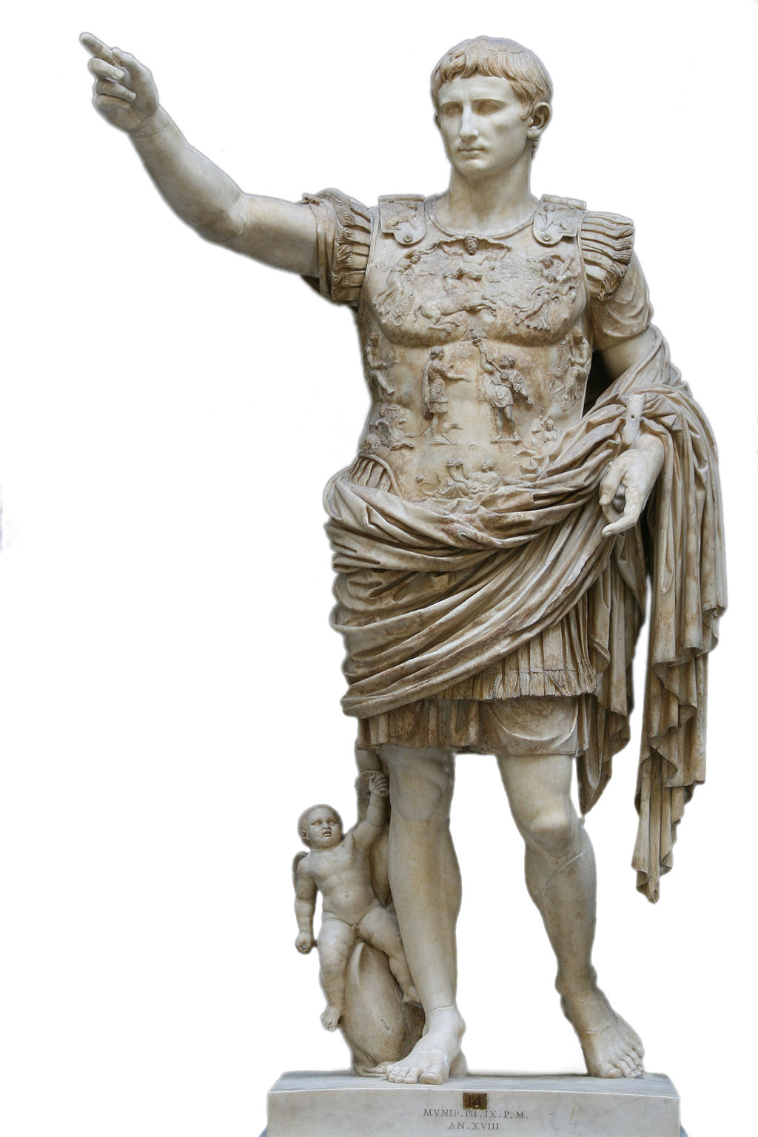

2. Silver denarius of Octavian (who later became Augustus)

- What does the inscription say on the ‘heads’ (obverse) side of the coin?

- What does the inscription say on the ‘tails’ (reverse) side of the coin?

- How is the young Octavian represented?

- Why does this coin feature a crocodile?

- What would the images on this coin mean for the average Roman who used it?
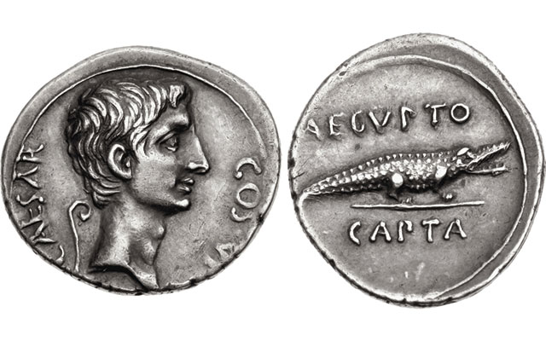

3. Imaginative Exercise

- Have a look at a modern coin. Do rulers today present themselves in similar ways to the Romans?

- What about statues? What would happen if a modern politician or ruler tried to make a statue of themselves in this fashion?

- Draw an imagined statue of a modern politician or ruler in the style of the Prima Porta statue.

