KS3 Artefact to Art
Session 2: Making Art in Classical Athens

Worksheet 1: Artists and Craftspeople

1. The Foundry Cup

- What is going on in this scene?

- How are the artists portrayed? Do they seem to be high status individuals?

- Where and in what kinds of situations would people have looked at this cup?

- What might they have thought about its depiction of art and artistry?

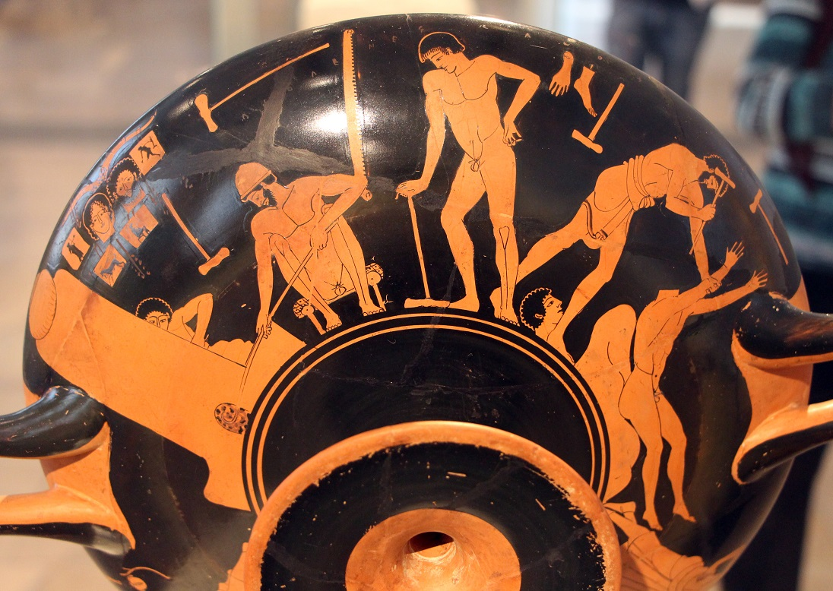

2. Xenophon, Estate Management 4.2-3

To be sure, the so-called ‘crafts’ are spoken against and quite rightly held in contempt in our states, for they ruin the bodies of those practising them and those who supervise, forcing them to sit still and pass their time indoors – some even to spend a say at the fire. As their bodies are softened, so too their minds become much more sickly. In addition, the so-called crafts leave no leisure time for paying attention to one’s friends or state, so that the persons who practise them have the reputation for treating their friends badly and being poor defenders of their homeland. In some states, particularly those with a warlike reputation, it is forbidden for any citizen to practise the crafts.

- What attitude does Xenophon have to craftspeople?

- What reason does Xenophon give for the crafts being viewed negatively?

- Why might it be bad for a citizen to engage in craftworking?

- What does this suggest about the way craftspeople and artists were viewed in classical Athens?

3. Imaginative exercise

- Can you imagine what would happen if the maker of the Foundry Cup met the writer Xenophon?

- What difference might there have been in their social status?

- Would the recognise each other as fellow artists?

- Would they have similar or different views of what constituted ‘art’?

- Write a short role-play of their conversation.

