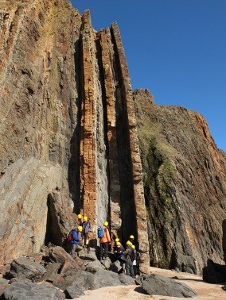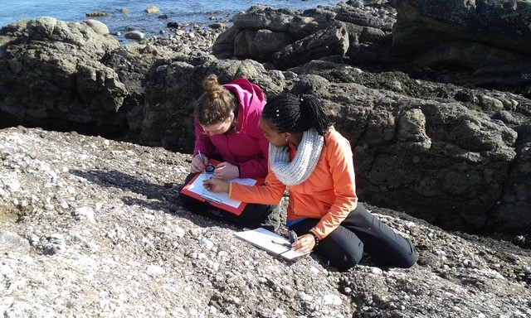

@GeologyLeics

@LeicesterFSOO

@leicesterfso

**Girls into GeoScience Junior**



**W/C Monday 23rd November**

**Pre-recorded content released**

Check out our website for some taster sessions and worksheet activities around a variety of Geology topics - <https://le.ac.uk/study/schools-and-colleges/pre-16/girls-into-geoscience>

**Wednesday 2nd December – 16:15 - 18:00**

**Live event**

A packed 1hr45 minute live session taking place on Zoom.

16:15 – Welcome & introductions – Nicola Lumb, Outreach Officer

16:20 - What is Geology & why is it important? – Dr Sarah Lee

16:30 – Welcome by Head of College – Prof Sarah Davies

16:35 – Live Q&A with staff & Post-Graduate students– Feedback on the worksheets released last week as well as your chance to ask any questions

17:00 – Live Q&A with current GeoScience students

17:10 – Virtual field trip

17:25 – How to get into GeoSciences?

17:35 – Live experiment – a chance to join in!

17:55 – Summary & close