Earthquake Activity Pack

Girls into Geoscience
Junior

In this activity pack we are going to explore earthquakes! We have plenty of hands on experiments you can recreate at home using everyday items you’ll find in your house.
Complete as many or as few of the activities as you wish. If you complete to the end of activity 6, you will know what an earthquake is and how we know where one happened. Activity 9 looks at the differences in earthquake magnitudes: just how much bigger is a magnitude 4 earthquake than a magnitude 3 earthquake? In activity 10 you can make your own earthquake model and see how crucial it is to have good building designs and knowledge of the underlying geology.
There is a lot of information in this pack, hopefully some of it will be familiar, and will relate to things you have studied in school, some of it will be new.
Bring any questions you have to the live event, and I’ll see you there!
Victoria
---------------------------------------------------------------------
To complete all the activities in this pack, you will need the following:
- 2 sheets of scrap A4 paper
- 3 x cans i.e. baked beans (unopened)
- 1 x table placemat or plastic chopping board
- 1 x handful of uncooked rice (or lentils)
- 1 x toothpaste tube (full / nearly full)
- 3 x toilet roll
- 1 x shower gel
- 1 x slinky spring + willing volunteer
  - Alternatively, a rectangular casserole dish half-filled with water, some tinfoil or card and a piece of string, approximately 1m long.
- Pair of compasses for drawing circles (or you can use pen & paper)
- A print out of page 8 (or you can use a drawing package on your computer, or even just approximate using the screen display)

What is an Earthquake?
The surface, or crust, of the Earth is made up of a number of tectonic plates. These plates contain a mix of continental and oceanic crust.
Activity 1: Look at map A below. This map shows the names and locations of the tectonic plates. The continents are clearly recognisable. Which tectonic plate is the UK on?
Answer:
Activity 2: Now look at map B. This map shows all large earthquakes recorded over two years. Compare map A with map B. What do you notice?
Answer:

Map A: Tectonic Plates
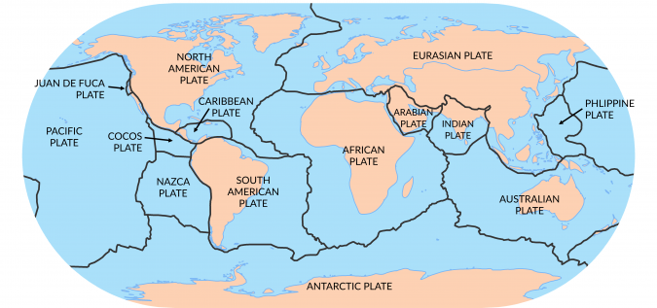
https://earthhow.com/7-major-tectonic-plates/
Map B: Earthquakes recorded between January 1999 and January 2001.
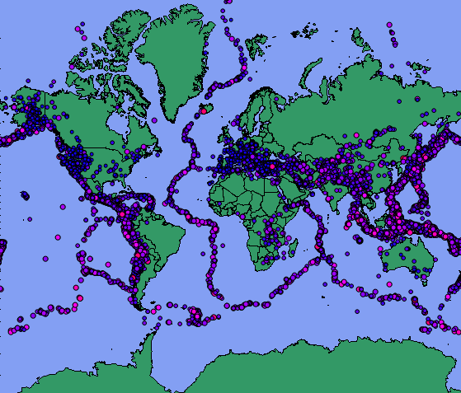
https://www.dplot.com/maps.htm

Tectonic plates are constantly moving, but very, very slowly – only a few cm per year! Along the edges, or boundaries, of these plates we see different interactions. Sometimes one plate will go underneath another plate, sometimes the plates crash into each other and other times they slide past each other. This plate motion is the major cause of volcanoes and earthquakes on Earth.
Did you know?
Over 90% of all earthquakes on earth happen at the plate boundaries. This means less than 10% happen in other areas.

Types of plate boundary
Have you studied plate boundaries yet? See how many of the below plate boundary types you recognise. Earthquakes happen at all of them, some types have deeper earthquakes than others.
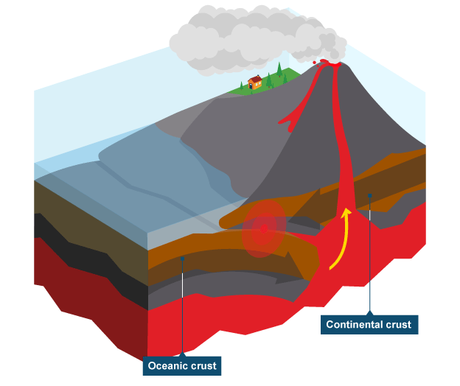
Destructive plate boundary
Continental crust on one plate collides with oceanic crust on another plate. The denser (heavier) oceanic crust is forced downwards, known as subduction.
The subducted plate triggers melting at depth, producing magma. Much like ‘lava’ in a lava lamp, this molten magma rises, forcing its way back to the surface where it erupts. Earthquakes can be shallow or deep in these zones.
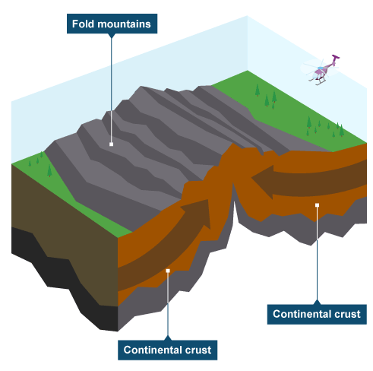

Collision zones
Two plates with buoyant continental crust collide. There is no subduction and instead, mountains are formed.

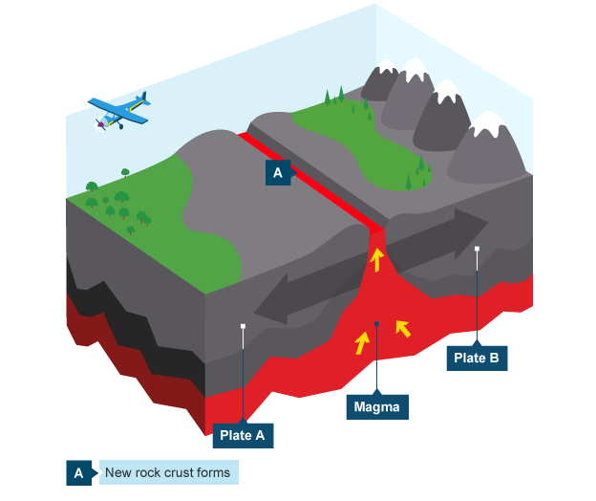
Constructive plate boundary

Plates move apart. Magma wells up and cools, creating new crust. Earthquakes are shallow here.

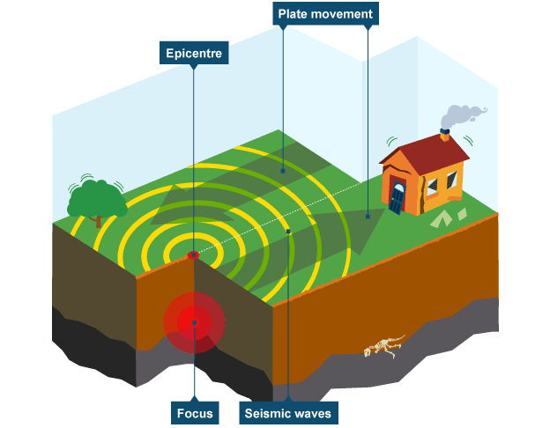
Conservative plate boundary
Also known as a transform faults, plates slide past each other here. Plates can move in opposite directions, or in the same direction at different speeds. Built up friction can be released suddenly, causing shallow earthquakes. These earthquakes tend to follow a straight line.

Plate boundary images from:
www.bbc.co.uk/bitesize/guides/zyhv4wx/revision/2
Did you know?
The point at which the earthquake occurs inside the Earth is called the focus. The epicentre is a point on the Earth’s surface, directly above the focus. This is shown in the above image.

Earthquakes
are a sudden release of energy caused by stress changes within the Earth.
What happens to the energy released by an earthquake?
Energy radiates away from the earthquake origin (the focus) as waves. These waves cause the ground to move and seismometers buried in the ground record that motion.

This is what a seismometer looks like. They record ground motion in 3 directions: North-South, East-West and Up-Down.

Activity 3: Waves
You will have studied waves in School. Can you name 2 different types of wave?
Answer:________________________________________________________________

Earthquakes are made up of several types of wave, there are body waves, which travel through the inside of the Earth, and surface waves, which travel around the outside of the Earth.
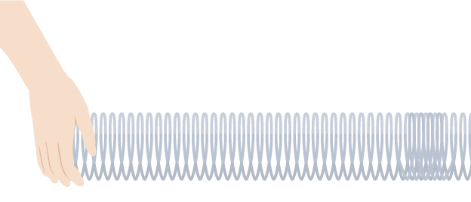
Body waves are the fastest waves. They are the first to be recorded by a seismometer. There are two main ones – P waves and S waves. Did anyone include sound waves in activity 3? A P wave is a longitudinal wave, just like a sound wave!
Activity 4: Make a P wave!
In a P wave, the direction of particle displacement (movement) is parallel to the direction of the wave. Let’s make one!
If you have a slinky spring:
Stretch it out in a straight line and get your volunteer to hold the far end. Rapidly pulse your side forward (in the direction of the spring) and pull it back towards you. Repeat this motion at about a 2 second interval. Do you see the pulses travelling along the spring? This is how a P wave propagates through the Earth.

Image source: https://www.bbc.co.uk/bitesize/guides/z9bw6yc/revision/1
If you don’t have a slinky spring:
Get your casserole dish, half-filled with water, and make a small cardboard or tinfoil rectangle, which is about 6cm high and the same width as your dish. Submerge this about 2cm into the water. Holding it taught at each end, push it forwards about 2cm and pull back (watch you don’t get wet!). Do you see the pulse moving along the dish?
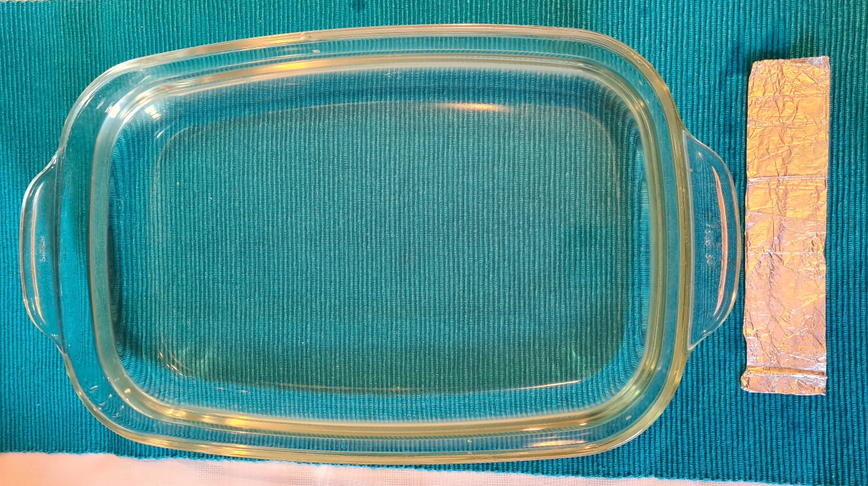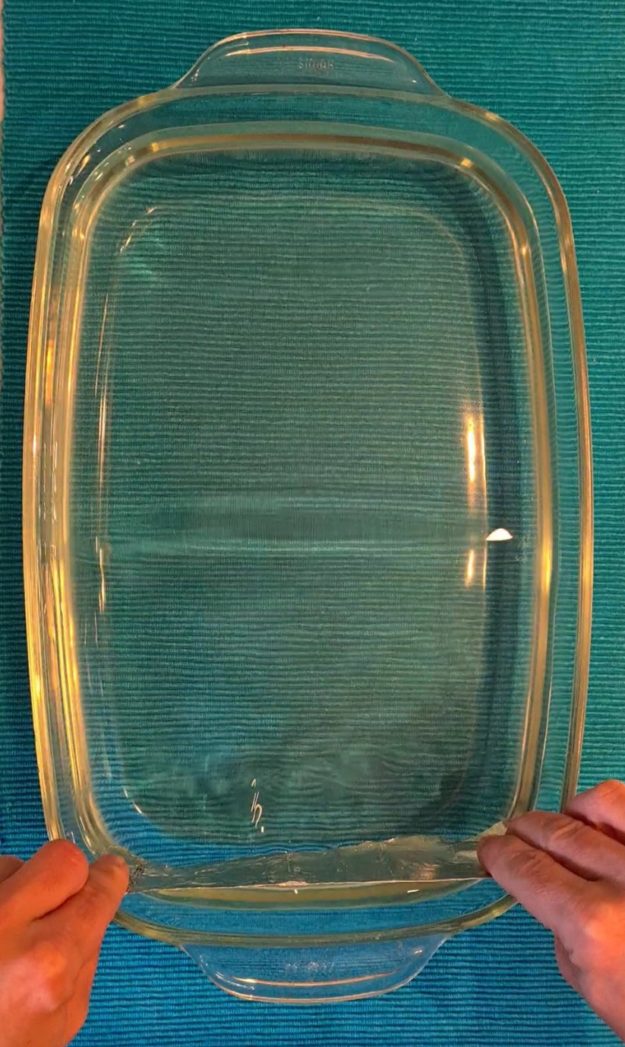
S waves are slower than P waves. They arrive second on our seismogram (a plot of data recorded by the seismometer). S waves are transverse waves.
Activity 5: Make an S wave!
In an S wave, the direction of particle displacement is perpendicular (at right angles) to the direction of the wave. Let’s make one!
As with activity 4, stretch the spring out and ask a volunteer to hold the far side. This time move the spring from left to right, repeating about every 2 seconds. If you don’t have a slinky spring, you can easily create an S wave with a piece of string.

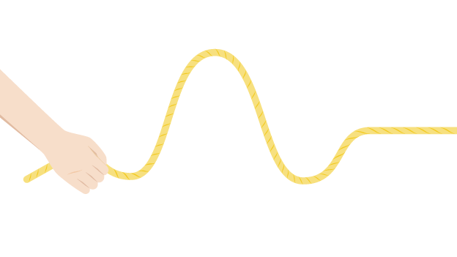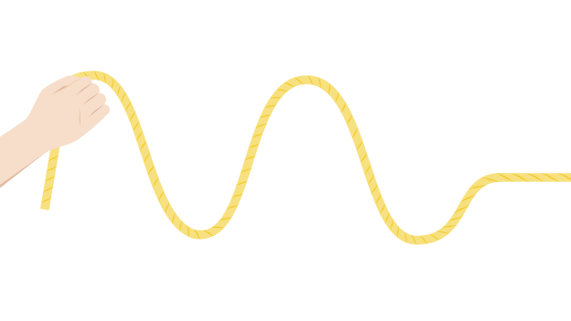
Image source: https://www.bbc.co.uk/bitesize/guides/z9bw6yc/revision/2
Surface waves are the final wave type to arrive at a seismometer after an earthquake. They travel around the outside of the earth, and are much slower. They also tend to contain much more energy than the P waves or the S waves, and for this reason it is the surface waves which do much of the damage we associate with earthquakes.

The below image shows a seismogram with the P, S and surface waves clearly visible.

Image: www.slideserve.com/gretchen-mcintosh/18-measuring-earthquakes
If we record the time difference between the P wave and the S wave arrivals (shown by the orange lines), then we are able to calculate the distance of the epicentre from the seismometer! Of course we would not know which direction it came from. To work out the direction, we would need to repeat this process at 2 other seismic stations, and then we could use a process called triangulation to work it out where the epicentre was.
Activity 6: Locate an earthquake
The below image shows 3 seismograms, from 3 different seismometers. For each one, the time difference between the P and S wave arrival has been worked out, and because we can estimate the speed at which each wave travels, we are able to work out the distance that these waves have travelled from the epicentre to reach our seismometer.

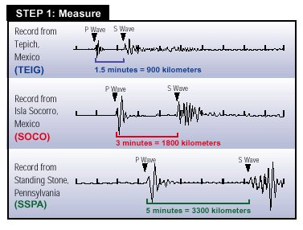

On the map below, draw circles with a radius equal to the distances calculated from the seismograms. There are three seismometers (named SSPA, TEIG and SOCO), so you should have 3 circles on the finished plot.
The green circle for SSPA has been done for you. The size of each radius is shown at the bottom of the plot. TEIG should be 900km and SOCO should be 1800km.

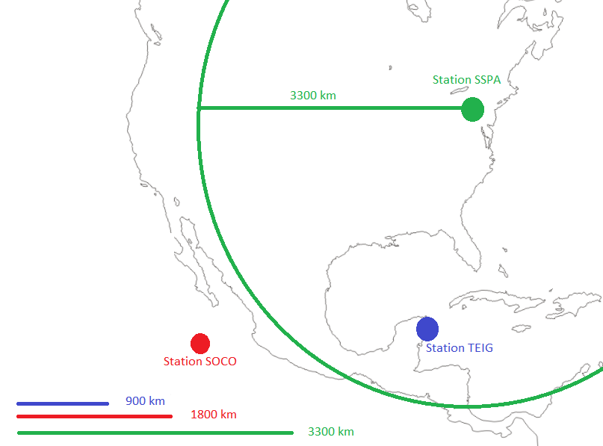
Once you have completed the remaining circles, they should all overlap at one point – this is where the epicentre of the earthquake was. Remember the epicentre is the point on the Earth’s surface, directly above the earthquake focus.
Activity amended from: https://www.iris.edu/hq/inclass/fact-sheet/how_are_earthquakes_located

Did you know?
S waves cannot travel through liquids. Depending on where your seismometer is on Earth, in relation to where an earthquake has happened, you may not see an S wave arrival on your seismogram. This is one of the ways we know that the Earth has a liquid outer core. P waves can travel through both liquid and solid material. This is shown on the below diagram.

Image source: https://in.pinterest.com/pin/359373245251359423/
Did you notice that the P waves do not have straight paths when crossing boundaries inside the Earth? This is because seismic waves follow the same laws of reflection and refraction that you will have studied with other types of wave!

Just how fast do earthquake waves travel?
Do you remember seeing in the news a few weeks ago that there was a magnitude 7.0 earthquake in Turkey, 31st October 2020?
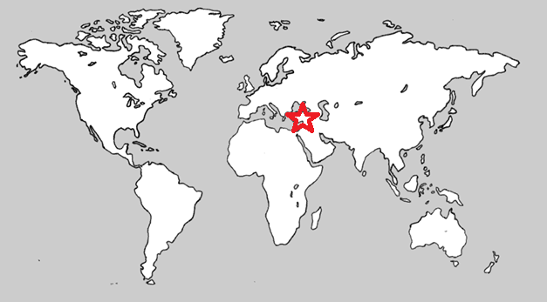
Energy from this earthquake travelled through the Earth as P and S waves, and surface waves, as we’ve seen in previous activities. This earthquake happened at 11:51am UK time and was recorded by one of our seismometers in Oxford.
The seismogram we recorded is shown below:

Activity 7: Roughly how long do these signals take to arrive in the UK from Turkey (remember the earthquake happened at 11:51)? ____________________________

Activity 8: Think about how long it takes to travel between the UK and Australia by plane. Roughly how many hours is the journey?
Answer___________________
Now look at the below map. There was a magnitude 6.1 earthquake in Tonga (shown by the red star) at 15:32 on 18th July 2020.
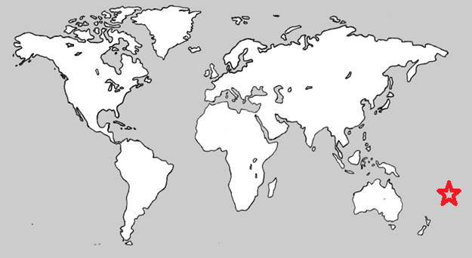
The energy contained within the waves spread through the Earth, as with the Turkey earthquake. When they got to the UK, they were recorded on our seismometers.
Take a look at the below plot of data recorded by a seismometer at Leicester University.
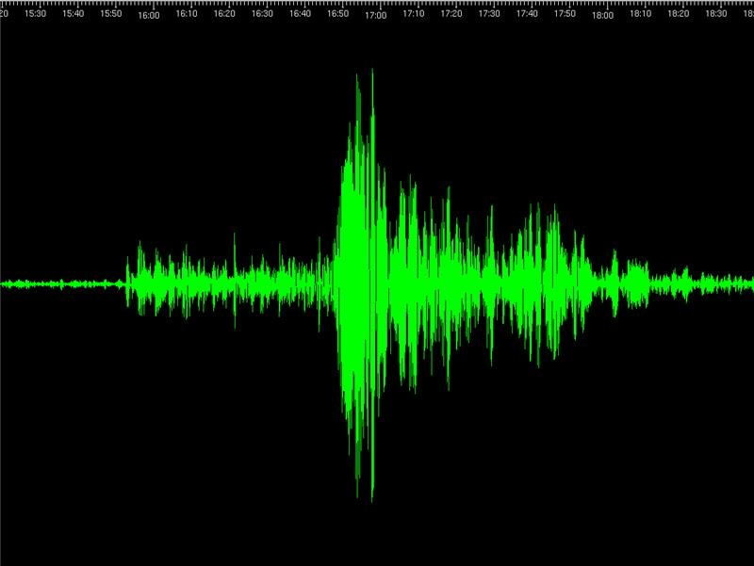
Roughly how long did it take for energy contained within in these waves to reach the UK (hint, remember the P wave is the first significant arrival, not the biggest)? ______________________________.
How many distinctive peaks / arrivals of energy do you see on each of these seismograms? ______________________________.

So these waves are travelling at around 5 – 8 km per second!
Did you know?
It’s not just earthquakes which are recorded on seismometers. Lots of events create seismic signals, including the movement of the oceans, rivers, the swaying of trees, moving vehicles, trains and even crowds jumping up and down as they celebrate at sporting events (Google “VardyQuake” to read about the work we did recording signals generated by the crowd celebrating Jamie Vardy scoring for Leicester City Football Club).

How do we measure Earthquakes?
Activity 9: Earthquake Energy
Take two pieces of scrap A4 paper and put them on the table in front of you. Pick up one piece of paper and rip it in half (does not need to be too accurate). Put the two ripped pieces together, one on top of the other and rip again, so you now have 4 pieces. Put the 4 pieces together and repeat this 3 more times. You will have done 5 rips in total and have 32 pieces in a pile of paper in your pile.
-----------------------------------------------
When we talk about earthquakes, we describe their relative size in terms of a magnitude scale. This scale goes from 1 to 10. The scale is Logarithmic with each whole number increase on the scale (i.e. from a magnitude 4 to a magnitude 5) representing an earthquake with an amplitude 10 times greater than the last. The amount of energy in the earthquake increases by 32 times for every one increment on the scale.
-----------------------------------------------
Let’s go back to our paper experiment. Imagine your one sheet of unripped paper is equivalent to a magnitude 3 earthquake. Rip the piece of paper in half as quickly as you can and put it on the table. How long did it take? Less than a second?
Now let’s imagine our second pile of paper is a magnitude 4 earthquake, so that’s an increase of just 1 on the magnitude scale but the energy (or pieces) have increased by 32. Rip that pile as quickly as you can. How long did that take? Could you do it? I couldn’t!
We know that each time we increment by one on the magnitude scale, the energy or power of the earthquake increases by 32 times.
If we wanted to try this for a magnitude 5 earthquake, how many pieces would we need to visualise the relative increase in energy?
Answer: ________________________________

Our paper experiment is a good way to visualise the relative difference in the scale but if we want to even attempt to visualise the actual energy of an earthquake then we would need to think much bigger, with experiments we definitely cannot do at home, or anywhere. A magnitude 1 earthquake would be like setting off 170g of explosives whilst a magnitude 8 would require 5.5 million tonnes of explosives!

Did you know?
Lots of people have heard of the Richter scale. As soon as there is an earthquake in a film, it will be declared a magnitude 7 or 8 on the Richter scale, maybe even a 9! They are big earthquakes but we don’t actually use the Richter scale to measure earthquakes anymore, and haven’t since the 1970s!
Today earthquakes tend to be measured using the Moment Magnitude Scale. This is a much more accurate way of defining earthquakes, especially the large ones!

What happens to the ground?
We all know that an earthquake makes the ground shake. The closer we are to the epicentre and the bigger the earthquake is, the more the ground will shake and the more damage will be done, but what can we do about this?
Activity 10: Make the ground shake!
For this experiment, we are going to make a “shaker table” by resting a chopping board lengthways on two cans of beans. Next we will make some ‘buildings’ with different structures by placing a tower of three toilet rolls, a can of beans, a shower gel and a tube of toothpaste on the board. Make sure the shower gel and toothpaste are parallel with the short axis of the board, as shown below:
Roll the board slowly, back and forth from left to right and watch what happens, which tower falls first?

What happens if you turn the shower gel around, so it’s now parallel with the long axis of the board (shown below) and repeat the slow rolling motion?

Finally, place your shower gel tower on a small and compacted bed of rice (or lentils). How does this change the stability of the building? Is it more or less able to withstand the ground motion?

In this activity we can see that not only does the design of a building influence its ability to withstand an earthquake, but also it is crucial to understand the geology of the land. Loose (unconsolidated) sediments, as represented by our rice, are known to shake more than the solid bedrock, creating an effect known as site amplification.
Did you know?
If sediments are saturated with water, then the shaking from an earthquake can cause this water to rise to the surface, making the ground lose its stiffness and behave more like a liquid. This is a process called liquefaction.
Earthquakes in the UK?
Do you think we have earthquakes in the UK? If so, how many would you say we have in a year? Answer: ___________________________

We’ll discuss this at the live event!

And Finally - Do earthquakes only happen on Earth?
No! We have been able to record moonquakes and more recently, Marsquakes!

https://en.wikipedia.org/wiki/Marsquake

Dr Victoria Lane is a seismologist working at SEIS-UK, part of the Natural Environment Research Council’s Geophysical Equipment Facility. SEIS-UK is based in the School of Geography, Geology and the Environment at the University of Leicester.

