Sport and Active Life

Sports Scholarship Programme
Application Pack

Contents
- Application submission Deadline
- Application form
- Key dates & check list
- Terms and conditions

Applications forms and any supporting documentation must have been received by Sport and Active Life by Midnight, 30th August, 2021.
Any applications, supporting documents or incomplete applications received after this date will not be considered by the Sports Scholarship Panel.
Any enquiries about the scholarship programme, please contact
Stephen Bayley, email smb76@leicester.ac.uk

The deadline for submission of applications is
Midnight 30th August, 2021

PERSONAL INFORMATION
First Name (s)
Last Name
Email: (Current University of Leicester students, please supply your university email address)
Date of birth | Gender
Mobile Number | Nationality
Home Address & postcode | Term address & postcode (If different)
Do you consider yourself disabled? (If yes, please provide details)
COURSE INFORMATION
University Course Title |  | Course duration (Years)
Faculty |  | Year of study you will be entering:
Undergraduate or Postgraduate
Will you have a placement or placements as part of your course during 2021/22? (If Yes, please provide details)

UCAS Number: | Student Number:
SPORTING INFORMATION
Specialist Sport and Discipline:

UK or Country of Eligibility Ranking (Please add which age group)

Highest level of performance representation achieved, including year, and age group (i.e. International Tournament, Academy, League, 2019, U18)

In the past two years, have you been selected for your respective sports NGB world class or home countries programmes? If yes, please provide the level and your current selection status
Main Club you are associated with |  | Name of Coach
MAJOR SPORTING & PESONAL DEVELOPMENT ACHIEVEMENTS
Please list your major sporting achievements and any personal development achievements achieved, January 2019 to present
Major Sporting & Representative Achievements | Personal Development Achievements
Example: Feb 2020 represented England Universities at home nationals competition | Example: March 2022- attended a nutrition webinar hosted by Swim England
ATHLETE SPORTING OBJECTIVES and ASPIRATIONS.
Please provide a statement explaining your future sporting aspirations and objectives whilst studying at the University of Leicester.

If you were successful in being awarded a scholarship for 2021-22 academic year, please provide a summary of your future engagement, connection, interaction and commitment to sport at Leicester.
I intend to contribute to Team Leicester or a Team Leicester club: (maximum of 300 words):

If you were successful in being awarded a Sports Scholarship for 2021-22 academic year, please provide a statement (maximum of 150 words) for each of the following:

How would you make the most of the following support package elements to help achieve your sporting goals?
Annual sports facility membership (150 words maximum)

Having the support of a lifestyle coach who will work with you to identify key goals (academic, sporting and preparing for Life after Leicester) (150 words maximum)
*2020/21 award recipients, please explain: (i) how the appointment and support of a lifestyle coach benefitted you this past year? (ii) If awarded for 2021/22- provide a summary how you would like to develop the engagement and interaction with the lifestyle coach? (150 words maximum for each answer)

Please take this opportunity to provide the awarding panel with any other relevant information that you would like to be considered as part of your application.

Referee details to provide supporting statements (e.g. Coach/NGB)

Please note: Current University of Leicester students must provide a supporting statement from their respective Team Leicester coach. New applicants must provide 1 referee to support your application, this can be either a current club, national or personal coach.
Name
Relationship
Address
Post Code
Telephone
Email
Signed
Date
Supporting Statement from coach
Please provide a supporting statement from your coach, outlining in no more than 300 words, your achievements and suitability for the programme.

Key dates
- Applications will close at midnight, 30th August, 2021
- You will be informed of the panel’s awarding decision by Friday 1st October at the latest.
- Sports Scholar welcome and introduction date and time, TBC.
Check List
Along with your application, please include the following in your email.
- Photo: Please submit an action photo of yourself competing for publicity purposes.
- Kit sizing for a ¼ zip Midlayer Top.
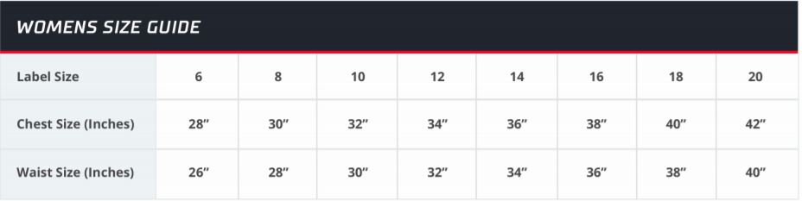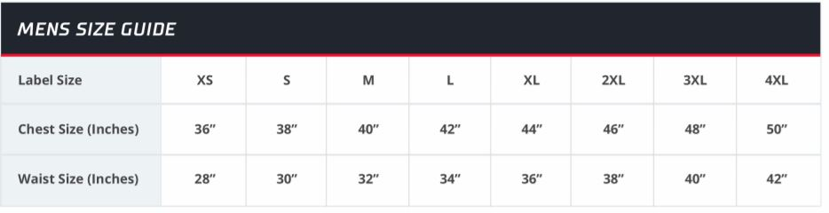
Please return application, photo and kit size, electronically to:
Stephen Bayley- Sport & Active Life
Email: smb76@leicester.ac.uk
Any personal data collected on any individual shall be treated with the strictest confidence and shall not be disclosed to anyone without prior consent from that individual in compliance with the Data Protection Act 1998.

Terms and Conditions
The University has developed the Sports Scholarship Programme to allow student athletes to continue their sporting lives alongside their academic studies whilst accessing a number of support services that look to assist a student athlete reach their potential.
The programme is seen as a partnership between the elite performer and the University and as such this document is produced to outline each partner’s commitment.

Administration
- Membership of the Programme is for a one year period only. All applicants are required to reapply each academic year.
- Membership on the Programme is decided by the Sports Scholarship Panel based upon the information supplied in the received application. The decision of the panel on all applications is final.
- You may only hold one of the following: Tier 1, 2 or 3 Sports Scholarship at any one time.

Conditions to be fulfilled by the Sports Scholar
- Members will be expected to contribute to the relevant Sports club and will be expected to represent the University in all relevant sporting competitions and at other events. In some circumstances this requirement may not be appropriate or possible and can be waived by agreement by the programme lead.
- Members will be asked to act as representative of the University, maintain
or improve their sporting performance and satisfy the University with their academic progress.
- Members will be required to produce an annual report giving details of their sporting achievements over the past year. This report should contain details of how any financial award was used. This report shall be taken into account if the member reapplies for a scholarship.
- Members shall provide help in promoting the sporting profile of the University in any way seen fit by the University.
- Members will be expected to attend any promotional events held by the University. This may be waived by agreement with the programme lead.

Unsatisfactory Conduct
  - In the event of the failure to comply with any of the above conditions of the scholarship programme, a scholarship may be:

    - Suspended for a specified period, or

    - Terminated

  - If a scholarship is terminated on any ground, the scholarship recipient will be required to return any advance awards given through the programme.

