- Construct energy-conserving SEDs for use in photoionization model calculations  - Construct time variable DC template spectra for sources with low-medium-high accretion rates  - Construct lag template spectra for sources with low-medium-high accretion rates | Level | PhD
 | First Supervisor | Dr Goad  mg159@le.ac.uk
 | Second Supervisor | Prof Sarah Vaughan
 | Application Closing Date | 19 May 2023
 | PhD Start date | September 2023
Testing the standard model for accretion in Active Galactic Nuclei

Project Details:

Correlated continuum and broad emission line variability studies have proven a powerful probe of the central regions of Active Galactic Nuclei (AGN).
Traditionally RM has focused on probing the spatial distribution and kinematics of the broad emission line region (BLR), and determining the mass of the central supermassive black hole. More recently, correlated continuum variations have been used to: (i) measure the distance to the hot dust (dust RM) which bounds the BLR, and (ii) map the disc radial temperature profile, T(r). Dust delays provide an upper limit to the BLR outer boundary necessary for constraining photoionization models of the BLR, while the disc inter-band continuum delays can be used to determine the nature of the accretion flow, and for AGN with known black hole mass, the mass accretion rate through the disc.
We have extensive ground-based data with Liverpool Telescope in support of a large HST program (AGNSTORM, 200 orbits with HST/COS) and Swift/XRT/UVOT monitoring programs, providing ground-based spectrophotometry, for disc, dust and broad emission-line variability studies, as well as related Intensive Disc Reverberation Mapping (IDRM) programs aimed at measuring the disc sizes in ~dozen nearby AGN.
This program will focus on constructing photoionization models of the broad emission line region (BLR) in low and high accretion rate sources in the context of self-consistent energy conserving models of the ionizing SED, necessary for quantifying the BLR diffuse continuum (DC) contribution to the total light (e.g., Fig 1), and inter-band continuum delays (the major contaminant to the disc delay signature). By quantifying and then removing the DC contribution to the delay signature we can use the residual delays to directly test the standard model for accretion. The work will involve a substantial computer modelling component and may also include some data reduction and analysis.

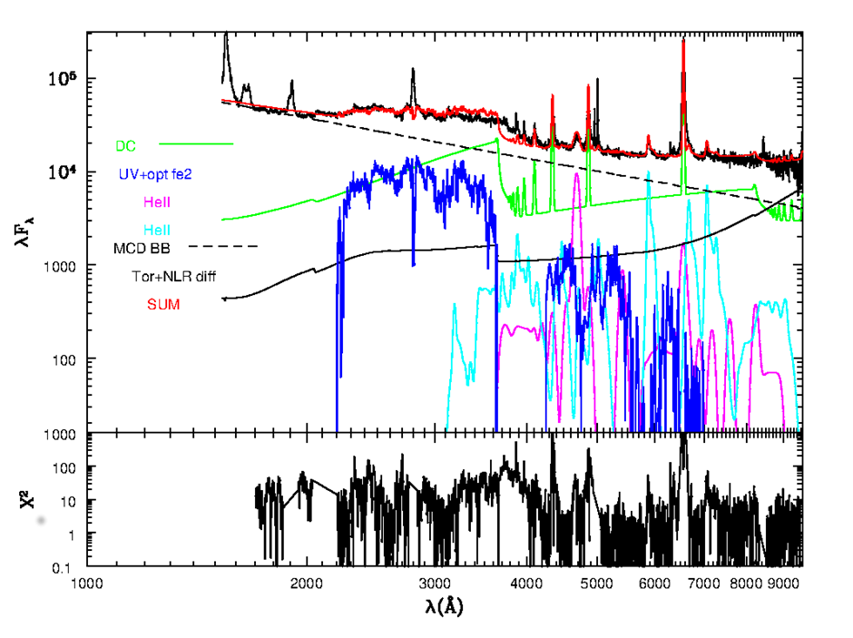

A spectral decomposition of the nearby NLS1 MKN110 showing the major contributory components, with prominent DC emission in green (Goad and Korista 2022, in prep).

References:
- Cackett, E. et al. 2022, ApJ 925, 29. https://arxiv.org/pdf/2109.02155.pdf
- Vincentelli, F.M. et al. 2022, MNRAS 512, 33. https://arxiv.org/pdf/2201.09897.pdf
- Korista, K.T. and Goad, M.R. 2019 MNRAS, 489, 5284. https://arxiv.org/pdf/1908.07757.pdf
- Lawther, D., Goad, M.R. et al. 2018 MNRAS 481, 533. https://arxiv.org/pdf/1808.04798.pdf

How to apply:
Include with your application:-
- CV
- Degree Certificates and Transcripts
- Details of any study currently being undertaken
- Personal statement
- Enter the supervisor’s name and project title in the Proposal Section (no proposal required)
- Enter contact details of two academic referees in the boxes provided or upload reference letters if already obtained.
- Evidence of English language if applicable.
- In the funding section include: Ref: STFC 2023
The University of Leicester School of Physics and Astronomy has advertised a number of PhD opportunities. If you are applying for more than one University of Leicester project, please indicate if this is your first, second or third choice, in your application.

