• Explore the dynamic atmospheres of giant planets with the James Webb Space Telescope (JWST).  • Learn how to acquire, analyse and interpret infrared spectra from multiple instruments.  • Study atmospheric dynamics, chemistry and origins of these archetypal giant planet systems. | Level | PhD
 | First Supervisor | Prof Leigh Fletcher  leigh.fletcher@leicester.ac.uk
 | Second Supervisor | Dr Henrik Melin
 | Application Closing Date | 19 May 2023
 | PhD Start date | September 2023
Exploring Giant Planet Systems with the James Webb Space Telescope

Project Details:
The highly-anticipated James Webb Space Telescope (JWST) began its scientific operations in the summer of 2022, and has already provided stunning new glimpses of our cosmos at infrared wavelengths. It will be the premier observatory for infrared astronomy for decades to come, and researchers within the Planetary Science Group at the University of Leicester are leading the giant planet atmospheres programme for the first cycle of JWST operations (2022-23). Leicester scientists and engineers were directly involved in the development of the MIRI instrument (5-30 micron spectroscopy in the mid-infrared), and the atmospheres team has unique access to guaranteed-time observations of all four giant planets.
Our programme will provide high-resolution spectroscopic maps of all four giant planets using reflected sunlight in the near-infrared (using the NIRSPEC instrument) and thermal emission in the mid-infrared (using the MIRI instrument). These spectra can be modelled, via a suite of radiative transfer and spectral inversion tools, to explore the atmosphere in three dimensions, deriving the temperatures, aerosol properties, and gaseous composition needed to understand atmospheric dynamics, chemistry, and origins. JWST observations of Jupiter’s meteorology were obtained in July-August 2022, providing rich infrared spectra of exceptional quality with a spatial resolution that surpasses even previous spacecraft observations from Cassini. In the coming months, we are expecting observations of Saturn, Uranus, and Neptune to complete the set. We hope that these world-leading datasets will allow us to explore the connection between the churning, banded weather layers of all four giants, and the energetics of their stratospheres and ionospheres. We intend this to be the start of a long-term programme of observations of atmospheric variability from this world-class facility.
The PhD candidate would be welcomed to a team of planetary atmospheres researchers at Leicester, to be trained in state-of-the-art spectroscopic inversion techniques to extract useful information on temperatures, chemical distributions, clouds, and atmospheric dynamics. The student will use a well-developed suite of radiative transfer and spectral inversion tools (known as NEMESIS) to compare previous spacecraft and ground-based observations to the highly-anticipated new data from JWST. JWST observations will be supplemented by a campaign of ground-based supporting observations from world-leading facilities (e.g., observatories in Chile and Hawaii), and there may be opportunities to get involved in the ground-based observations. The specific focus of the PhD project will be reactive to new discoveries, with potential topics including the seasonal atmosphere of Saturn, the stratospheres of Uranus and Neptune, comparative measurements of elemental/isotopic composition to study planetary origins, and the deep dynamics of their weather layers, among other topics. The final PhD programme will be catered to the interests and expertise of the candidate.
Through these studies, the student will gain skills in processing and manipulating spacecraft data, extensive software development, and will have the opportunity to engage with the wider community of planetary observers across the globe. With Leicester's current involvement in Juno and JWST, and future involvement in the Jupiter Icy Moons Explorer (JUICE) and Ice Giant missions, this Planetary Science PhD project offers the potential for exciting new discoveries on the giant planets. Successful PhD candidates would have some prior background in coding, as they will be using Python and Fortran-based packages on Leicester's High-Performance Computing facility. Some prior knowledge of planetary atmospheric science and radiative transfer is desirable.
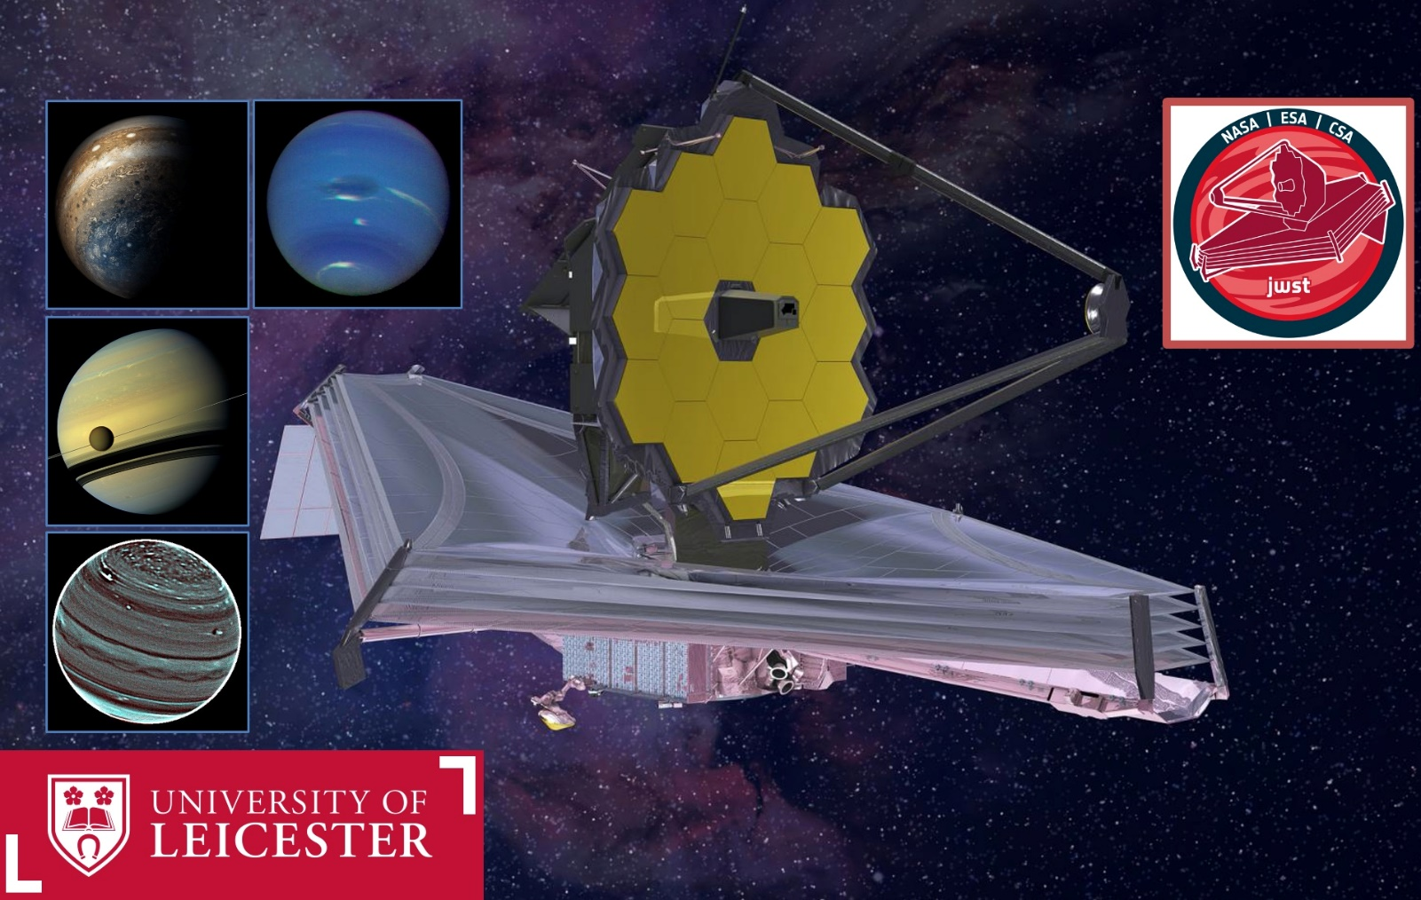

The James Webb Space Telescope Giant Planet Programme consists of spectroscopic mapping of all four giants, Jupiter, Saturn, Uranus and Neptune, during the first year of operations.

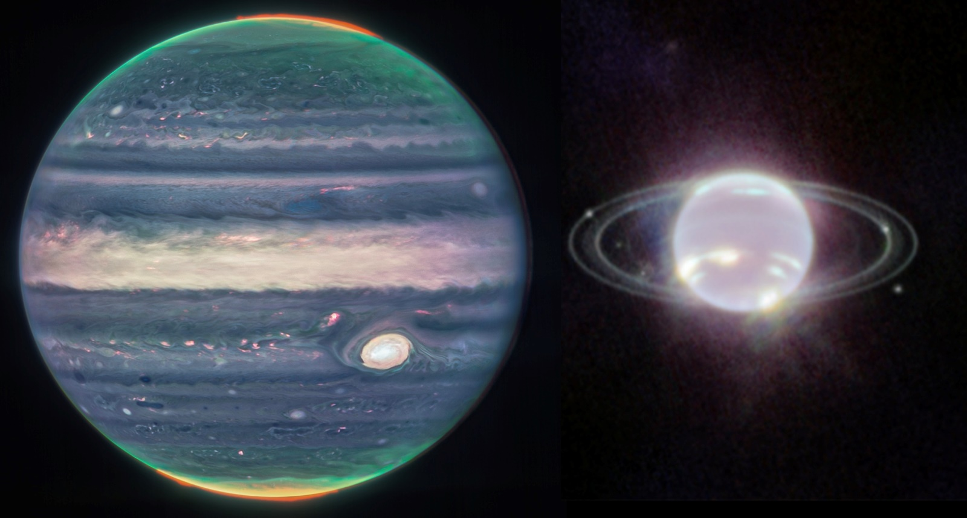

Infrared images of Jupiter (Credit: NASA, ESA, CSA, Jupiter ERS Team; image processing by Judy Schmidt) and Neptune (Credits: NASA, ESA, CSA, STScI) observed by the JWST NIRCAM instrument – this imaging whets the appetite for the spectroscopy still to come.
References:
- Fletcher et al. (2021), The JWST Giant Planet Atmospheres Programme, https://doi.org/10.5194/epsc2021-39, 2021.
- Further information on the giant planet observations, including press releases about proposed science: https://jwstgiantplanets.github.io/web/
- Fletcher et al., (2020), How well do we understand the belt/zone circulation of Giant Planet atmospheres? Space Science Reviews, https://arxiv.org/abs/1907.01822
- Fletcher (2022), JWST: A New Infrared Eye on the Solar System, Europlanet Magazine, https://www.europlanet-society.org/europlanet-magazine/issue-3/jwst-solar-system/
How to apply:
Use the application link on the web page
Include with your application:-
- CV
- Degree Certificates and Transcripts
- Details of any study currently being undertaken
- Personal statement
- Enter the supervisor’s name and project title in the Proposal Section (no proposal required)
- Enter contact details of two academic referees in the boxes provided or upload reference letters if already obtained.
- Evidence of English language if applicable.
- In the funding section include: Ref: STFC
The University of Leicester School of Physics and Astronomy has advertised a number of PhD opportunities. If you are applying for more than one University of Leicester project, please indicate if this is your first, second or third choice, in your application.

