

**Funding Source: STFC**

**Proposed start date: September 2023**

**Closing date for applications: May 19th 2023**

**Eligibility:** UK/EU/International

**Department/School:** School of Physics and Astronomy

**Supervisors:** Dr. Phil Evans ([pae9@leicester.ac.uk](mailto:pae9@leicester.ac.uk))

Dr. Michael Goad ([mg159@leicester.ac.uk](mailto:mg159@leicester.ac.uk))

**Project Title:** Transient X-ray events found with the Swift satellite

**Project Description**

The study of transient X-ray events is a powerful tool for probing physics in extreme conditions, uncovering new, rare or poorly-understood astrophysical processes. The University of Leicester has a world-wide reputation for its excellence in transient astrophysics, and plays a significant role in both current and upcoming satellites designed to study X-ray transients.

Ideally, we would identify new transient events as soon as they are observed and then request rapid follow-up observations to help study the new object in detail. This is difficult for a simple reason: transients cannot be predicted! Instead, researchers search through the archives of X-ray data taken with different observatories, and look for transients that were serendipitously in the field of view. Recently, we at Leicester have produced a new system which can combine these approaches. This system (called ‘LSXPS’) has analysed all historical data from the X-ray Telescope (XRT) on the *Swift* satellite, and analyses all new data as they are received. In both cases, the automated pipelines attempt to identify transient events.

This PhD project will focus on the detection, classification and study of X-ray transient phenomena using LSXPS. Initially, this will involve creating simulated *Swift*-XRT data for a range of different astrophysical phenomena, then feeding these data into LSXPS analysis pipelines to see what it finds and reports. This will enable the student to identify how effective those pipelines are at detecting and identifying different types of system.

These results will then have a range of applications the student will be able to exploit: predicting performance of new and proposed missions with which the University of Leicester are working; using the simulation results to produce an improved transient identification pipelines; using techniques such as machine learning to build an automated transient classification scheme for transients found by *Swift*; using the simulation results to identify a specific set of interesting transients in the archival *Swift* data, and then studying their physics.

The field of time-domain astronomy is rapidly growing and new facilities are planned to exploit this field, thus the candidate will be gaining experience and learning vital skills in a growth area of astrophysics.

This project will require some computer programming skills: experience and confidence writing Python code will be a significant advantage to potential applicants.

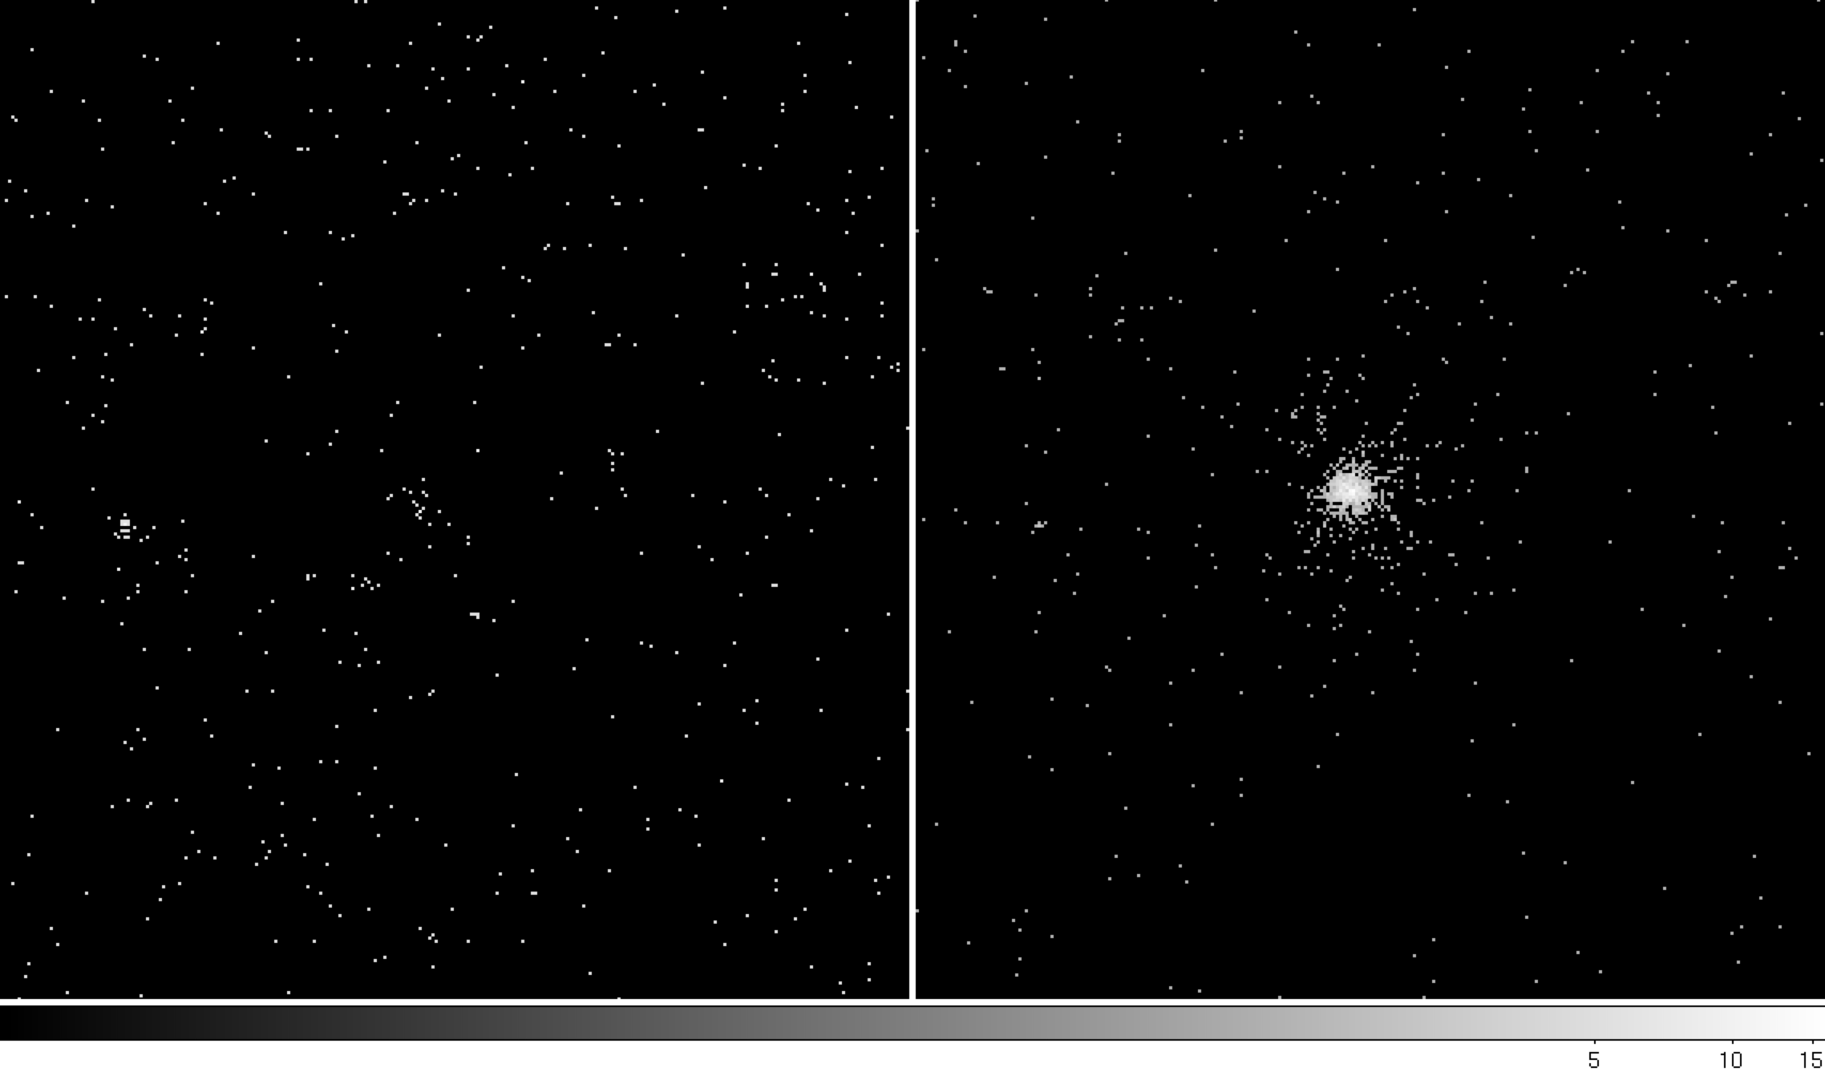

*Figure 1: Now you don’t see it; now you do! This pair of images shows the serendipitous discovery of an X-ray transient. Swift was observing the same field every day, to gather UV data on a specific supernova. As you can see, between one observation and the next, an X-ray transient suddenly switched on. This event is still the “gold standard” serendipitous X-ray transient. It is supernova SN2008D, the first (and only) time the supernova shock has been captured breaking out of the dying star.*

*Figure 2: The long-term X-ray light curve of a transient discovered in new data by the LSXPS pipeline. This object is thought to be the first example of a “quasi-periodic eruption” with a period of ~weeks. It may indicate a star being repeatedly shredded as it orbits around a million solar-mass black hole.*

**References:**

A real-time transient detector and the living Swift-XRT point source catalogue —Evans P.A., et al., 2023, MNRAS, 518, 174

Discovery of a New Kind of Explosive X-Ray Transient near M86 – Jonker P. G., et al., 2013, ApJ, 779, 14

Nine-hour X-ray quasi-periodic eruptions from a low-mass black hole galactic nucleus – Miniutti G.,

2019, Nature, 573 381

An extremely luminous X-ray outburst at the birth of a supernova – Soderberg A., 2008, Nature, 453, 469

How to apply:

Use the application link on the web page

Include with your application:-

* CV
* Degree Certificates and Transcripts
* Details of any study currently being undertaken
* Personal statement
* Enter the supervisor’s name and project title in the Proposal Section (no proposal required)
* Enter contact details of two academic referees in the boxes provided or upload reference letters if already obtained.
* Evidence of English language if applicable.
* In the funding section include: Ref: STFC

The University of Leicester School of Physics and Astronomy has advertised a number of PhD opportunities. If you are applying for more than one University of Leicester project, please indicate if this is your first, second or third choice, in your application.