- Identify candidate eclipsing binaries with very low mass red dwarf, brown dwarf and white dwarf companions in NGTS and TESS survey data. | Level | PhD
 | First Supervisor | Dr Matthew Burleigh  mrb1@le.ac.uk
- Obtain ground-based photometric light curves to precisely measure the stellar radii, and spectroscopic radial velocity measurements to determine their masses. | Second Supervisor | Dr Mike Goad or  Dr Sarah Casewell
 | Application Closing Date | 19 May 2023
- Test the mass-radius relation for very low mass stars, particularly through wide, long-period binaries that can be monitored with the NGTS telescopes. | PhD Start date | September 2023
Characterising eclipsing binaries from NGTS and TESS
Project Details:
Eclipsing binaries allow us to determine accurate, model-independent radii and masses for the two stars in the system. These measurements are important for understanding uncertainties in the mass-radius relationship for, in particular, very low mass red (M) dwarf stars. This has become increasingly important as more exoplanets are discovered with M-dwarf hosts. Indeed, some of the most intriguing planetary systems have been found orbiting very low mass stars, for instance the nearby late M-Dwarf TRAPPIST-1 (Gillon et al. 2016) hosts seven Earth and sub-Earth sized planets.
The Next Generation Transit Survey (NGTS) and NASA’s ongoing TESS mission are currently revealing many excellent examples of eclipsing binaries that include a very low mass red dwarf, brown dwarf, or white dwarf. As a founding member of the NGTS consortium, Leicester has priority access to the NGTS telescopes and data, while NASA releases new TESS survey data on a monthly basis. All the new eclipsing binary systems discovered by these two surveys are suitable for follow-up studies with ground-based telescopes to better measure the stellar radii via higher precision photometric light curves, and to determine the stellar masses through spectroscopic radial velocity measurements.
By combining TESS and NGTS survey data, we are also now able to find very long period eclipsing binaries, with orbits as large as 100s of days. We have the great benefit of being able to use some of NGTS’s twelve telescopes at Paranal in Chile to monitor and observe further transits of these systems, to unambiguously solve their orbital periods. These wide, long period binaries are particularly suitable for testing evolutionary models, since the secondary stars should not be particularly susceptible to heating and irradiation by the primary star, or to tidal forces.
In this PhD you will participate in identifying new such binary systems in TESS and NGTS survey data, and then characterising them through follow-up observations. You will help to obtain follow-up light curves with ground-based 1m class telescopes such as those at the South African Astronomical Observatory. Leicester leads a long-running observing programme at SAAO, and you will undertake some of these observations.
You will also help to obtain radial velocity measurements with precision spectrographs such as Coralie and HARPs, as well as spectrographs available at SAAO and other observatories. You will analyse these datasets with suitable modelling codes, and lead papers to publish the results.
As the PhD develops, opportunities may develop for new avenues of research, eg developing and utilising neural network codes for automated identification of eclipsing binaries in NGTS and TESS survey data, or collaborating with the NGTS Planet Hunters team to enable citizen scientists to participate in discovering these systems. And as a member of the NGTS team, you will also be able to participate in identifying and characterising candidate transiting exoplanet systems in our survey data.
Candidates for this PhD should be enthusiastic to learn how to observe on large telescopes. Some knowledge of programming in python and other codes would be advantageous.
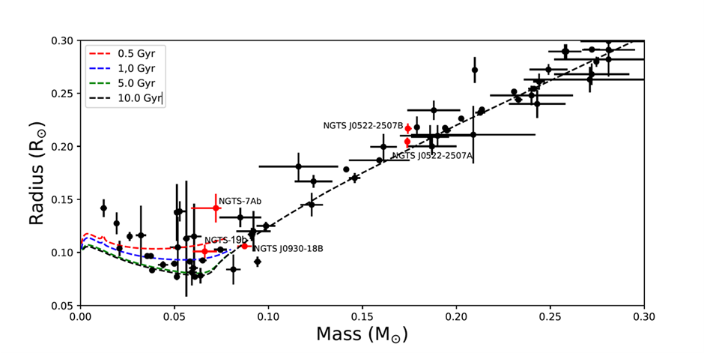
Mass-Radius relationship for known transiting brown dwarfs from Carmichael et al 2020 and eclipsing M-dwarfs from Parsons et al 2018. NGTS discoveries are shown in red. Brown dwarf model isochrones from Marley et al 2018 for ages of 0.5, 1, 5 and 10 Gyr are plotted for comparison as well as a 10 Gyr stellar isochrone from Baraffe et al 2015 for M-dwarfs. The core H-burning limit separating brown dwarfs from the coolest M dwarfs is around 0.07-0.08 solar masses.

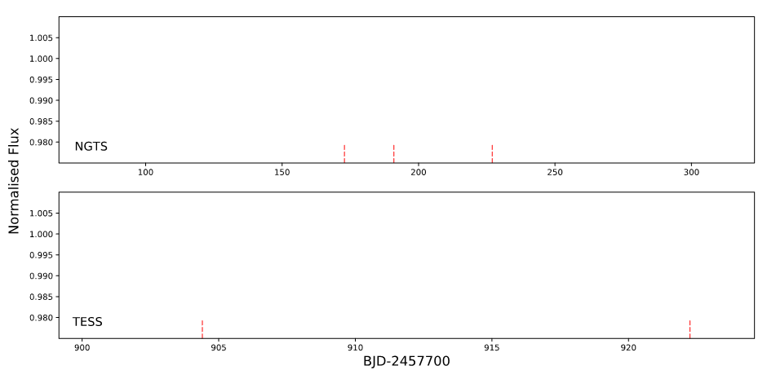
NGTS (Upper) and TESS (Lower) light curves for NGTS-19b (Acton et al, 2021). The TESS light curve contains just two eclipses, insufficient alone to unambiguously constrain the binary period. In contrast, the longer, ~150 day baseline of NGTS observed three transits. Combining the two datasets allowed us to solve the system.

References:
- “NGTS J214358.5-380102 - NGTS discovery of the most eccentric known eclipsing M-dwarf binary system” – Acton, J. et al., 2020, MNRAS, 494, 3950 arXiv:2003.14314
- “A long-period (P = 61.8 d) M5V dwarf eclipsing a Sun-like star from TESS and NGTS” – Gill, S. et al., 2020, MNRAS, 495, 2713 arXiv:2002.09311
- “An eclipsing M-dwarf close to the hydrogen burning limit from NGTS” – Acton, J. et al., 2020, MNRAS, 498, 3115 arXiv:2008.07354
- “NGTS-19b: a high-mass transiting brown dwarf in a 17-d eccentric orbit” – Acton, J. et al., 2021, MNRAS, 505, 2741 arXiv:2105.0857

How to apply:
Use the application link on the web page
Include with your application:-
- CV
- Degree Certificates and Transcripts
- Details of any study currently being undertaken
- Personal statement
- Enter the supervisor’s name and project title in the Proposal Section (no proposal required)
- Enter contact details of two academic referees in the boxes provided or upload reference letters if already obtained.
- Evidence of English language if applicable.
- In the funding section include: Ref: STFC
The University of Leicester School of Physics and Astronomy has advertised a number of PhD opportunities. If you are applying for more than one University of Leicester project, please indicate if this is your first, second or third choice, in your application.

