
Novel Pu Gd oxides for Space Nuclear Power Systems
- Spacecraft require Radioisotope Power Systems for electrical/thermal power to explore dark/distant locations | Level | PhD
 | First Supervisor | Dr Emily Jane Watkinson  ejw38@leicester.ac.uk
- ¹⁴⁸Gd may provide a way to supplement ²³⁸Pu material for US Radioisotope Power Systems. | Second Supervisor | Dr Fabrizio Ortu
 | Application Closing Date | See web page
- PhD investigates the synthesis, sintering & analysis of non-radioactive surrogates for novel 238Pu-148Gd oxides | PhD Start date | 21st September 2026

Details:
Radioisotope power systems, such as radioisotope thermoelectric generators (RTGs), are technologies that underpin the ability to explore the outer solar system and have enabled space science missions on the Moon and Mars. Radioisotope power systems provide electrical and/or thermal power to spacecraft/vehicles and their scientific instruments in any location. This PhD supports STFC’s Strategic Delivery Plan (2022-2025) to conduct “fundamental research and technology development for future science and exploration missions” (STFC Strategic Delivery Plan 2022-2025). Examples of some famous space science missions that have used RPSs include Cassini, New Horizons, Mars Science Laboratory and Voyager 1 & 2.
This project will investigate how a new isotope option, specifically 148Gd, could be used to supplement 238Pu material, which is used for US RPSs. 238Pu is limited in supply. 148Gd is theoretically desirable as it has a similar half-life (87 years) and decays only via alpha-decay. Specifically, a student will investigate how to synthesise and analyse non-radioactive surrogates/simulants for mixed 238Pu-148Gd oxides with varying Pu:Gd compositions, how to transform these into sintered pellets and how these would influence US RPSs design/performance. A range of analytical techniques will be used by the student to analyse the materials e.g. scanning electron-microscopy coupled with energy-dispersive X-ray spectroscopy and X-ray diffraction. The effect of the RPS design/performance on a space mission concept can be explored. Borland et al. (2009) indicates the current process used to synthesise, sinter and create the US RPS 238Pu fuel form.
You will be supervised by experts developing separate radioisotope power systems for European Space Agency.

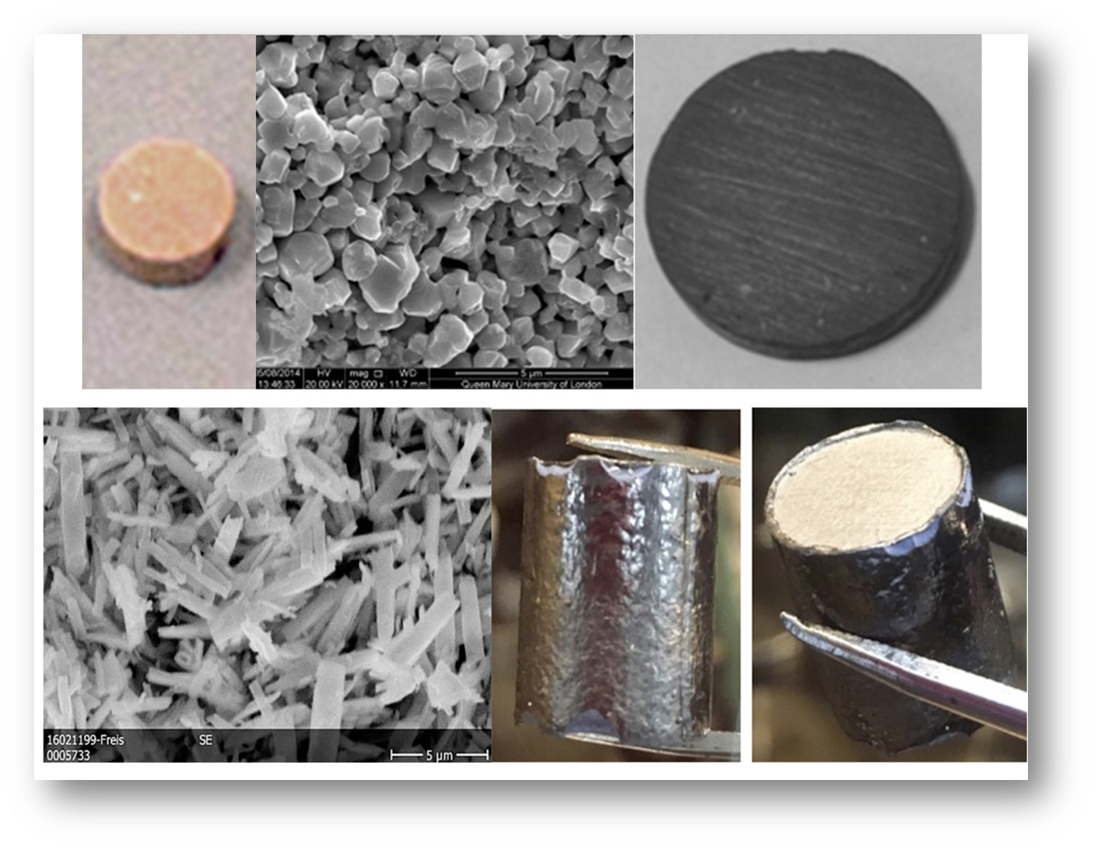

Cerium and neodymium oxide simulants were used for americium oxides in previous research. The raw material is shown in B and D and sintered discs are shown in A, C and E, Credit: E. J. Watkinson et al., 2017, https://doi.org/10.1016/j.jnucmat.2017.04.028 and Ambrosi et al., https://doi.org/10.1007/s11214-019-0623-9

Further Reading:
- Borland et al. (2009), INL, Evaluation of Aqueous and Powder Processing Techniques for Production of Pu-238-Fueled General Purpose Heat Sources https://core.ac.uk/download/pdf/71321573.pdf
- G. Hula, INL, Atomic Power in Space II, INL/EXT-15-34409-Revision-0 https://inldigitallibrary.inl.gov/sites/sti/sti/Sort_63995.pdf
- E. J. Watkinson (2017), PhD Thesis, University of Leicester, https://figshare.le.ac.uk/articles/thesis/Space_Nuclear_Power_Systems_Enabling_Innovative_Space_Science_and_Exploration_Missions/10206722
Further information on how to apply and funding can be found here

