
AGN variability: hidden signals in the noise
- Use data from space-based observatories, from optical to X-rays, spanning timescales of minutes to decades | Level | PhD
 | First Supervisor | Prof Simon Vaughan  sav2@leicester.ac.uk
- Test and use methods to identify properties of the variability such as non-linearity and the distribution of fluxes | Second Supervisor | Dr Mike Goad
 | Application Closing Date | See web page
- Compare with mathematical and computational models of variable processes | PhD Start date | 21st September 2026

Details:
Scientific Background Active Galactic Nuclei (AGN) are among the most energetic objects in the universe, powered by matter falling into supermassive black holes. Their brightness changes on timescales from minutes to decades (and probably much longer), reflecting dynamic processes in accretion disks, jets, and surrounding environments. These variations are not always simple or predictable—they show signs of non-linearity, non-Gaussian flux distributions, and non-stationary behaviour. Understanding these patterns offers a way to study the dynamics and constrain the physics of powerful accretion flows and black hole accretion.
Scope and Aims This project will explore the statistical and physical properties of AGN variability in detail. Our goals are to:
- Characterize variability beyond traditional linear methods and models
- Quantify deviations from Gaussian flux distributions and compare with a range of non-Gaussian and non-linear models.
- Detect and interpret non-stationary changes in variability over time.
Tools and Methodology
We will use data from cutting-edge space-based observatories, including XMM-Newton, Swift, GAIA, as well as ground-based observatories, covering optical to X-ray wavelengths. These archives provide light curves spanning minutes to decades. Advanced time-series techniques—such as higher-order statistics and surrogate data tests—will be applied to identify non-linear and non-Gaussian features. Observational results will be compared with mathematical and computational models to test theoretical predictions.
International Context
AGN variability is a central topic in astrophysics, with major international efforts underway through projects like LSST (Vera Rubin Observatory) and ESA’s NewAthena X-ray mission. This study complements these initiatives by focusing on statistical characterization and model comparison, providing insights that will help interpret future large-scale surveys. By leveraging existing space-based archives and modern analysis techniques, the project aligns with global priorities in time-domain astronomy and contributes to understanding black hole growth and feedback in galaxies.

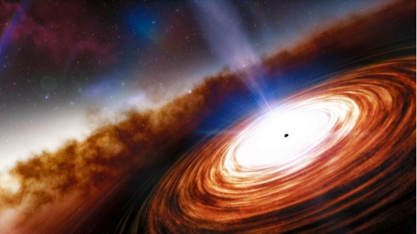

Artist’s impression of the central engine of an AGN (accreting supermassive black hole). Credit: NOIRLab

Further Reading:
- Random time series in astronomy, 2013, Vaughan, S., [1309.6435] Random time series in Astronomy
- Non-linear X-ray variability in X-ray binaries and active galaxies, Uttley, P., et al., 2005, Non-linear X-ray variability in X-ray binaries and active galaxies - Astrophysics Data System
Further information on how to apply and funding can be found here

