
SMILE: Northern Lights, Camera, Action!
- Exploit auroral observations from ESA’s new SMILE spacecraft mission | Level | PhD
 | First Supervisor | Prof Steve Milan  steve.milan@leicester.ac.uk
- Understand the relationship between Earth’s auroras and electrical currents in space | Second Supervisor | Dr Jenny Carter
 | Application Closing Date | See web page
- Provide new understanding of solar wind-magnetosphere-ionosphere-coupling | PhD Start date | 21st September 2026

Details:
The Earth’s auroras are a manifestation of electric currents flowing between the magnetosphere and ionosphere, known as magnetic field aligned currents or FACs, though the exact relationship between the two phenomena is poorly understood. Further progress has been waiting for simultaneous measurements of the two to become available. In the last few years, the Active Magnetosphere and Planetary Electrodynamics Response Experiment (AMPERE) has been developed which infers the FACs from magnetometer measurements onboard the 66 satellites of the Iridium telecommunications constellation. In 2025/26, the ESA-CAS (European Space Agency - Chinese Academy of Sciences) Solar Wind-Magnetosphere-Ionosphere Link Explorer (SMILE) spacecraft will be launched, carrying an auroral camera that will make global measurements of the UV emissions produced by these FACs. The combination of these two datasets will allow the first comprehensive study of the electrodynamics of the magnetosphere-ionosphere system.
Prior to the launch of SMILE, preparatory work will involve a) exploiting legacy auroral datasets (involving the FUV and SSUSI cameras onboard the IMAGE and DMSP satellites, respectively), b) ionospheric radar measurements of ionospheric flows, another manifestation of FACs, and c) understanding a new FAC phenomenon that was recently discovered by Leicester scientists termed “R2 Bifurcations” or R2Bs (Sangha et al., 2020). R2Bs are associated with proton auroras and fast flow channels in the ionosphere: determining the occurrence of R2Bs will shed new light on the coupling between the ionosphere and the inner magnetosphere.
Once SMILE auroral observations become available, the study will target a range of auroral phenomena including the formation of the main auroral oval, and more localised but dynamic features such as substorm break-up auroras and cusp auroras. These observations will explain not just the formation of the auroras but also the large-scale dynamics of the solar wind-magnetosphere coupled system.

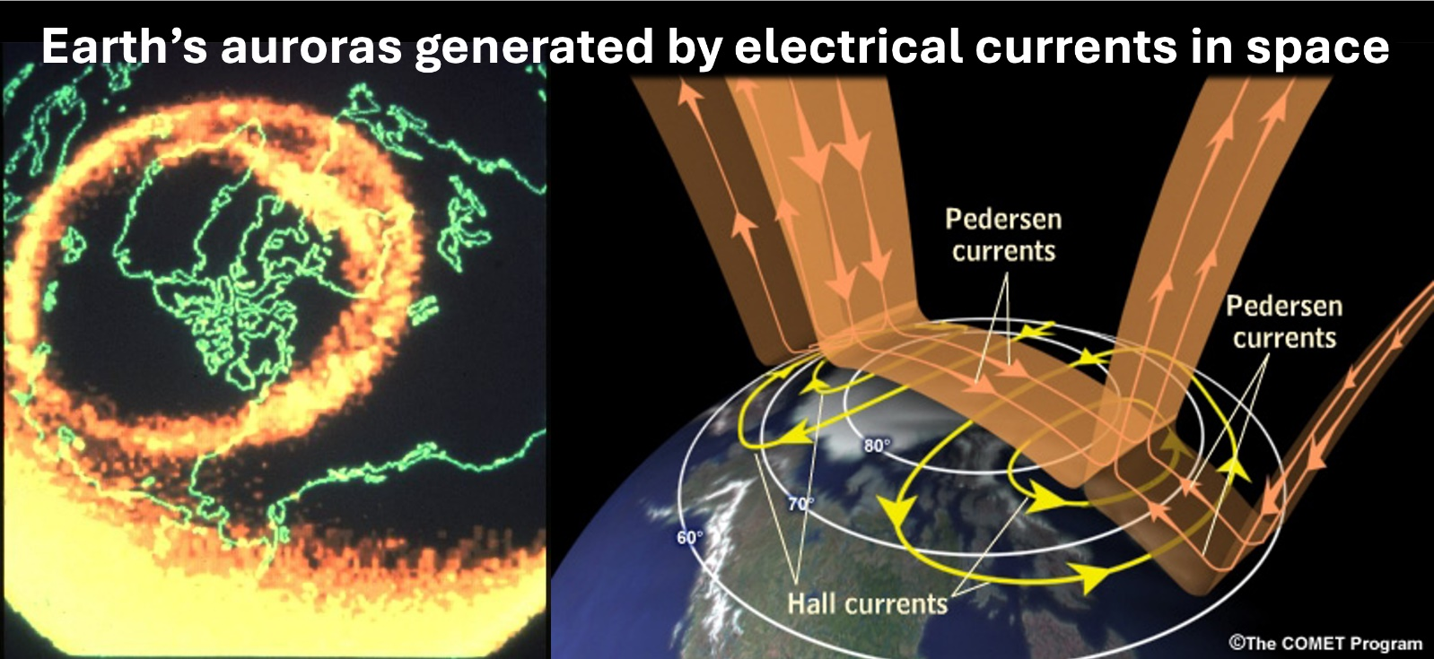

Electric currents in space. An artist’s impression of the field-aligned currents that connect the magnetosphere and ionosphere. Auroral emissions are produced where the currents strike the atmosphere.
Further Reading:
- Milan et al. (2017), “Overview of Solar Wind–Magnetosphere–Ionosphere–Atmosphere Coupling and the Generation of Magnetospheric Currents”: https://link.springer.com/article/10.1007/s11214-017-0333-0
- Milan et al. (2022), “Lobe Reconnection and Cusp-Aligned Auroral Arcs”: https://doi.org/10.1029/2021JA030089
- Sangha et al. (2020), “Bifurcated Region 2 Field-Aligned Currents Associated With Substorms”: https://doi.org/10.1029/2019JA027041
Further information on how to apply and funding can be found here

