
Towards a unified model of the Milky Way's dynamics
- Decode the structure and history of the Milky Way | Level | PhD
 | First Supervisor | Dr Paul McMillan  paul.mcmillan@le.ac.uk
- Use cutting-techniques from theoretical physics to understand the movements of the stars | Second Supervisor | Prof Sergei Nayakshin
 | Application Closing Date | See web page
- Build towards a full understanding of the properties of dark matter | PhD Start date | 21st September 2026

Details:
The Milky Way is the galaxy we can study more closely than any other. In this project a student will be using the latest tools for understanding the orbits of stars in the Milky Way, using them to understand its structure and history. This will bring us closer to a having a full working model of the galaxy that tells us about the processes that formed and shape it, and that shape all galaxies.
Our understanding of the Milky Way has been revolutionised by data from the European Space Agency’s Gaia mission. It has allowed us to measure the velocities of tens of millions of the Milky Way’s stars for the very first time. The challenge this project addresses is that we can only observe a snapshot and cannot follow the stars on their orbits around the galaxy because these take tens of millions of years. The orbits of these stars in the galaxy are more complicated than those of planets around a star, because the gravitational force they feel is due to a combination of the galaxy’s stars and dark matter, rather than a single object, and is nearly impossible to directly measure.
The key to understanding the galaxy is understanding the orbits of its stars. If the galaxy was in equilibrium, then this would be a relatively easy job because the stars would be evenly distributed around the orbits, but Gaia has shown us that this is not the case because the galaxy has clearly been relatively recently disturbed.
Methods using clever concepts from Hamiltonian mechanics (called “action-angle coordinates”) were developed to understand the orbits an equilibrium Milky Way, but in this project, we will adapt them to understand the way that the galaxy is disturbed and what that means for our interpretation of observations. The models will be compared to and used to understand the results from Gaia (with a new data release expected early in the project) and from state-of-the-art galaxy simulations.

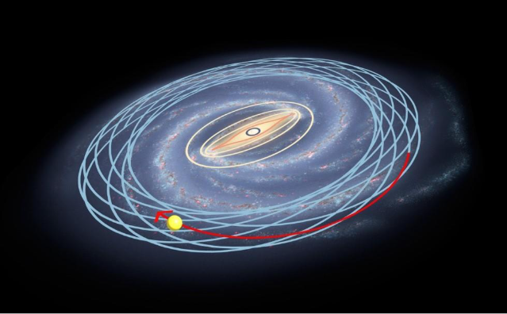

Illustration of the orbits of stars in the Milky Way. Image credit: Adapted by P. McMillan from an image by NASA-JPL, Caltech, ESO, Robert Hurt

Further Reading:
- McMillan et al (2022) “The disturbed outer Milky Way disc”, MNRAS, 516, 4988 https://doi.org/10.1093/mnras/stac2571
- Binney & McMillan (2016) “Torus mapper: a code for dynamical models of galaxies”, MNRAS, 456, 1982 https://doi.org/10.1093/mnras/stv2734
- Frankel et al (2023), “Vertical motion in the Galactic disc: unwinding the Snail”, MNRAS, 521, 5917 https://doi.org/10.1093/mnras/stad908
Further information on how to apply and funding can be found here

