
Revealing Mercury’s surface composition with BepiColombo MIXS.
- Analyse the first data from BepiColombo Mercury Imaging X-ray Spectrometer | Level | PhD
 | First Supervisor | Dr Adrian Martindale  am136@leicester.ac.uk
- Reveal Mercury’s surface composition | Second Supervisor | Dr Tiff Barry
 | Application Closing Date | See web page
- X-ray Spectroscopy of planetary surfaces | PhD Start date | 21st September 2026

Details:
The successful student will perform analyses on the first data returned by BepiColombo MIXS and ground-based experiments to reveal the surface composition of Mercury and its implications for key geological processes that have altered its surface. Using the data analysis approach developed in Hall et al 2024, they will test the hypothesis that Mercury’s unexplained high magnesium/silicon terrane (HMT) is a consequence of heterogeneity in the composition of Mercury’s crust and/or mantle, revealed by uplifted material from depth. In this region, an anomalously-high spatial density of basin-sized impacts with peak rings has been observed, distributing previously buried material laterally over the planet's surface. By taking BepiColombo MIXS data of the HMT, the successful student will compare the abundance of key elements to neighbouring clusters of peak-ringed craters (e.g. Nabokov and/or Borealis Planitia areas). They will determine how physical features and chemical signatures of the impact basins (ejecta fields, central peaks, diameter of peak ring to crater size, etc) differ across the clusters. Using iSALE simulations of impact dynamics, the student will reveal whether chemical signatures correlate to the depth from which uplifted materials came and whether there is any contribution from the mercurian mantle.
Clustering of peak-ring basins may relate to either the impact history of the planet, or the physical properties of the HMT lithosphere. To test the latter, the student will study a range of physical properties (including density, strength, porosity) on Mg-rich rocks and simulant analogues, to assess the role physical properties could play in generating the peak-ring craters in the HMT crust. Linking this back to impact simulations of the HMT lithosphere, the student will ultimately test whether the HMT reflects lateral and/or vertical crust-mantle heterogeneity on Mercury.

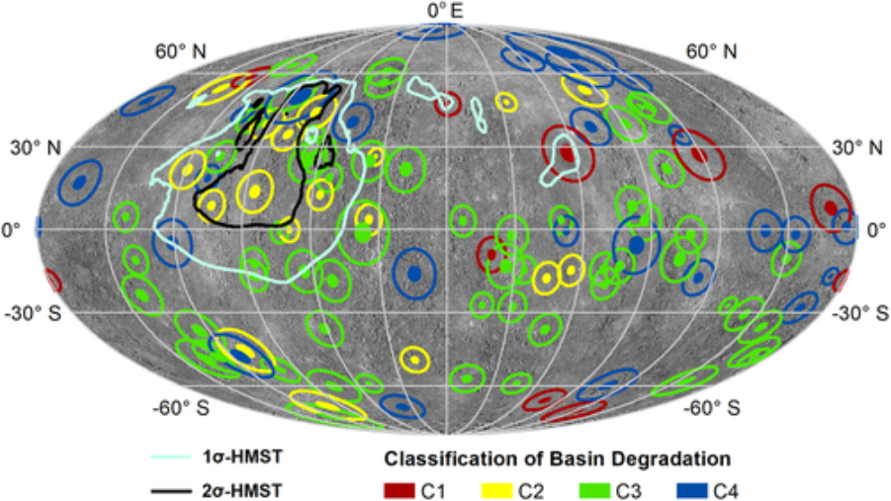

The distribution of peak ring basins on Mercury and their correlation with the high magnesium/silicon terrane on Mercury’s surface. The successful student will use data from BepiColombo MIXZ to reveal why this correlation exists. (Hall et al. 2021)
Further Reading:
- https://link.springer.com/article/10.1007/s11214-020-00750-2
- https://link.springer.com/article/10.1007/s11214-020-00694-7
- https://agupubs.onlinelibrary.wiley.com/doi/full/10.1029/2021JE006839
- https://academic.oup.com/rasti/article/doi/10.1093/rasti/rzaf008/8063944?login=false

Further information on how to apply and funding can be found here

