

SMILE! Novel X-ray views of the magnetosphere
- Make key measurements of the magnetopause boundary | Level | PhD
 | First Supervisor | Dr Jennifer Carter  jac48@le.ac.uk
- Understand the rate of magnetic reconnection with respect to the dynamic solar wind | Second Supervisor | Prof Steve Milan
 | Application Closing Date | See web page
- Relate the magnetopause to signatures at multiple scales in the ionosphere | PhD Start date | 21st September 2026

Details:
The Solar wind Magnetosphere Ionosphere Link Explorer (SMILE) is a joint European Space Agency, Chinese Academy of Sciences mission due for imminent launch in early 2026. Leicester is taking a leading role in the mission, having led the build of SMILE’s Soft X-ray Imager (SXI) camera, and Leicester scientists are embedded in the large, international SMILE Consortium. SXI will detect solar wind charge exchange emissions in the X-ray regime. SXI will be used to track the shape and movement of the magnetopause boundary that separates the solar wind from the Earth’s magnetosphere. SMILE also carries an Ultraviolet Imager (UVI) to monitor the auroral borealis in the Northern Hemisphere. Together, SXI and UVI provide a completely novel view of how the solar wind, magnetosphere, and ionosphere are coupled, and SMILE promises to revolutionise our understanding of the solar terrestrial relationship.

The three-dimensional magnetopause shape needs to be extracted from SXI’s two-dimensional images, using a process of forward modelling. Carefully tailored SXI images, both temporally and spatially, will be needed. Once the magnetopause is found, its behaviour can be compared to multi-scaled measurements at the ionosphere. To do this, auroral images from SMILE’s UVI and maps of movements of plasma in the ionosphere will be used, from ground-based facilities such as the Super Dual Auroral Radar Network. In addition, spectral studies of SXI images can reveal details of solar wind composition and identify transient phenomena such as coronal mass ejections impinging on the magnetosphere. SMILE will provide a rich and varied data set to be explored, and Leicester is the forefront of those efforts.

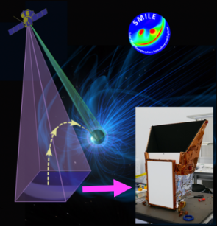

SMILE will have two imagers; the SXI with a view of the dayside magnetopause (purple), and the UVI with a view of the Northern Hemisphere aurora (green). The University of Leicester led the build of the SXI, shown in the inset.
Credit: Composite by J. A. Carter, background NASA.
Further Reading:
- Wang et al. 2025, Overview of the SMILE mission: https://link.springer.com/article/10.1007/s11214-024-01126-6
- Sembay et al. 2024, The SMILE Soft X-ray Imager: https://www.eppcgs.org/article/doi/10.26464/epp2023067
- Carter et al. 2025, Linking SMILE SXI and UVI observations with other facilities: https://link.springer.com/article/10.1007/s11214-025-01175-5
Further information on how to apply and funding can be found here

