

Discovering and characterizing extra-solar planets with the Next Generation Transit Survey and TESS
- Participate in identifying new candidate transiting extra-solar planets from TESS and NGTS data. | Level | PhD
 | First Supervisor | Dr Matt Burleigh  mrb1@leicester.ac.uk
- Collect follow-up photometric transit light curves, plus spectroscopic and other data, to validate and confirm these planets. | Second Supervisor | Dr Mike Goad
 | Application Closing Date | See web page
- Analyse, model and publish newly discovered planets, from short-period hot Neptunes to long period cold Jupiters in orbits of hundreds of days. | PhD Start date | 21st September 2026
Details:
The Next Generation Transit Survey (NGTS) is located at Paranal, Chile and consists of a suite of twelve 20cm telescopes. By achieving a photometric precision of about 0.1%, at the limit of what is possible from the ground, NGTS is designed to detect the transits of Jupiter, Neptune, sub-Neptune and Super-Earth sized planets around stars brighter than about 15th magnitude.
Over 40 NGTS planet discoveries from its surveys have been published or are currently being written up for publication. However, dozens more still await follow-up photometric and radial velocity measurements to confirm their radii and masses. In this project, you will help confirm new NGTS exoplanets by obtaining, reducing and analyzing follow-up light curves with ground-based telescopes such as those at the South African Astronomical Observatory (SAAO). You will combine these data with radial velocity measurements, and/or other datasets such as high resolution speckle imaging. You will analyse these datasets with suitable modelling codes, and lead papers to publish the results, validating, confirming and characterizing these new planets, and placing them in context.
Today, NGTS’s main focus includes the discovery of transiting planets in much longer period orbits than had previously been possible. In particular, NGTS’s telescopes are used to follow-up single transit events detected by the TESS mission. Since TESS typically observes a star for only 30 days or so, NGTS is ideal for long term monitoring to detect further transits and thereby determine the planets’ true orbital periods. Unlike hot Jupiters, these “warm” and “cold” gas giants will have temperatures and atmospheres much more akin to Jupiter and Saturn in our own solar system, and will become key targets for future investigations with JWST. You will join NGTS’s long period planet discovery team, analysing new single transit candidates from TESS together with follow-up NGTS transits and associated radial velocity data. Again, you will have the opportunity to publish some of these new discoveries. During this PhD new long period planet candidates will be added to NGTS’s target list from other surveys such as ESA’s GAIA satellite, and ESA’s Plato mission which is due for launch in late 2026.

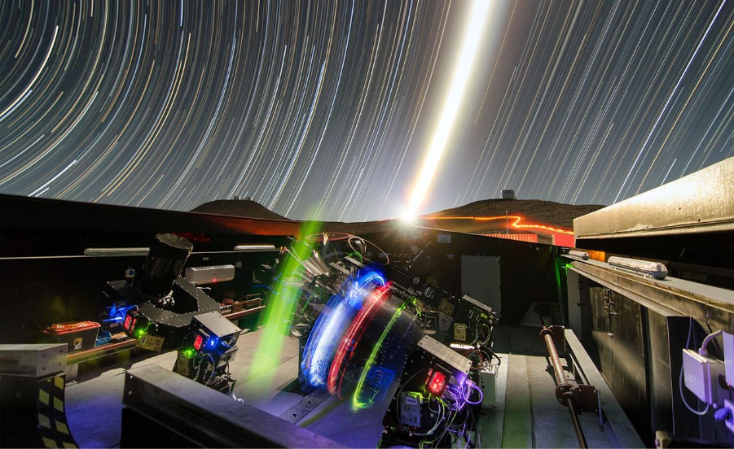

The NGTS telescopes operating in their shed at ESO’s Paranal Observatory, Chile Credit: ESO/G. Lambert

Further Reading:
- “The Next Generation Transit Survey (NGTS)” – Wheatley et al. 2018, MNRAS, 475, 4476 https://arxiv.org/abs/1710.11100
- NGTS project website
- “NGTS 15b, 16b, 17b, and 18b: four hot Jupiters from the Next Generation Transit Survey” – Tilbrook et al. 2021, MNRAS, 504, 6018 http://arxiv.org/abs/2103.10302
- “Detection and characterisation of a 106-day transiting Jupiter : TOI-2449 b /
NGTS-36 b” – Ulmer-Moll et al. 2025, A&A, in press https://arxiv.org/abs/2509.15424
Further information on how to apply and funding can be found here

