
The astrophysics and environments of the most luminous galaxies Project
- We will investigate how some infrared galaxies blaze thousands of times brighter than others. | Level | PhD
 | First Supervisor | Prof Andrew Blain  ab520@leicester.ac.uk
- We will probe the effects of driving radiation and winds into the galaxy and its environment. | Second Supervisor | Prof Nial Tanvir
 | Application Closing Date | See web page
- We will look in the environment of the galaxies for triggers of dramatic activity. | PhD Start date | 21st September 2026

Details:
As the Universe evolves, some galaxies undergo bursts of remarkable luminosity. They grow thousands of times brighter than average, as mass cascades onto a central supermassive blackhole. The most remarkable two thousand such galaxies currently visible, nicknamed HotDOGs, are substantially hidden from traditional optical view by dense gas and dust. They were first catalogued in the all-sky mid-infrared WISE survey in 2010. Since then, high-resolution images and spectra taken using ALMA and JWST have help to reveal some of the processes within, and provided the first information about how ejected material and the intense luminosity may modify their surroundings. A growing but still modest fraction of HotDOGs have this excellent data: we continue to gain more in an ongoing international effort that a student will join.
A key open question concerns the nature of these galaxies’ surrounding environment: whether it stimulates the onset of a HotDOG phase, and how it might be influenced by one. Revealing the surroundings of these remarkable, dramatic and distant galaxies demands deep, wide data that covers a substantial fraction of the sky, as HotDOGs are typically spread many degrees apart all over the sky. Suitable data is now becoming available from radio surveys with Square Kilometre Array telescope precursors like LOFAR, and from the almost complete VLASS survey, along with the data from the SPHEREx and Euclid space telescopes and soon from the Vera Rubin Observatory in Chile. These facilities will greatly expand our view of the environments around HotDOGs.
A student will work to reveal the environment of HotDOGs, developing cutting-edge classification techniques from machine learning across all the available wavelengths to identify companions, first around the best-studied HotDOGs, and then expanding to full coverage of the thousands known. The project will investigate HotDOGs’ locations in the wider web of cosmic structure, and how their ejected energy and matter feedback into and modify their surroundings. Building on the availability of these new, deep wide-field surveys, we seek to reveal whether rare HotDOGs are found in special locations, or if they are a common if brief phase in the lives of relatively ordinary galaxies.

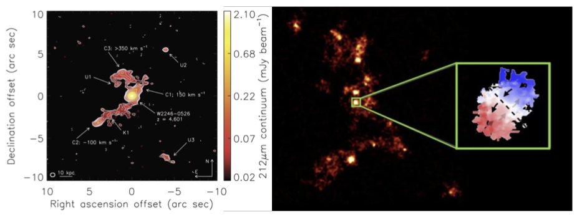

The environments and internal structure of example HotDOGs. The left panel shows an ALMA image of structure in the distribution of cosmic dust around HotDOG W2246, see Diaz-Santos et al. (2018) above in Science. The right panel shows gas around another HotDOG in the background, with ALMA velocity information highlighted in the centre, see the space.com reference above.

Further Reading:
- https://irsa.ipac.caltech.edu/Missions/wise.html The WISE archive
- https://ui.adsabs.harvard.edu/abs/2010AJ....140.1868W/abstract WISE description
- https://www.esa.int/Science_Exploration/Space_Science/Euclid Euclid’s website
- https://spherex.caltech.edu The SPHEREx website
- https://rubinobservatory.org The Rubin Observatory website
- https://arxiv.org/abs/2502.10503 Recent paper on a dusty HotDOG
- https://arxiv.org/abs/2412.04436 Paper on galaxies found around a HotDOG.
- https://www.science.org/doi/10.1126/science.aap7605 First dissected HotDOG
- https://www.space.com/cosmic-hot-dog-galaxy-surrounded-by-smaller-galaxies
Further information on how to apply and funding can be found here

