
Study Phobos surface with MMX

- Study the surface of Martian moon Phobos. | Level | PhD
 | First Supervisor | Dr Chrysa Avdellidou  c.avdellidou@leicester.ac.uk
- Combine remote sensing data (spectra and imaging) obtained by the Martian Moon eXploration mission (MMX). | Second Supervisor | Prof Emma Bunce
 | Application Closing Date | See web page
- Study the impact craters and search for exogenous material on Phobos surface. | PhD Start date | 21st September 2026
Project Details:
Scientific Context: Investigating the physical properties of small Solar System bodies and planetary moons, and their link to meteorites, reveals their composition, formation, size, and thermal evolution. Such studies are vital for reconstructing the Solar System’s early history and identifying major collisional and dynamical epochs. Following successful asteroid sample return missions, JAXA’s Martian Moon eXploration (MMX) mission (launch 2026) seeks to resolve the debated origin of Phobos and Deimos. MMX will be the first mission to sample a body that either formed in the outer Solar System and migrated inwards or resulted from a giant impact on Mars. In both cases, surface modification by impacts is expected and requires detailed study. MMX carries a comprehensive suite of instruments to address these questions.
Objective and Methodology: The objective is to study the cratering process in terms of number and sizes of craters and the investigation of the potential presence of exogenous material on Phobos, which arrived by small body impactors or Martian ejecta after large impacts on Mars. To achieve this the PhD candidate will need to combine imaging and spectroscopic data, as well as use information from LIDAR measurements. The results of this work will be compared to the data that the team obtained from a previous experimental impact campaign that was launched to provide additional support to the mission for the data interpretation.
The Hard Rocks team: The team has extensive experience in remote sensing data analysis from past sample return missions. For MMX, the main supervisor (Avdellidou) is an ESA Participating Scientist, and the external supervisor (Delbo) a Co-Investigator of the MMX InfraRed Spectrometer. The team also studies D-type asteroids considered similar to Phobos, and over the past decade has conducted numerous hypervelocity impact experiments on natural materials to investigate cratering and impact-induced contamination.
Position and Impact: Following the OSIRIS-REx and Hayabusa2 missions to primitive carbonaceous asteroids, MMX represents the next major sample return mission, targeting a rare, primitive, red-sloped, D-type-like body whose link to meteorites remains crucial. MMX includes significant international collaboration, with strong UK involvement. The study of Mars’ moons unites two major research priorities for space agencies (e.g. NASA’s Decadal Strategy) and the national agenda (STFC Roadmap): (i) investigation of Mars and its environment, and (ii) exploration of primitive small bodies that formed in the giant planet region.

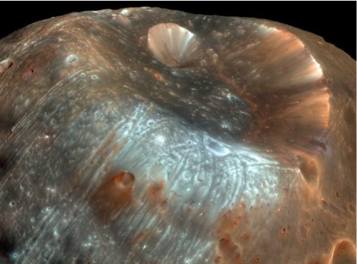

Figure 1: Stickney crater on martian moon Phobos as observed by HiRISE camera on the Mars Reconnaissance Orbiter.

Further Reading:
- DellaGiustina et al. Nature Astronomy 5, 31-38 (2021)
- Barucci et al. Earth, Planets and Space 73:211 (2021)
- Vernazza et al. Progress in Earth and Planetary Science 12:46 (2025).
Further information on how to apply and funding can be found here

