
Understanding protoplanetary disc evolution
- Creating new theoretical/computational models of planet-forming discs. | Level | PhD
 | First Supervisor | Prof Richard Alexander  rda5@leicester.ac.uk
- Simulating observations, in order to compare these models directly to ALMA and JWST observations. | Second Supervisor | Dr Paul McMillan
 | Application Closing Date | See web page
- Using high-performance computing to study protoplanetary disc evolution. | PhD Start date | 21st September 2026

Project Details:
Planets form in cold discs of dust and gas around young, newly-formed stars, but so-called protoplanetary discs are observed to evolve dramatically over the planet-forming epoch. Discs evolve due to a combination of accretion on to the star, and mass-loss in winds. Observationally we see evidence for both processes, but we cannot yet tell which is the dominant driver of disc evolution. In this project the student will build new models of disc evolution where accretion can be either turbulent or wind-driven, and investigate how these processes change the observable properties of protoplanetary discs. We will first build new models of dust dynamics during the final stages of gas disc dispersal. We will then use radiative transfer modelling to generate synthetic observations, in order to test our models against new data from ALMA and JWST. Further calculations will consider the effects of structures in both the gas and dust discs. The overall aim of the project is to understand the key processes driving the transition from gas-rich protoplanetary discs to gas-less debris discs, and how this transition shapes young planetary systems.
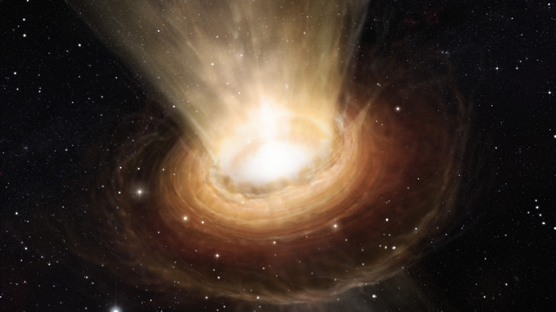

Artist’s impression of a disc wind dispersing a planet-forming disc around a young star. Credit ESO / M. Kornmesser.
[Image from UoL press release on JWST observations of disc winds, March 2024.]

Further Reading:
- The distribution of accretion rates as a diagnostic of protoplanetary disc evolution
- The dispersal of protoplanetary disks
- JWST MIRI MRS observations of T Cha: discovery of a spatially resolved disk wind
- Demographics of young stars and their protoplanetary disks: lessons learned on disk evolution and its connection to planet formation
- The ALMA Survey of Gas Evolution of PROtoplanetary Disks (AGE-PRO). VII. Testing Accretion Mechanisms from Disk Population Synthesis
Further information on how to apply and funding can be found here

