University of Leicester
EPSRC DLA Studentship

First Supervisor | Dr. Behnam Hashemi
School/Department | School of Computing and Mathematical Sciences
Email | bh241@le.ac.uk

Second Supervisor | Dr. Alberto Paganini
School/Department | School of Computing and Mathematical Sciences
Email | admp1@le.ac.uk

Section 2 – Project Information
Project Title | Solving Absolute Value Equations: Theory, Algorithms, and Applications
Project Summary
Absolute value equations (AVEs) are equations of the form

$$Ax - \left|x\right|= b,$$

where $A$ is a given square matrix, $b$ is a given vector, and $|x|$ denotes the componentwise absolute value of the unknown vector $x$. AVEs arise in several important areas, including the linear complementarity problem (LCP) [3] and the solution of interval linear systems. The study of AVEs is an active and rapidly developing area of research with many open problems [2], some of which will be addressed in this project.

Solving AVEs is challenging because of the non-differentiability of the absolute value function. For instance, it is well-known that even just deciding whether an AVE is solvable is NP-hard. Moreover, several natural questions about the structure of the solution set (see Figure 1) are computationally intractable [1]. For example, in the case of infinitely many solutions, determining whether the solution set is bounded is NP-hard. Likewise, checking whether the solution set is convex is NP-hard, even when A has rank one.

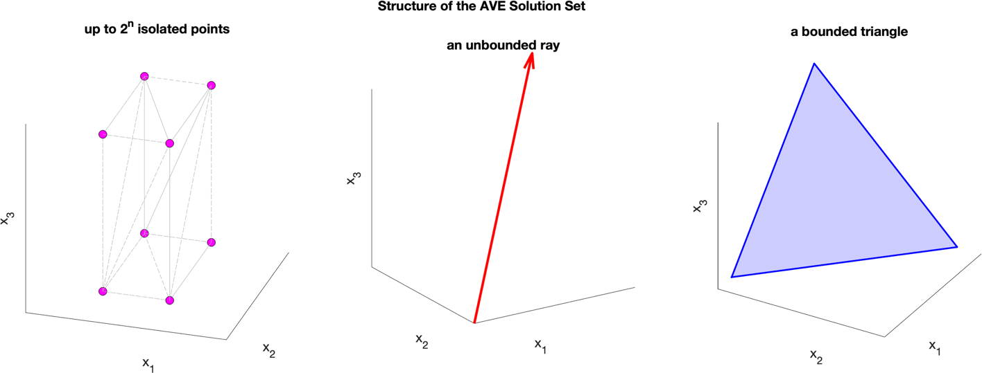
Figure 1. A 3D visualisation illustrating three distinct cases. From left to right: a non-convex solution set consisting of eight isolated points, an unbounded solution set, and a bounded solution set forming a triangle.

A range of algorithms for solving AVEs already exists (e.g., Mangasarian’s generalised Newton method, Lemke’s LCP-based algorithm, and Rohn’s sign-accord algorithm). However, these methods are not always efficient and often do not scale to high dimensional problems.

In this PhD project, we will both address theoretical computational complexity questions and improve the efficiency of existing algorithms. Specifically, we will:
- develop new necessary and sufficient conditions for non-solvability, solvability and unique solvability, with particular emphasis on feasible sufficient conditions --- i.e., sufficient conditions that can be checked with a cubic complexity in the matrix dimension.
- design, implement, test and benchmark new algorithms against current state-of-the-art methods across a wide range of numerical experiments.

Familiarity with linear algebra and enthusiasm for the subject are essential for the successful completion of this project. A background in numerical analysis and scientific computing, experience in high-quality open-source software development, and prior research experience would be desirable.

References
[1] M. Hladík, Properties of the solution set of absolute value equations and the related matrix classes, SIAM Journal on Matrix Analysis and Applications 44 (2023) 175-195, https://doi.org/10.1137/22M1497018

[2] M. Hladík, H. Moosaei, F. Hashemi, S. Ketabchi and P. Pardalos, An overview of absolute value equations: from theory to solution methods and challenges, Computational Optimization and Applications (2025), https://doi.org/10.1007/s10589-025-00717-5

[3] O. L. Mangasarian and R. R. Meyer, Absolute value equations, Linear Algebra and its Applications 419 (2006) 359-367, https://doi.org/10.1016/j.laa.2006.05.004

