School of Chemistry Graduate Teaching Assistant

PhD Project Proposal

First Supervisor | Fabrizio Ortu
School/Department/Institute | Chemistry
Email | fabrizio.ortu@leicester.ac.uk

Second Supervisor | Jake Yang
School/Department | Chemistry
Email | jake.yang@leicester.ac.uk

Additional Supervisor(s) or Collaborators | Yinshan Meng (Dalian University of Technology, China)

Project Title | Rare Earth Materials for Reprocessing and Spintronics
Project Highlights: | 1. | Activation of strategic small molecules (CO, CO₂, H₂, N₂)
Project Highlights: | 2. | Rare earth reprocessing
Project Highlights: | 3. | Applications in molecular magnetism and spintronics
Project Description
Background. Small molecule activation (SMA) is a pillar of the chemical industry. The activation and transformation of CO, CO₂, H₂ and N₂ is vital for the industrial production of numerous commodity chemicals that sustain modern society (global market worth >$600 billion). These transformations classically require expensive, toxic and scarce metals, thus posing significant challenges towards the long-term sustainability of chemical manufacturing. To tackle these challenges, other approaches must be investigated, including the employment of earth-abundant and non-toxic metals – such as rare earth metals. Our research group studies the fundamental chemistry of rare earth metals and their application in new chemical processes and reprocessing strategies. Most rare earth metals have very low toxicity and remarkable reactivity, which has already led to numerous applications in SMA.

Aims. As part of this project, we will develop new rare earth materials by using mechanochemical methods and ligand design to reprocesses mixed rare earths. In preliminary work, we have already shown that complexes with specific molecular design can deliver facile activation of CO₂ and CS₂, leading to the transformation of these basic feedstocks into more complex organic molecules. We have also demonstrated that it is possible to use SMA to form multimetallic rare earth clusters, which are of great interest for their potential applications in molecular magnetism. In this project we will build on these exciting preliminary results and produce a large family on new rare earth materials and target new reprocessing strategies, strategic chemical transformations and the production of multimetallic clusters with interesting magnetic properties.

Methodology. Compounds in this project will be obtained using state-of-the-art anaerobic methods (e.g. glovebox, Schlenk line) and solvent-free mechanochemical synthesis, paired with a suite of characterisation techniques (multinuclear NMR, X-ray diffraction, UV-vis-NIR spectroscopy, photoluminescence). Additionally, this work will be complemented by comprehensive magnetic studies (EPR and SQUID) to evaluate potential applications of the new materials in molecular magnetism.

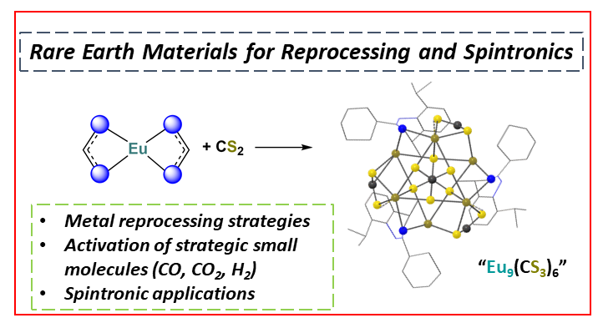

See web page for details of how to apply

Project / Funding Enquiries: Application enquiries to r.g.doveston@leicester.ac.uk (PGR Admissions tutor for School of Chemistry)

