School of Chemistry Graduate Teaching Assistant

PhD Project Proposal

First Supervisor | Dr Sandy Kilpatrick
School/Department/Institute | School of Chemistry
Email | afrk1@leicester.ac.uk

Second Supervisor | Prof. Steven Bull
School/Department | School of Chemistry
Email | sdb45@leicester.ac.uk

Project Title | Bio-Derived Carbonate Materials for Circular Chemical Manufacturing: Titanium Complexes for CO₂ Valorisation
Project Highlights: | 1. | Synthesis of titanium complexes and their application as catalysts for cycloaddition of CO₂ and epoxides
Project Highlights: | 2. | Use of biosourced feedstock in the synthesis of organic carbonates, and exploring potential applications as green solvents.
Project Highlights: | 3. | Excellent training towards a research career in either academia or industry (e.g. energy sector, battery technology, bioeconomy, etc.)
Project Description
CO₂ chemistry and the development of reactions utilising CO₂ as a C₁ feedstock have drawn significant attention because CO₂ is not only an abundant, inexpensive, and non-toxic carbon source but also a major contributor to climate change. One of the most promising reactions for using CO₂ is its transformation with epoxides to yield cyclic carbonates (Figure 1).^{[1]} Cyclic carbonates can be used as synthetic intermediates in the synthesis of fine or bulk chemicals. They have been used as a raw material for the synthesis of polycarbonates, and as components in other carbonate-containing materials and composites. Another application of cyclic carbonates, which has grown significantly in recent years, is as green polar aprotic solvents because of their excellent solubilising properties and relatively low toxicities. This has also led to their use as electrolyte solvents in lithium-ion batteries (LIBs).^{[2]}

The replacement of oil-derived oxiranes with a terpene-based epoxides, such as 1,2-limonene oxide, presents a pathway to new bio-derived carbonate materials.^{[3]} This PhD project aims to develop a sustainable catalytic cycloaddition process, using CO₂ and epoxides derived from terpenes, and study the material properties of the new carbonate products towards applications as green solvents.

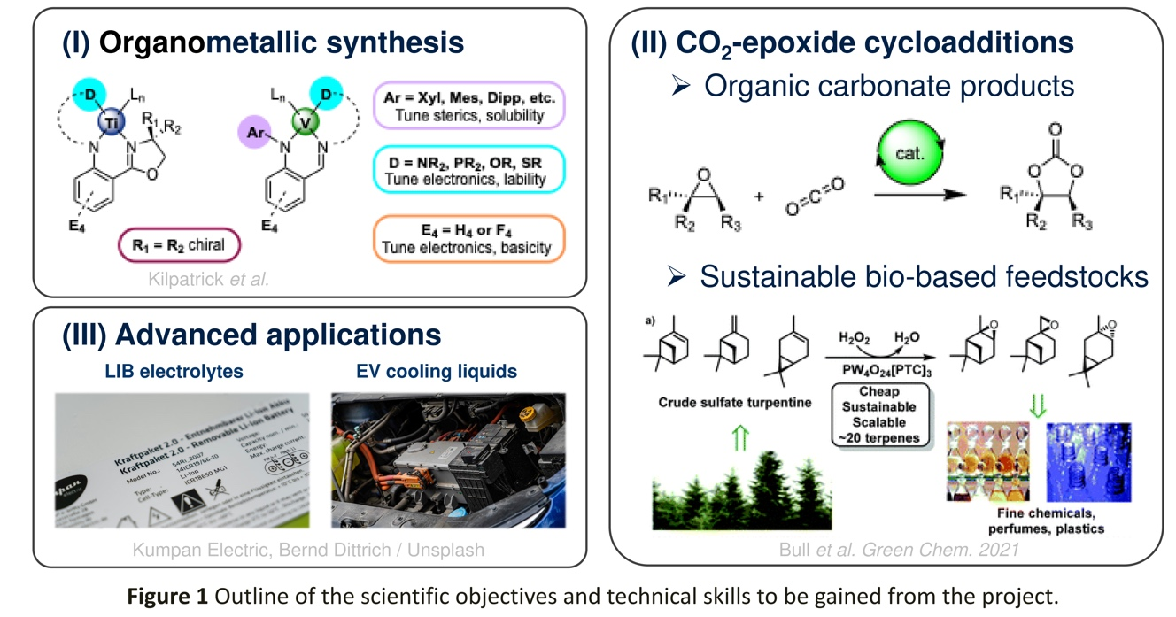

An approximate timeline and workplan for the 4 year PhD project is shown in Scheme 1.
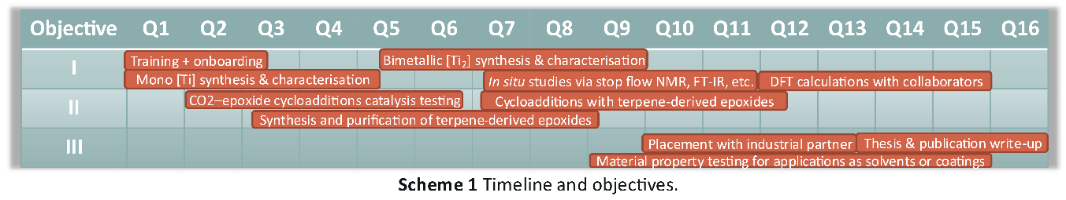
Kilpatrick et al. have a strong research focus on organometallic chemistry of the Earth abundant metals,^{[4]} including CO₂-epoxide copolymerisation,^{[5]} and have recent discovered a titanium-based catalyst that is highly active under mild conditions. Bull et al. have a wealth of experience developing sustainable routes to biorenewable feedstocks for applications in the green chemical industry.^{[6]} The project will be informed by engagement with industrial partners active in the development and deployment of functional fluids and electrolyte materials for energy storage and electric vehicle technologies.

This PhD project will expand the scope of early transition metal catalysts and bio-derived monomers applied to CO₂-epoxide cycloaddition reactions and address key questions on the technical and economic feasibility of carbonate products. The research will contribute to the development of more sustainable chemical processes and materials, supporting the transition towards a circular economy and the long-term goal of reducing net CO₂ emissions.
References
[1] D. Prasad, K. N. Patil, N. K. Chaudhari, H. Kim, B. M. Nagaraja and A. H. Jadhav, Catal. Rev. - Sci. Eng., 2022, 64, 356–443. DOI: 10.1080/01614940.2020.1812212.
[2] V. Aomchad, À. Cristòfol, F. Della Monica, B. Limburg, V. D’Elia and A. W. Kleij, Green Chem., 2021, 23, 1077–1113. DOI: 10.1039/D0GC03824E.
[3] K. Xu, Chem. Rev., 2004, 104, 4303–4417. DOI: 10.1021/cr030203g.
[4] J. Allen, T. Krämer, L. G. Barnes, R. R. Hawker, K. Singh and A. F. R. Kilpatrick Organometallics, 2025, 44, 749. DOI: 10.1021/acs.organomet.4c00513.
[5] A. C. Deacy, A. F. R. Kilpatrick, A. Regoutz and C. K. Williams, Nat. Chem., 2020, 12, 372–380. DOI: 10.1038/s41557-020-0450-3
[6] J. D. Tibbetts, W. B. Cunningham, M. Vezzoli, P. Plucinski and S. D. Bull, Green Chem., 2021, 23, 5449–5455. DOI: 10.1039/d1gc01734a.

See web page for details of how to apply

Project / Funding Enquiries: Application enquiries to r.g.doveston@leicester.ac.uk (PGR Admissions tutor for School of Chemistry)

