School of Chemistry Graduate Teaching Assistant

PhD Project Proposal

First Supervisor | Dr. Richard Doveston
School/Department/Institute | School of Chemistry and Institute for Structural and Chemical Biology
Email | r.g.doveston@leicester.ac.uk

Second Supervisor | Dr. Gareth Hall
School/Department | School of Biological and Biomedical Sciences and Institute for Structural and Chemical Biology
Email | gh126@leicester.ac.uk

Additional Supervisor(s) or Collaborators | Prof. Salvador Macip (School of Biological and Biomedical Sciences)

Project Title | Pin-ing it down: Novel Inhibitors for the Enigmatic Pin1 Enzyme to treat Cancer
Project Highlights: | 1. | Develop drug molecules with a novel mode-of-action
Project Highlights: | 2. | Exciting protein target (Pin1) for treating cancer
Project Highlights: | 3. | Interdisciplinary training at the chemistry-life science interface
Project Description
Background: Pin1 is a prolyl isomerase enzyme that catalyses the cis/trans isomerization of proline residues in over 200 protein substrates. Dysregulation of Pin1 levels is strongly associated with regulation of pathways associated with DNA repair and ageing, and is overexpressed in many cancer types. Consequently, the development of strategies to impede and probe Pin1 function has gained significant interest. Despite efforts to design traditional small-molecule inhibitors that target Pin1’s catalytic domain, none have emerged as effective drugs or probes. Thus, there is a need to develop alternative approaches to achieve Pin1 inhibition.
Our team has discovered a new strategy for Pin1 inhibition which involves combinatorial covalent modification of cysteine residues in Pin1 (Figure 1). This leads to the targeted degradation of Pin1 in cancer cells, and impedes cancer cell proliferation. The approach could be a powerful way to induce the degradation of other aberrant proteins across a broad spectrum of disease.
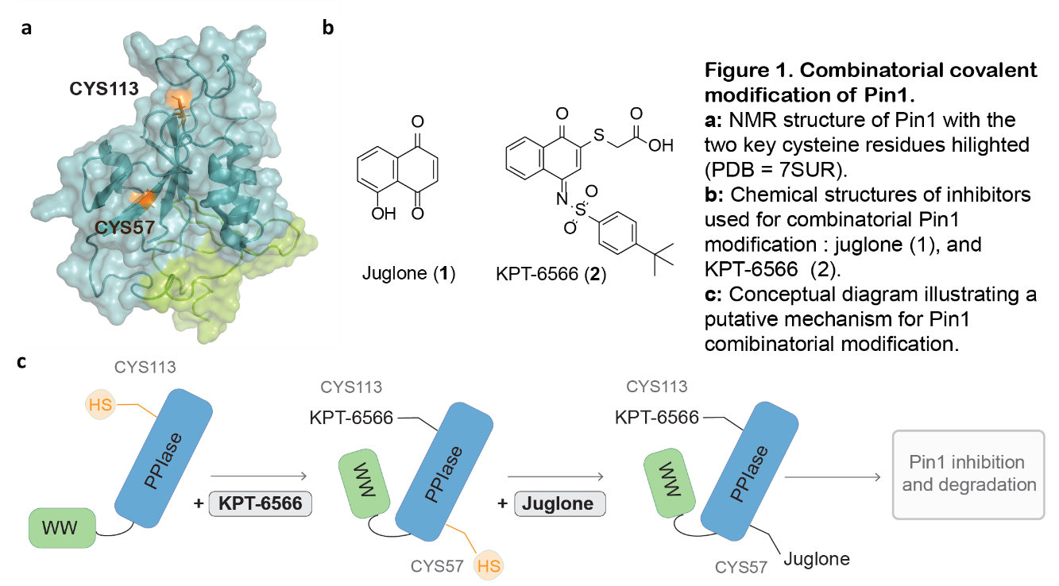
Aim: The aims of this project are to:
(1) understand the molecular mechanisms by which combinatorial covalent modification leads to Pin1 degradation.
(2) exploit this mechanism in the design, synthesis and evaluation of potent and selective Pin1 degraders and inhibitors that are effective against cancer cell lines.
Approach: The project will take an interdisciplinary chemical biology approach drawing on the expertise of the supervisory team. We will use synthetic organic chemistry methods to make new covalent Pin1 ligands alongside a combination of biochemical assays, structural biology, and cellular biology to evaluate their activity and deduce the molecular mechanisms by which they work. In the longer term, we are interested to demonstrate the broad applicability of this approach to other cancer relevant protein targets.
Training: This project will provide excellent training for those with a keen interest in drug design and development, and the chemical events that drive disease progression. You will receive excellent training across the following techniques, providing you with the ideal skillset for future research in the pharmaceutical and chemical biology sectors:
- Organic synthesis and molecular characterisation
- Protein expression and purification
- Protein X-ray crystallography and NMR
- Protein mass spectrometry
- Biophysical assays (e.g.) fluorescence polarisation, isothermal titration calorimetry, and thermal stability assays.
References: 10.1002/pro.5138; 10.1038/s41598-025-89342-0
Enquiries are welcome. To discuss the project in more detail please email r.g.doveston@le.ac.uk.

See web page for details of how to apply

Project / Funding Enquiries: Application enquiries to r.g.doveston@leicester.ac.uk (PGR Admissions tutor for School of Chemistry)

