University of Leicester
BBSRC MIBTP Studentship Project 2025-6 entry.

First Supervisor | Dr Harriet Walter and Dr Yolanda Markaki
School/Department | Department of Genetics, Genomics and Cancer Sciences  Molecular & Cell Biology
Email | hw191@le.ac.uk & yolanda.markaki@leicester.ac.uk  Harriet Walter | University of Leicester  https://le.ac.uk/people/yolanda-markaki

Second Supervisor | Dr Emma Hesketh
School/Department | Molecular and Cellular Biology
Email | emma.hesketh@leicester.ac.uk

Additional Supervisor

Section 2 – Project Information
Project Title | Imaging the consequences of CD20 cross-linking in B cells using super-resolution microscopy (SRM) and Cryo-Electron Tomography (CryoET).
Project Summary
Imaging the consequences of CD20 cross-linking in B cells using super-resolution microscopy (SRM) and Cryo-Electron Tomography (CryoET).
Background. Therapeutic B cell depletion is now commonly used in autoimmune, neurological and malignant disorders. CD20 is a B-cell specific surface membrane protein expressed is widely used as a target in these conditions. Several therapeutic CD20 monoclonal antibodies (Mabs) recognising different CD20 epitopes have been clinically transformational, for example rituximab in autoimmunity and B cell malignancies, ocrelizumab in relapsing/remitting multiple sclerosis. Several million people worldwide have received CD20 Mabs. However, the functions of CD20 both in health and disease and the precise mode(s) of action of the various MAbs remain largely unexplored. The structure of CD20 is shown below. Most of the protein is expressed intracellularly, with only two loops of 9 and 47 amino acids extracellular. The loops are unlikely to play a ligand-binding role. Cross-linking of CD20 by bivalent CD20 Mabs via the extracellular loops is therefore unlikely to occur in nature.
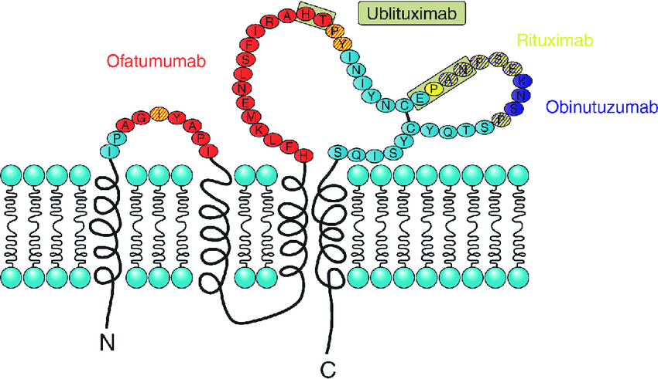
Recently however, CD20 cross-linking has been shown to cause intracellular signalling along multiple pathways (1). Many questions remain but GSEA pathway analysis indicates that reorganisation of the actin cytoskeleton is central.
At the cellular level, the consequences of CD20 cross-linking are pleiotropic, depend on the B-cell type and the nature of the CD20 Mab but include:-
- Cell death – either apoptosis or lysosomal cell death.
- Cell cycle inhibition.
- CD20 internalisation.
- B cell polarisation
- Metabolic changes
- Cell surface “remodelling” – eg CD20 crosslinking results in rapid loss of CD19 expression.
Using a panel of B cell lines, we have shown (unpublished data) that the above consequences of CD20 crosslinking vary considerably, in a cell-type dependent manner, independent of levels of CD20 expression, highlighting the critical importance of CD20 signalling following cross-linking at the cell surface.
Recently, SRM has been used to determine the cellular consequences of T and B cell activation following antigen receptor cross-linking (2). To the best of our knowledge, similar techniques have not been used following CD20 cross-linking. We propose to exploit the unique skillsets available within the University of Leicester in B-cell biology, SRM and CryoEM to investigate the cellular events in B cells following CD20 cross-linking.
Methods
- A panel of 10 well characterised B cell lines with defined levels of expression of CD20, defined response to CD20 cross-linking described above and with defined expression of known CD20 interacting proteins will be studied.
- Cells will be exposed to three different CD20 Mabs and then stained with a panel of Mabs including CD20 (intracellular epitopes) and CD20-interacting proteins including other cell surface membrane proteins, kinases adapters (PAG1) and cytoskeletal proteins.
- SRM; the LSM980 Airyscan 2 and the Elyra 7 allow live cell imaging down to a few nanometers. Dr Markaki is an expert in SRM and will establish these protocols with the Walter/Dyer labs.
- CryoET; (Dr Emma Hesketh). Using the Titan Krios Electron microscope situated in the Midlands Regional CryoEM facility will allow us to image in situ in native like conditions. The resolution will range from nanometer resolution to higher resolutions as low as 3 Å to 10 Å resolution when using subtomogram averaging. Super resolution imaging will be used in parallel with cryoET to locate CD20 and interacting proteins.
Collectively, these data will shed new insights into the consequences of CD20 cross-linking with different Mabs and into the functions of CD20.
These studies will run in parallel with studies determining the CD20 interactome being performed in the Walter/Dyer labs

Techniques that will be undertaken during the project
Cell culture
Flow cytometry
Super-resolution imaging.
CryoET

References
1) DOI: 10.1126/science.ade3925
2) https://doi.org/10.1038/s42003-024-06393-1

