University of Leicester
BBSRC MIBTP Studentship Project 2025-6 entry.

First Supervisor | Thomas Schalch
School/Department | Molecular and Cell Biology, Leicester Institute for Structural and Chemical Biology
Email | thomas.schalch@le.ac.uk  https://le.ac.uk/people/thomas-schalch

Second Supervisor | Yolanda Markaki
School/Department | Molecular and Cell Biology, Leicester Institute for Structural and Chemical Biology
Email | gm365@leicester.ac.uk

Additional Supervisor

Section 2 – Project Information
Project Title | Uncovering the mechanisms of epigenetic regulators using cutting-edge molecular biology and advanced imaging methodologies
Project Summary
This PhD project aims to investigate the intricate mechanisms regulating histone H2B ubiquitination (H2Bub), a critical post-translational modification on nucleosomes, which plays a pivotal role in gene expression and chromatin dynamics (Fetian et al. 2024). Histone H2B ubiquitination is intricately linked to fundamental cellular processes, including transcription and DNA repair. This project will investigate the structure and function of the highly conserved histone H2B ubiquitin ligase and its interaction with the transcription apparatus, particularly the PAF (Polymerase Associated Factor) complex (Fig. 1).
The project will explore the following key objectives:
- Characterization of Ubiquitin Ligase Activity: Investigate the enzymatic activity of the histone H2B ubiquitin ligase complex, identifying its specificity in the context of the nucleosome and the regulatory factors that modulate its function. This will involve biochemical assays and structural biology techniques to elucidate the molecular basis of its activity.
- Interaction with the PAF Complex: Examine the functional interplay between the ubiquitin ligase and the PAF complex during transcription. This will include biophysical techniques like bio-layer interferometry, as well as functional assays and super-resolution imaging to assess the impact of these interactions on transcriptional regulation.
- Impact on Gene Expression: Assess the biological consequences of altered H2Bub levels on gene expression. This will involve western blotting to determine H2Bub levels and transcriptomic analyses using RNA-seq to identify target genes and pathways affected by changes in H2B ubiquitination.
- Regulatory Mechanisms: Investigate the role of H2Bub in X-inactivation during female mammalian development. The mammalian H2B ubiquitin ligase complex (RNF20/RNF40) has been tightly linked to the silencing of the inactive X chromosome, its mechanism, however, remains mysterious.
The outcomes of this research will provide valuable insights into the regulatory mechanisms governing histone modifications and their implications for transcriptional control. Understanding the role of H2B ubiquitination in gene expression will contribute to the broader knowledge of epigenetic regulation and its potential impact on developmental biology and disease.
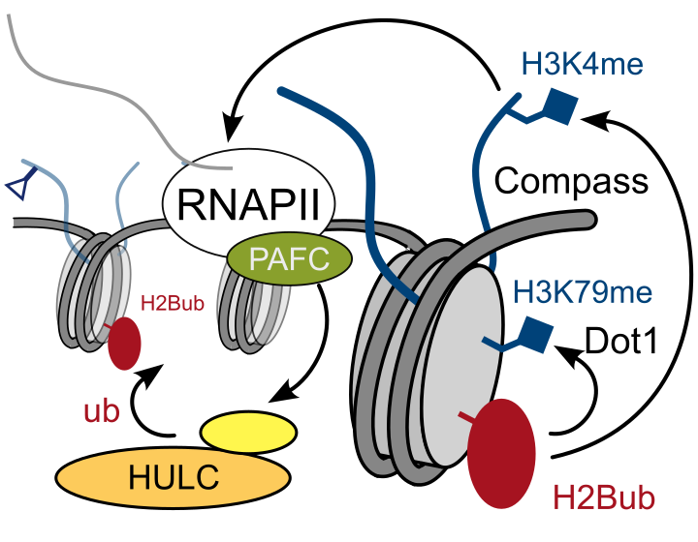
Figure 1: The H2B ubiquitin ligase complex (HULC) is part of the RNA Polymerase II elongation machinery. It is recruited by the PAF complex and deposits H2Bub, which stimulates H3K4 and H3K79 methylation, both marks of active transcription.

Techniques that will be undertaken during the project
Cryo-EM, Alphafold modelling, cloning, protein expression and purification from insect cells and bacteria, enzymatic assays, biophysical techniques, tissue culture, Chromatin Immunoprecipitation (ChIP-seq), RT-qPCR

References
T. Fetian, A. Grover, K. M. Arndt, Histone H2B ubiquitylation: Connections to transcription and effects on chromatin structure. Biochimica et Biophysica Acta (BBA) - Gene Regulatory Mechanisms 1867, 195018 (2024).

