University of Leicester
BBSRC MIBTP Studentship Project 2025-6 entry.

First Supervisor | Prof Ezio Rosato (he/his)
School/Department | Genetics, Genomics and Cancer Sciences
Email | er6@leicester.ac.uk  https://le.ac.uk/people/ezio-rosato

Second Supervisor | Prof Charalambos P Kyriacou (he/his)
School/Department | Genetics, Genomics and Cancer Sciences
Email | cpk@leicester.ac.uk

Additional Supervisor

Section 2 – Project Information
Project Title | Establishing black soldier flies as an efficient biodegrading agent.
Project Summary
Graphical Abstract
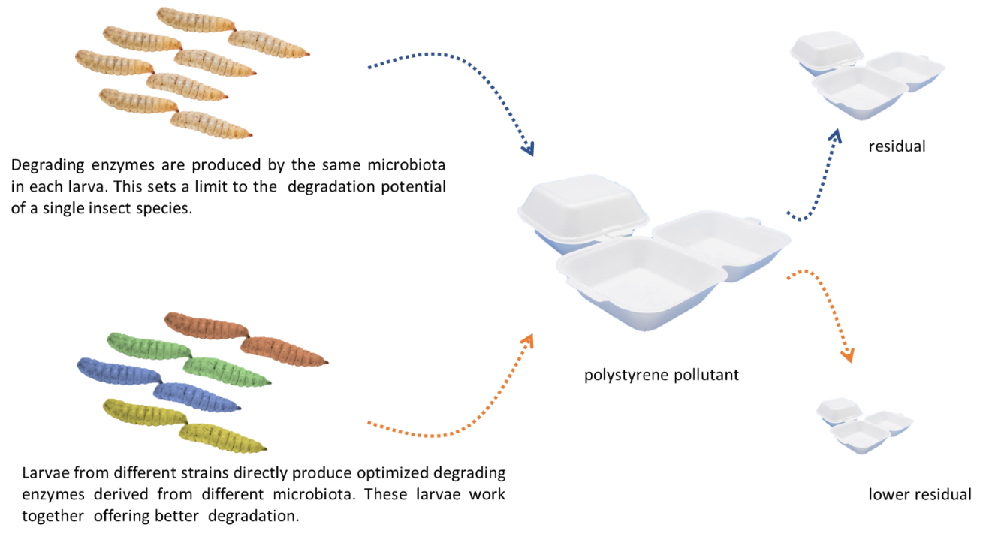
In recent years black soldier flies (BSFs, scientific name: Hermetia illucens) have become extremely popular. They are cheap and safe to grow, have a low carbon footprint and are equally easy to farm in developed and less developed countries. Their larvae are voracious; they feed on a variety of organic materials converting waste into valuable biomass that can be used for animal feed or human food [1]. Additionally, they decontaminate the environment removing microorganisms and pollutants. The aim of this project is to build strains with augmented detoxifying capacity; in particular, with increased ability to degrade polystyrene plastic. Larvae from several insect species can degrade plastic, but such an ability relies on their gut microbiota [2]. Although each microbiota provides this capability, there are constrains on the composition of the community of microorganisms one single insect species can carry in their gut. Thus, the bacteria/fungi producing the best enzymes for each part of the degradation process may never come together in the same microbiota. We propose to express these enzymes directly in the gut of BSFs. The long-term aim of the project is to generate strains each expressing an optimal enzyme that operates in the degradation pathway of polystyrene. BSF larvae are highly gregarious, by mixing larvae from different engineered strains on the feeding substrate (containing polystyrene) we will be able to increase the efficiency of polystyrene degradation. To that end the immediate goal is to engineer BSFs by building robust and flexible genetic tools that allow the production of transgenic and/or gene edited insects.
Techniques that will be undertaken during the project
Molecular biology, cloning, PCR, gene expression, protein expression and purification, Elisa, bioinformatics, databases, genetics, confocal microscopy.

References
[1] Review of Black Soldier Fly (Hermetia illucens) as Animal Feed and Human Food. DOI: 10.3390/foods6100091.
[2] Plastics shape the black soldier fly larvae gut microbiome and select for biodegrading functions. Doi: 10.1186/s40168-023-01649-0.

