University of Leicester
BBSRC MIBTP Studentship Project 2025-6 entry.

First Supervisor | Dr Robert Mahen (he/him/his)
School/Department | Molecular & Cell Biology
Email | rm722@leicester.ac.uk  https://le.ac.uk/people/robert-mahen

Second Supervisor | Dr Robert Hirst / Professor Edward Hollox
School/Department | Department of Respiratory Sciences / Genetics and Genome Biology
Email | rah9@leicester.ac.uk / ejh33@leicester.ac.uk

Additional Supervisor

Section 2 – Project Information
Project Title | Understanding centriole assembly in diverse human cells using advanced imaging and genomics
Project Summary
Centrioles are microtubule-based structures that form two different important cellular organelles: centrosomes and cilia. Centrosomes organise the microtubule cytoskeleton, and consequently have critical roles in cell division and cell polarity. Non-motile cilia are hair-like appendages present on most human cells that act as sensory antennae. Motile cilia function as extracellular propellers to move fluid – a function which is important in human tissues including the airway. Dysfunction of centrioles is linked to human pathologies including ciliopathies and cancer, and so understanding centriole function is both a fascinating fundamental question and a pressing concern for disease diagnosis and therapy. The Mahen lab is focused on understanding the mechanisms underpinning healthy and unhealthy centriole function, using tools including advanced light microscopy, genetics and organotypic culture (e.g. Mahen et al., 2012, PNAS; Mahen PLOS Biol., 2018).
Inside the lung, billions of motile cilia beat a million times a day to protect the airway from pollution and infectious agents. This mucociliary clearance is critical for respiratory epithelium health, and its dysfunction contributes to progression of diseases including primary ciliary dyskinesia and asthma. Whereas most cells contain just two centrioles, airway cells in contrast contain hundreds of centrioles per cell, each at the base of a cilium. How the activity, position and number of these centrioles is regulated to allow ciliary beating is still poorly understood. Remarkably, recent work in our lab has shown that airway centrioles are connected by a cytoskeletal meshwork of centriolar rootlets. Rootlets are fibres that have long been known from electron microscopy images, yet their functions are largely mysterious. Using expansion microscopy in organotypic cultures from human nasal brush biopsies, we have discovered that rootlets form branching networks, characterised by different types of morphological motifs. Many exciting questions have now arisen about this newly discovered structure (Fig. 1).

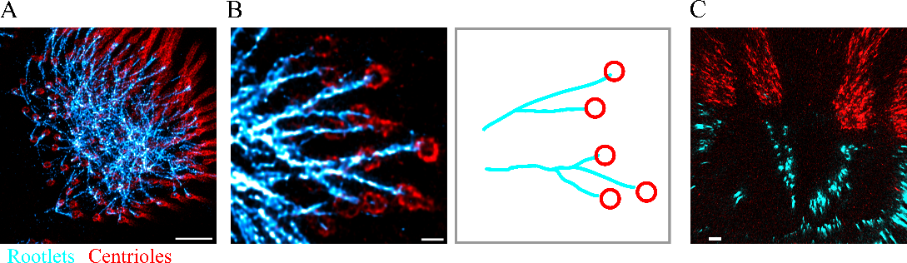
Fig.1: Rootlets form branching networks in human airway cells (Mahen, unpublished). (A-C) Rootlets (blue) and centrioles (red) visualised in human multiciliated cells with expansion microscopy and immunolabelling.

In this multidisciplinary project you will use combined advanced imaging technologies including expansion microscopy, super resolution live-cell imaging and electron microscopy to understand centrosomes at unprecedented resolution in human airway cell types. In parallel, we will use in silico analysis to discover how individuals in human populations have differing genetic variation that influences centriole structure in human tissues. This will allow us to create mutant in vitro lung models to understand the effects of this genetic variation.
The project will provide training in specialised skills from our expert team, as you learn state-of-the-art fluorescence imaging, organoid and air-liquid interface culture, and analysis of genomic structural variation. It is an exciting opportunity to discover fundamental mechanisms of organelle function that are important for human health.

Techniques that will be undertaken during the project
- Live-cell time-lapse imaging
- Expansion microscopy
- Super-resolution microscopy (SIM, STORM)
- Air-liquid interface and organoid culture
- In silico analysis of genomic structural variation
- Molecular cloning and genome editing (CRISPR Cas9, prime editing)
- Electron microscopy
- Specialist techniques for cilia analysis, including high speed video microscopy

References
Mahen, R. cNap1 bridges centriole contact sites to maintain centrosome cohesion. PLOS Biology. 2022. 20(10).
Mahen, R. The structure and function of centriolar rootlets. Journal of Cell Science. 2021. 134(16).

