University of Leicester
BBSRC MIBTP Studentship Project 2025-6 entry.

First Supervisor | Dr. Abhinav Koyamangalath Vadakkepat,
School/Department | Department of Molecular & Cell Biology (MCB) and Leicester Institute of Structural and Chemical Biology (LISCB)
Email | akv10@leicester.ac.uk

Second Supervisor | Dr. Julie Morrissey,
School/Department | Department of Genetics, Genomics and Cancer Sciences and Leicester Microbial Sciences and Infectious Disease Research Centre
Email | jam26@leicester.ac.uk

Additional Supervisor | Prof. Joan Geoghegan  Professor in Microbiology and Infection,  Institute of Microbiology and Infection,  University of Birmingham,  j.geoghegan@bham.ac.uk

Section 2 – Project Information
Project Title | Structural and Functional Analysis of Copper-Transporting ATPases in MRSA: Targets for Antimicrobial Intervention
Project Summary
Background

Copper is an essential trace element, crucial for various biological processes, but in high concentrations, it is toxic to cells¹. Host organisms, including humans, exploit this toxicity by using copper as an antibacterial weapon during infections^{2,3,4}. During infection, host cells actively transport copper into the phagosomes containing bacteria, where elevated copper levels help neutralize the invading pathogens. Pathogenic bacteria such as Staphylococcus aureus, particularly methicillin-resistant S. aureus (MRSA), have developed defence mechanisms, including copper-transporting ATPases like CopA, CopB and CopX, to manage copper toxicity and survive within the host (Figure 1a and 1b)^{5,6} and evade the host's defences^{6,7,8}. Despite their importance as promising targets for novel antibacterial therapies, little is known about the detailed structure and function of these ATPases in MRSA. This PhD project aims to investigate the structural and functional mechanisms of CopA, CopX and CopB from S. aureus strains JE2 and MRSA252 respectively, using a combination of cloning, expression, purification, and structural analysis techniques. Understanding these copper pumps will provide insights into their role in copper homeostasis and their potential as therapeutic targets for combating multidrug-resistant bacterial infections like MRSA⁹.

Aims

This project aims to answer the following questions about the structure and function of the copper ATPases in S. aureus:

- What are the structural features of the ATPases that facilitate copper transport and detoxification in S. aureus and how do these structural differences compare in different clinical isolates?
- How do ATP and copper binding influence the structural and functional dynamics of these proteins?
- How do these ATPases respond to different copper concentrations, and what role do they play in copper homeostasis in MRSA?

The longer-term aim is to investigate if inhibiting the function of the ATPases can provide a viable therapeutic strategy for combating MRSA infections.

Research Plan
The project will be divided into several phases. Initially, the genes encoding CopA and CopB/CopX from S. aureus strains JE2 and MRSA252 will be cloned and expressed in E. coli and solubilised from membranes using detergents. The proteins will then be purified using His-tag affinity chromatography and size exclusion chromatography. We will also try and stabilise these proteins by optimizing the buffer conditions as well as reconstituting them into SMALPs and amphipols. The next phase will involve the biochemical characterization of the purified proteins through ATPase and copper transport assays to confirm their activity. Once functional, the structural characterization will be conducted using single-particle cryo-electron microscopy (cryo-EM) to determine the high-resolution structures of CopA and CopB in both their Apo and ATP-analog bound states. Structural analysis of the Apo-, the non-hydrolysable ATP analog (AMPPNP) and product bound (ADP-bound) states will allow the identification of key regions involved in copper binding and dynamics during transport. Hypotheses generated from the structural data will be tested using site-directed mutagenesis, targeting specific residues that are predicted to play important roles in ATPase activity or copper transport. The functional impact of these mutations will be evaluated through ATPase and transport assays. Finally, in vivo studies will be conducted in collaboration with Prof. Julie Morissey’s group to assess the physiological relevance of these findings in S. aureus mutants.

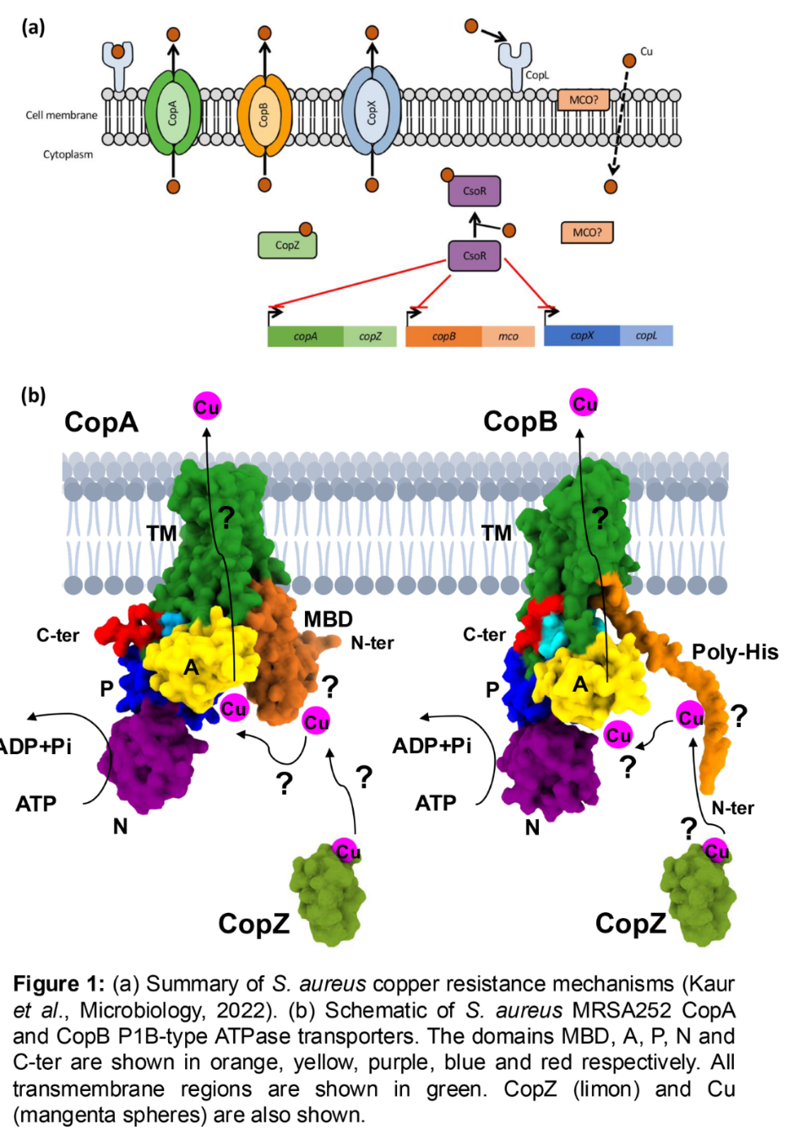

Expected Outcomes and Impact
By integrating structural data with functional assays, this project on copper-transporting ATPases will elucidate the mechanisms by which they manage copper toxicity in S. aureus. These findings could pave the way for the development of new antimicrobial strategies that target copper detoxification systems in bacteria, offering a novel approach to combating antibiotic-resistant infections like MRSA.

Techniques that will be undertaken during the project
- Cloning, over-expression and purification of recombinant protein-complexes.
- Membrane-protein biochemistry, Biophysical and Activity assays.
- Cryo-electron microscopy (cryo-EM) and integrative structural biology.

References
- Halliwell B, Gutteridge JM. Oxygen toxicity, oxygen radicals, transition metals and disease. Biochem J. 1984; 219:1-14.

- Achard ME, Stafford SL, Bokil NJ, Chartres J, Bernhardt PV, Schembri MA, Sweet MJ, McEwan AG. Copper redistribution in murine macrophages in response to Salmonella infection. Biochem J. 2012; 444:51-7.

- White C, Lee J, Kambe T, Fritsche K, Petris MJ. A role for the ATP7A copper-transporting ATPase in macrophage bactericidal activity. J Biol Chem. 2009; 284:33949-56.

- Johnson MD, Kehl-Fie TE, Klein R, Kelly J, Burnham C, Mann B, Rosch JW. Role of copper efflux in pneumococcal pathogenesis and resistance to macrophage-mediated immune clearance. Infect Immun. 2015; 83:1684-94.

- Sitthisak S, Knutsson L, Webb JW, Jayaswal RK. Molecular characterization of the copper transport system in Staphylococcus aureus. Microbiology (Reading). 2007; 153:4274-4283.

- Kaur I, Purves J, Harwood M, Ketley JM, Andrew PW, Waldron KJ, Morrissey JA. Role of horizontally transferred copper resistance genes in Staphylococcus aureus and Listeria monocytogenes. Microbiology (Reading). 2022; 168:001162.

- Zapotoczna M, Riboldi GP, Moustafa AM, Dickson E, Narechania A, Morrissey JA, Planet PJ, Holden MTG, Waldron KJ, Geoghegan JA. Mobile-Genetic-Element-Encoded Hypertolerance to Copper Protects S. aureus from Killing by Host Phagocytes. mBio. 2018; 9:e00550-18.

- Purves J, Thomas J, Riboldi GP, Zapotoczna M, Tarrant E, Andrew PW, Londoño A, Planet PJ, Geoghegan JA, Waldron KJ, Morrissey JA. A horizontally gene transferred copper resistance locus confers hyper-resistance to antibacterial copper toxicity and enables survival of community acquired methicillin resistant Staphylococcus aureus USA300 in macrophages. Environ Microbiol. 2018; 20:1576-1589.

- Saenkham-Huntsinger P, Hyre AN, Hanson BS, Donati GL, Adams LG, Ryan C, Londoño A, Moustafa AM, Planet PJ, Subashchandrabose S. Copper Resistance Promotes Fitness of Methicillin-Resistant Staphylococcus aureus during Urinary Tract Infection. mBio. 2021; 12:e0203821.

