University of Leicester
BBSRC MIBTP Studentship Project 2025-6 entry.

First Supervisor | Prof Shaun Cowley
School/Department | Molecular and Cell Biology
Email | smc57@leicester.ac.uk  https://le.ac.uk/people/shaun-cowley

Second Supervisor | Prof John Schwabe
School/Department | Molecular and Cell Biology
Email | john.schwabe@le.ac.uk

Additional Supervisor

Section 2 – Project Information
Project Title | Understanding HDAC1 recruitment into diverse multi-protein complexes
Project Summary
Background
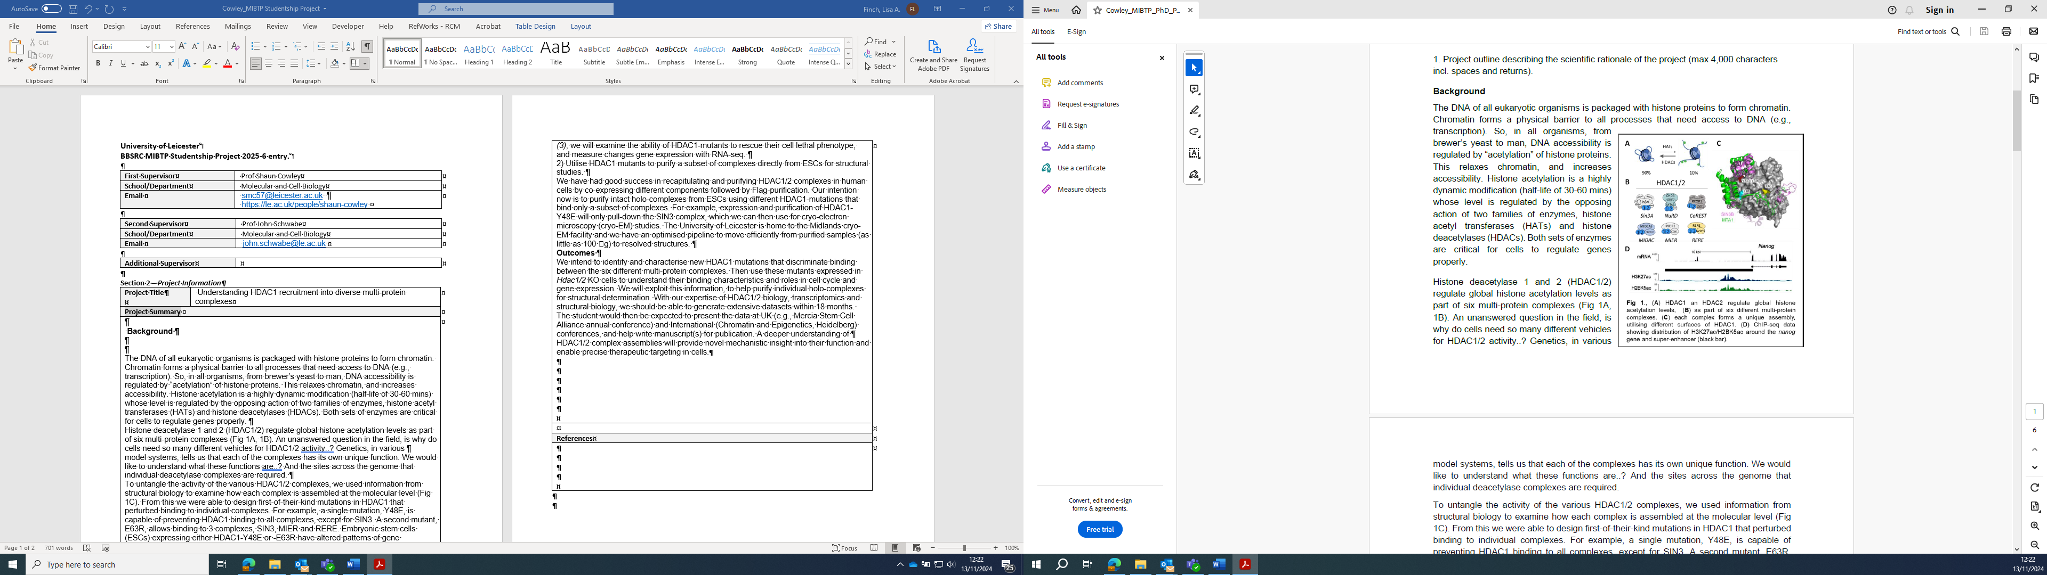

The DNA of all eukaryotic organisms is packaged with histone proteins to form chromatin. Chromatin forms a physical barrier to all processes that need access to DNA (e.g., transcription). So, in all organisms, from brewer’s yeast to man, DNA accessibility is regulated by “acetylation” of histone proteins. This relaxes chromatin, and increases accessibility. Histone acetylation is a highly dynamic modification (half-life of 30-60 mins) whose level is regulated by the opposing action of two families of enzymes, histone acetyl transferases (HATs) and histone deacetylases (HDACs). Both sets of enzymes are critical for cells to regulate genes properly.
Histone deacetylase 1 and 2 (HDAC1/2) regulate global histone acetylation levels as part of six multi-protein complexes (Fig 1A, 1B). An unanswered question in the field, is why do cells need so many different vehicles for HDAC1/2 activity..? Genetics, in various
model systems, tells us that each of the complexes has its own unique function. We would like to understand what these functions are..? And the sites across the genome that individual deacetylase complexes are required.
To untangle the activity of the various HDAC1/2 complexes, we used information from structural biology to examine how each complex is assembled at the molecular level (Fig 1C). From this we were able to design first-of-their-kind mutations in HDAC1 that perturbed binding to individual complexes. For example, a single mutation, Y48E, is capable of preventing HDAC1 binding to all complexes, except for SIN3. A second mutant, E63R, allows binding to 3 complexes, SIN3, MIER and RERE. Embryonic stem cells (ESCs) expressing either HDAC1-Y48E or -E63R have altered patterns of gene expression, indicating that a full repertoire of HDAC1/2 complexes are required to regulate transcription properly.
Objectives
1) Identify additional residues on the surface of HDAC1 to distinguish the binding of individual complexes.
Using known structures of HDAC1 bound to components of NuRD and MiDAC (1, 2), we successfully identified mutants that perturbed binding to all complexes, apart from SIN3. We intend to turn this around and find mutations that perturb SIN3 binding, but retain all the rest. Since SIN3 binds predominantly to the opposite face of HDAC1 relative to other complexes (Fig 1C), there are a range of residues for us to mutate. We will confirm binding characteristics of HDAC1-mutants using co-immunoprecipitation/western blotting and later mass-spectrometry. Then, using our established HDAC1/2 double knockout cells (3), we will examine the ability of HDAC1-mutants to rescue their cell lethal phenotype, and measure changes gene expression with RNA-seq.
2) Utilise HDAC1 mutants to purify a subset of complexes directly from ESCs for structural studies.
We have had good success in recapitulating and purifying HDAC1/2 complexes in human cells by co-expressing different components followed by Flag-purification. Our intention now is to purify intact holo-complexes from ESCs using different HDAC1-mutations that bind only a subset of complexes. For example, expression and purification of HDAC1-Y48E will only pull-down the SIN3 complex, which we can then use for cryo-electron microscopy (cryo-EM) studies. The University of Leicester is home to the Midlands cryo-EM facility and we have an optimised pipeline to move efficiently from purified samples (as little as 100 g) to resolved structures.
Outcomes
We intend to identify and characterise new HDAC1 mutations that discriminate binding between the six different multi-protein complexes. Then use these mutants expressed in Hdac1/2 KO cells to understand their binding characteristics and roles in cell cycle and gene expression. We will exploit this information, to help purify individual holo-complexes for structural determination. With our expertise of HDAC1/2 biology, transcriptomics and structural biology, we should be able to generate extensive datasets within 18 months. The student would then be expected to present the data at UK (e.g., Mercia Stem Cell Alliance annual conference) and International (Chromatin and Epigenetics, Heidelberg) conferences, and help write manuscript(s) for publication. A deeper understanding of
HDAC1/2 complex assemblies will provide novel mechanistic insight into their function and enable precise therapeutic targeting in cells.

Techniques that will be undertaken during the project
The project utilizes cutting-edge methodologies that will put the student at the forefront of gene regulation research:
Embryonic stem cell culture, CRISPR/Cas9 gene editing, transcriptomic techniques (RNA-seq, SLAM-seq and ATAC-seq), bioinformatics, protein purification and cryo-electron microscopy (cryo-EM).

References
Millard, C. J., Watson, P. J., Celardo, I., Gordiyenko, Y., Cowley, S. M., Robinson, C. V., Fairall, L., and Schwabe, J. W. (2013) Class I HDACs share a common mechanism of regulation by inositol phosphates, Mol Cell 51, 57-67.
2. Turnbull, R. E., Fairall, L., Saleh, A., Kelsall, E., Morris, K. L., Ragan, T. J., Savva, C. G., Chandru, A., Millard, C. J., Makarova, O. V., Smith, C. J., Roseman, A. M., Fry, A. M., Cowley, S. M., and Schwabe, J. W. R. (2020) The MiDAC histone deacetylase complex is essential for embryonic development and has a unique multivalent structure, Nat Commun 11, 3252.
3. Jamaladdin, S., Kelly, R. D., O'Regan, L., Dovey, O. M., Hodson, G. E., Millard, C. J., Portolano, N., Fry, A. M., Schwabe, J. W., and Cowley, S. M. (2014) Histone deacetylase (HDAC) 1 and 2 are essential for accurate cell division and the pluripotency of embryonic stem cells, Proc Natl Acad Sci U S A 111, 9840-9845.

