University of Leicester
BBSRC MIBTP Studentship Project 2025-6 entry.

First Supervisor | Dr Amanda Chaplin
School/Department | Molecular and Cell Biology
Email | ac853@leicester.ac.uk  https://le.ac.uk/people/amanda-chaplin

Second Supervisor | Prof Thomas Schalch
School/Department | Molecular and Cell Biology
Email | thomas.schalch@leicester.ac.uk

Additional Supervisor

Section 2 – Project Information
Project Title | Redefining the molecular mechanism of DNA double-strand break repair in humans
Project Summary
DNA double-strand breaks (DSBs) describe a break across both strands of DNA. This type of DNA damage can be catastrophic for cell survival as if not repaired correctly can lead to deletions, translocation, cell death and cancer. Complex processes have evolved to repair this type of DNA damage, including a mechanism called non-homologous end joining (NHEJ). The molecular details of this process are still not completely understood but it is known to involve several core proteins including DNA-PK holoenzyme, formed by a Ku70/80 heterodimer and DNA-dependent protein kinase catalytic subunit (DNA-PKcs) together with DNA. Understanding the structural mechanism of NHEJ has been a long-standing challenge, however recent advances in cryo-electron microscopy have begun to allow us to visualise large complex multicomponent assemblies involved in this process (Figure1) (Chaplin et al., 2020, NSMB, Chaplin et al., 2021 Mol Cell, Chen et al.,2021 Nature).
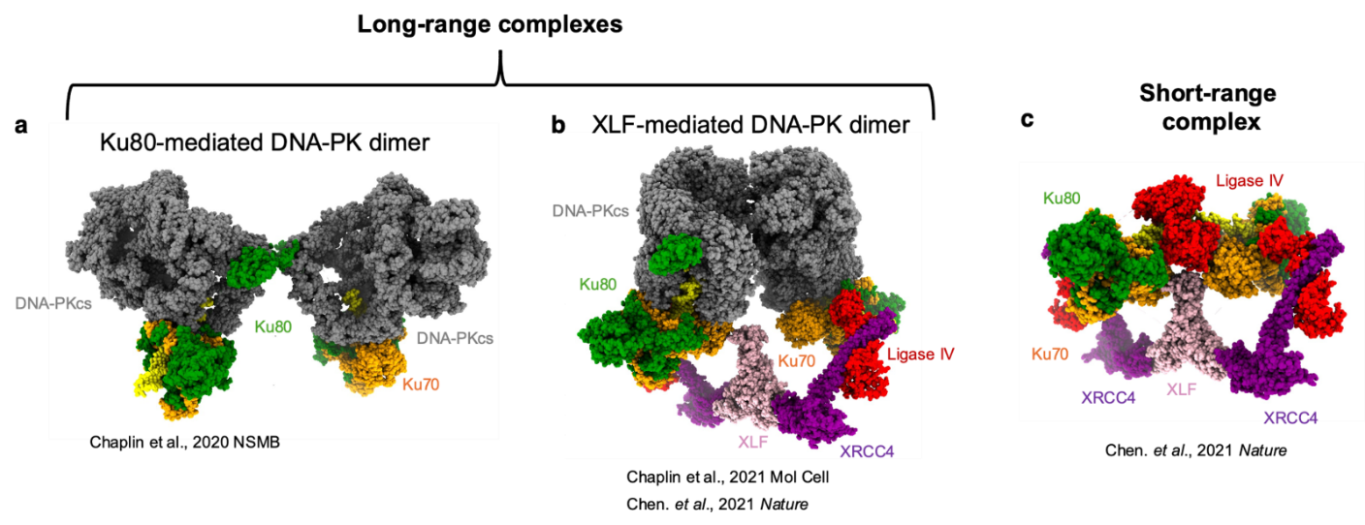
Figure 1: Cryo-EM structures of DNA-PK long-range complexes (LRCs) and short-range complex (SRC). a) Ku80-mediated LRC, b) XLF-mediated LRC and c) SRC.

Traditionally, the process of NHEJ is depicted as following three linear steps, termed synapsis, end-processing and ligation (Figure 2a). However, the rapidly expanding structural portfolio of these NHEJ assemblies has provided glimpses of unexpected arrangements of complexes that do not fit the traditional model. These structures are, leading us to consider a more complex branched model (Figure 2b). The aim of this PhD proposal is to determine the time it takes for this mechanism to occur, to understand what dictates it and capture intermediate states.
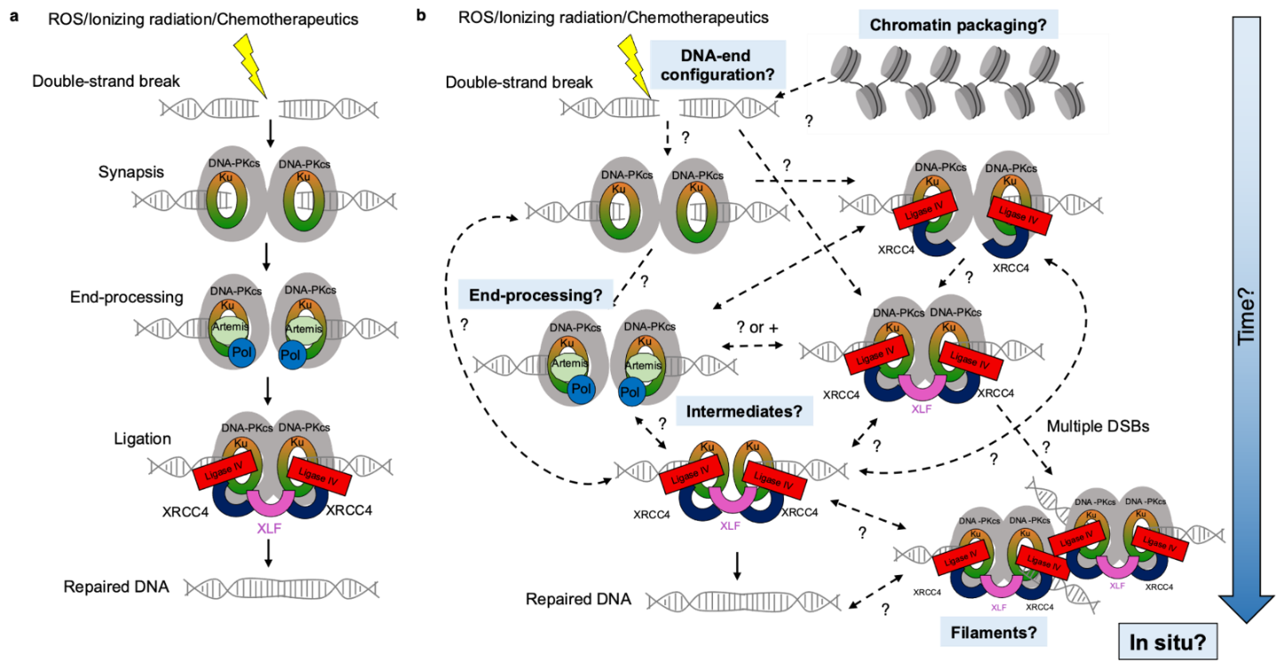
Figure 2: Traditional versus branched models of NHEJ. DNA-PKcs is shown in grey, Ku70/80 orange/green, polymerases blue, nucleases beige, ligase IV red, XLF pink and XRCC4 navy. a) Displays the traditional view and b) the complex mechanism with key questions coloured in blue

Moreover, as part of this proposal, we aim to move away from considering how the NHEJ machinery processes isolated, linear DNA substrates, and instead put greater emphasis on more biologically relevant substrates. DNA is packaged within the cell in nucleosomes and chromatin, it is unknown how the NHEJ machinery access DSBs when packaged in nucleosomes. We have recently visualised Ku70/80 binding to nucleosomes (Figure 3). As part of this PhD proposal, we will investigate access and interactions between the NHEJ proteins and nucleosomes and determine the mechanism of DNA-repair.
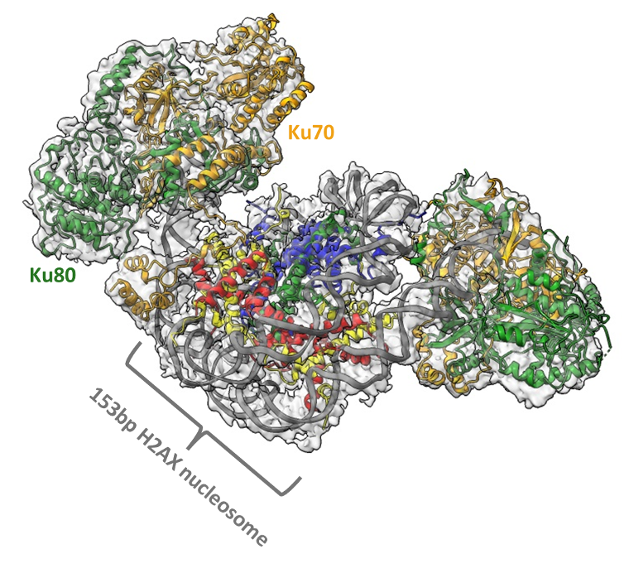
Figure 3: Cryo-EM structure of Ku70/80 bound to a nucleosome. Ku70 is in orange, Ku80 in green, DNA in grey.

Ultimately, the data produced by this project will define the fundamental mechanism of NHEJ and guide the design of more specific therapeutics to target NHEJ. Targeting NHEJ has been shown to be effective in cancer therapies when used in combination with chemo- and radiotherapy. We have recently shown the power of cryo-EM in determining the molecular details of specific inhibitors, bound to DNA-PKcs. Therefore, understanding the detail of this mechanism is crucial in the development and design of future therapies.

Techniques that will be undertaken during the project
- Cryo-EM and X-ray crystallography – sample preparation, data collection, processing and analysis.
- Biophysical techniques such as ITC, EMSA, gel filtration, Octet/BLI.
- Molecular biology such as PCR, ligations, mutagenesis plasmid construction and DNA isolation.
- Protein expression and purification – Insect cells, E. coli and human cell extracts using AKTA purification systems.
- Biochemistry techniques such as SDS-PAGE gels, ligation assays, kinase activity, mass spectrometry.

References

