EPSRC DLA PhD Studentships

First Supervisor | Professor Paul D. Ledger
School/Department | School of Computing & Mathematical Sciences (Mathematics)
Email | pdl11@leicester.ac.uk

Second Supervisor | Dr Matias Ruiz
School/Department | School of Computing & Mathematical Sciences
Email | mr447@leicester.ac.uk

Additional Supervisor | Professor Antonio Gil, Swansea University  Dr Mike Mallett, Siemens Healthineers Magnet Technology

Section 2 – Project Information
Project Title | Improved minimisation of ghosting effects in MRI scanner images using an  advanced computational modelling tool for accurate prediction of magneto-  mechanical vibrations
Project Summary
Siemens Healthineers is a global leading company in the manufacture of MRI magnets. A key
challenge for the company is the generation of ghosting artefacts that arise as part of the imaging process. These artefacts present challenges for medical professionals attempting to draw diagnoses from the images. The ghosting artefacts arise due to the strong uniform magnetic field across the bore of the magnet being disturbed by eddy currents and mechanical vibrations of the conducting components of the scanner. Current processes to remove the effects are based on post-processing the images, but with the move towards more sustainable magnet designs, predicting the field perturbations and understanding how to account for them has become very challenging.

The aim of this PhD is to develop a computational tool for predicting field inhomogeneities across
the bore of the MRI imaging region and to understand how this can be used as part of the imaging
process to minimise ghosting. The research also aligns with our wider developing research activities on predictive digital twins.

The methodology of the PhD will be as follows

1. Gain a good physical understanding of the physical engineering processes in the design and
build of MRI scanners.
2. Understand the suite of current computational tools developed by Ledger and Gil to predict
magneto-mechanical coupling in MRI scanners [1] and extend this software to predict
complex situations in 3D and apply reduced order models for computational efficiency [2].
3. Build on existing software bases that lead to tools that can be used by industry by working
effectively with software libraries.
4. Gain familiarity with current techniques used for removing ghosting effects and how these
could benefit from the additional insights provided by an accurate prediction of the field
inhomogeneities across the bore of the MRI imaging region.

As well as the outstanding opportunities for collaboration with teams of engineers, computer scientists and mathematicians at the University of Leicester, the PhD student will have the opportunity to collaborate with the teams of computational engineering researchers at the Zienkiewicz Institute for Modelling and AI, Swansea University and with the industrial supervisor at Siemens Heathineers Magnet Technology.

We look forward to receiving your application.
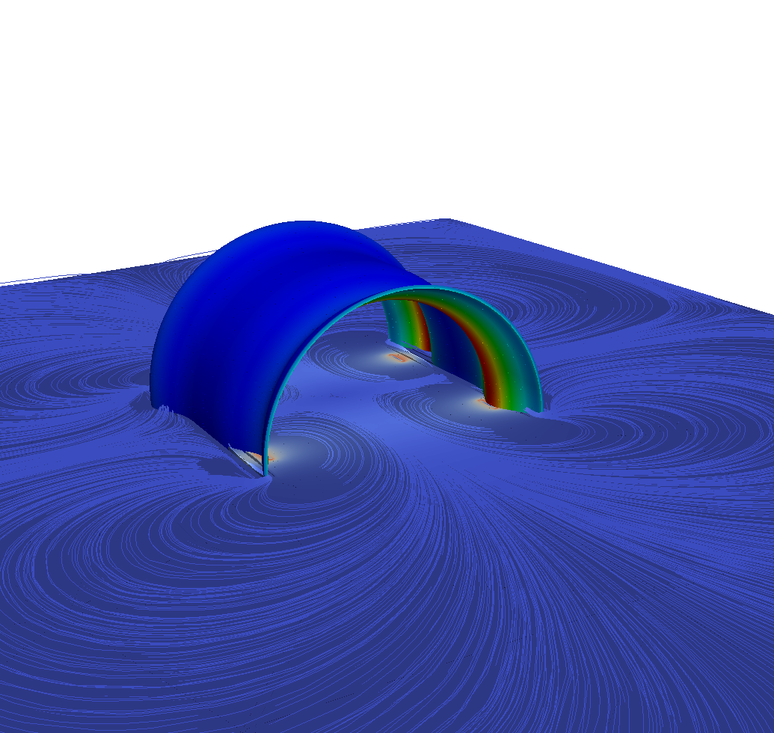

The above image shows a test magnet configuration and a distribution of computed magnet fields.

References
[1] M. Seoane, P.D. Ledger, A.J. Gil, S. Zlotnik, M. Mallett, A combined reduced order-full order methodology for the solution of 3D magneto-mechanical problems with application to magnetic resonance imaging scanners, International Journal for Numerical Methods for Engineering,
2020;121:3529–3559. DOI: 10.1002/nme.6369

[2] M. Seoane, P.D. Ledger, A.J. Gil, M. Mallett, An accurate and efficient three-dimensional high-order finite element methodology for the simulation of magneto-mechanical coupling in MRI scanners International Journal for Numerical Methods for Engineering, 2019;119:1185–1215. DOI:
10.1002/nme.6088.

