EPSRC DLA PhD Studentships

First Supervisor | Dr Daniel Hao
School/Department | School of Computing and Mathematical Sciences (computer science)
Email | d.hao@leicester.ac.uk

Second Supervisor | Dr Timothy Pearce
School/Department | School of Engineering
Email | tcp1@leicester.ac.uk

Additional Supervisor | Dr Sam Siamie (Airbus) sam.simaei.external@airbus.com

Section 2 – Project Information
Project Title | Embodied Intelligence for Trustworthy Robotic Autonomy in Unconstructed  Environments
Project Summary
This PhD project addresses the challenge of achieving trustworthy robotic autonomy in dynamic, unstructured environments—such as hazardous manufacturing facilities, orbital and planetary space robotic operations, or deep-sea installations. While today’s robots can perform impressive tasks, they often lack the safety, reliability, and transparency required to earn human trust. This research focuses on Embodied Intelligence [1], emphasising accurate perception and spatial understanding to guide robots’ decision-making and adaptability amid real-world uncertainties.

State-of-the-art methods integrate Vision-Language Models (VLMs) [2] and multi-agent architectures, encoding sensor and control inputs into shared representations that inform actions. However, these approaches have rarely been tested in highly unstructured scenarios, often struggling with the Sim2Real gap and limited generalisation beyond their initial training conditions. To address these gaps, this project will combine Multimodal Large Language Models (MLLMs), reinforcement learning, and synthetic scenario generation. Industrial datasets and generative AI techniques will support the creation of diverse, photorealistic training conditions that better reflect complex operational environments.

Methodologically, the student will first curate and preprocess both open-source and industry-derived datasets, ensuring that the training materials capture a wide range of challenging tasks and edge cases. These data will be integrated into MLLM-driven reinforcement learning frameworks that incorporate spatial and environmental cues into reward functions.

High-fidelity simulation platforms like Isaac Sim will enable rapid iteration and parallel experimentation, while a UR5e robotic arm will serve as the hardware-in-the-loop testbed. By gradually transitioning from simulated to physical domains, the project seeks to validate the robustness, scalability, and trustworthiness of the developed policies.

The expected outcomes include demonstrable improvements in task completion rates and execution speed, verified through quantitative metrics and qualitative assessments. Ultimately, the project aims to deliver autonomous systems capable of safe and effective collaboration with humans, enhancing productivity, lowering operational risks, and expanding the practical scope of robotics in industries that demand precision and resilience.

The successful candidate will also have the opportunity to undertake a three-month placement at a reputable UK-based robotics manufacturing industrial partner (subject to final agreement and approval), providing hands-on experience and facilitating pathways to real-world impact.

Candidate Criteria:
- Highly motivated individual with excellent communication and teamwork skills
Strong time management abilities, Willingness to publish in high-impact venues.
- A first-class or upper second-class (2:1) degree in computer science, robotics, artificial intelligence, or a related field. Prefer a MSc degree in a related field.
- A track record in robotic programming and simulation (e.g., ROS, Isaac Sim) and proficiency in Python or/and C++
- Experience operating and programming real robotic hardware (e.g., robotic arms, rovers, robotic dogs)
- Knowledge or, preferably, experience in reinforcement learning, large language models, vision-language models, and robot agents

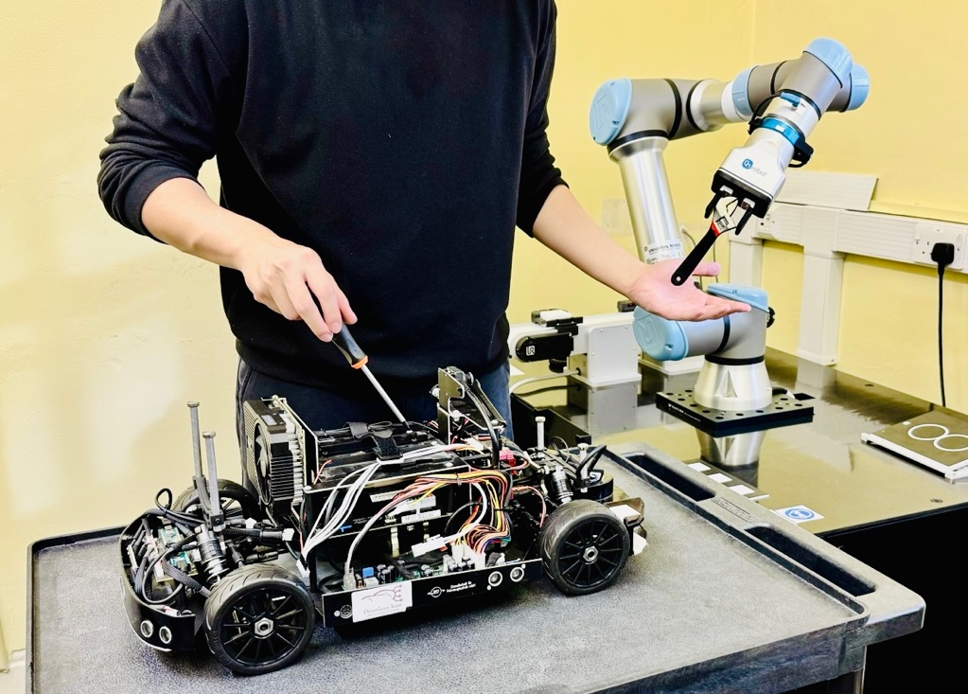

Caption: Embodied Intelligence could make an Iron-Man-like JARVIS a reality, capable of collaborating autonomously and trustworthily with humans in unstructured tasks and environments. Copyright: DANiLab, University of Leicester

References
[1] A. O’Neill et al., "Open X-Embodiment: Robotic Learning Datasets and RT-X Models : Open X-Embodiment Collaboration0," 2024 IEEE International Conference on Robotics and Automation (ICRA), Yokohama, Japan, 2024, pp. 6892-6903, doi: 10.1109/ICRA57147.2024.10611477.

[2] C.-L. Cheang et al., “GR-2: A Generative Video-Language-Action Model with Web-Scale Knowledge for Robot Manipulation,” Oct. 08, 2024, arXiv:2410.06158. Accessed: Oct. 16, 2024. [Online]. Available: http://arxiv.org/abs/2410.06158

[3] Hao, Z., et al. (2021) ‘Intelligent spacecraft GNC architecture with the state-of-the-art AI components for on-orbit manipulation’, Frontier in Robotics and AI. doi: 10.3389/frobt.2021.639327

