University of Leicester
School of Engineering - Les Booth Studentship 2025

Project 7. Multifunctional Thermal Energy Storage

Dr Audrius Bagdanavicius - ab746@leicester.ac.uk

Project Title | Multifunctional Thermal Energy Storage
Project Highlights: | 1. | Design of novel thermal energy storage systems that function simultaneously as integrated components of larger energy storage systems and as flexible thermal hubs for other energy services.
 | 2. | Modelling and dynamic analysis of new multifunctional thermal energy storage systems.
 | 3. | Innovations in thermal energy storage through improved system  design, advanced storage materials, and AI-based control and  operation strategies.
Project Overview
Thermomechanical energy storage (TMES) systems, such as Compressed Air Energy Storage (CAES), Pumped Thermal Energy Storage (PTES) or Liquid Air Energy Storage (LAES), are designed to store electricity. A unique feature of all these systems is that a large amount of heat is generated during operation. To avoid energy losses and improve overall system performance, the generated heat must be captured and stored in a Thermal Energy Storage (TES), which becomes an integral part of the TMES structure. The use of TES allows to significantly increase the overall energy efficiency of the TMES by reusing the stored heat during the charging and discharging phases.

In addition to being an important component of TMES systems, TES can also function as a thermal energy source for external applications, such as heating and cooling in buildings, District Energy Networks, or industrial processes. It is, therefore, possible to conceive multifunctional TES systems that simultaneously store heat from TMES and deliver thermal energy to other sectors.

The development of such innovative multifunctional TES systems requires the application of unconventional research methods. Heat transfer during charging and discharging must be fast and efficient. Therefore, heat transfer processes should be well understood. In addition, TES systems integrated with TMES often operate at high temperatures. Therefore, they require a suitable and durable storage medium that this research will investigate. Promising materials that could be considered for TES applications are phase change materials (PCMs) for latent heat storage and various fluid or solid-based materials for sensible heat storage. Also, the performance of TES systems, especially multifunctional TES, depends on changes in thermal load, so a detailed understanding of the dynamic behaviour of TES is needed.

In this project, novel, multifunctional thermomechanical energy storage (TES) systems will be designed and modelled. These TES systems will be specified to operate as integrated TMES components and as flexible thermal hubs that meet a range of energy needs. The aim of this research is to address important challenges in developing efficient, multifunctional TES systems, focusing on improving their design, selecting suitable storage materials, and implementing AI-based control for their goal-oriented operation.
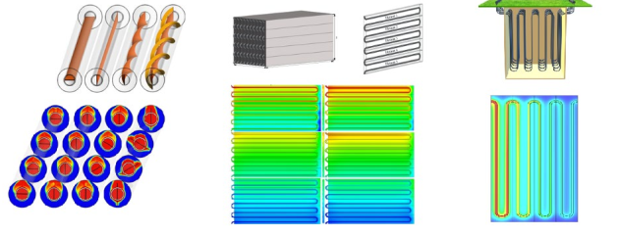
Latent and sensible Thermal Energy Storage systems

Methodology
This project will focus on developing TES system models tailored for integration with TMES. Suitable TES materials, including PCMs and sensible heat storage media, will be screened and selected based on their thermal properties and compatibility. Next, time-resolved TES models will be developed using Computational Fluid Dynamics simulation tools to analyse heat transfer mechanisms during charging and discharging phases under typical TMES operating conditions. Using these models, the dynamic behaviour of TES systems will be examined using MATLAB to assess transient responses under varying thermal loads. AI-enabled control strategies will be developed and tested within the simulation environment to optimise TES performance and responsiveness. Finally, the simulation outcomes will guide the design of efficient, modular, multifunctional TES units, aimed at enhancing TMES operation and supporting diverse thermal energy applications. Where applicable, model validation will be performed against experimental data or established literature to ensure accuracy and reliability.

Further Reading: | 