University of Leicester
School of Engineering - Les Booth Studentship 2025

Project 6. Optimised lattice structure in HPDC mould for better conformal cooling
Dr. Essam Abo-Serie - e.aboserie@leicester.ac.uk

Project Title | Optimised lattice structure in HPDC mould for better conformal cooling
Project Highlights: | 1. | Lattice structure mechanical and thermal properties in the HPDC  moulds
 | 2. | Optimum Lattice structure distribution to improve cooling using adjoint optimisation method applied in a thermofluids model
 | 3. | Experimental validation of the model and application to a complex industrial mould
Project Overview
The application of conformal cooling (CC) in high-pressure die casting (HPDC) in 3D-printed steel moulds/inserts for aluminium casting has demonstrated significant benefits, including up to 80% reduction in cooling time and 60–70% decrease in cycle time [1]. Our recent research employing adjoint optimisation has further shown that CC can triple the service life of 3D-printed mould [2].

Despite these significant improvements, high thermal gradients can be found in specific regions of complex mould geometries; particularly near small intrusions, sharp corners, and fins (see Fig. 1a–1b). These areas often experience insufficient cooling due to industrial limitations that prevent close or embedded placement of small cooling channels near the cavity. Such temperature gradients can cause thermal stresses, leading to local cracking and rendering the entire mould unusable.

Optimising the heat flux transfer from the molten aluminium inside the mould cavity to the coolant can also significantly enhance the casting product quality and its mechanical properties. It is also worth to mentioning that the lattice structure was successfully implemented in the casting mould to achieve lightweight structure [1]. To address this issue, we propose 3D-printing lattice structures within an industrial mould in areas
where thermal resistance required to be increased, to modify the path of heat flux. In a recent study, we implemented lattice structures as sleeves around cooling channels in corners areas, achieving a 42% improvement in temperature uniformity [3]. In this project the aims is to optimise internal heat transfer pathway using various lattice structure configurations in the mould to minimise thermal gradients and improve surface temperature uniformity at the cavity interface.

The lattice structure will be an additional design variable in adjoint optimisation technique, enhancing control over thermal conductivity distribution. The work will build upon a validated thermal optimisation model developed during a 4-year Innovate UK project with CastAlum, and supports the continuation of this collaboration in future proposals.

The research fits with the activities provided by EPSRC centre of Doctoral Training (DigitalMetal-CDT) and supported by existing facilities available in our lab; shown in Fig. 2.
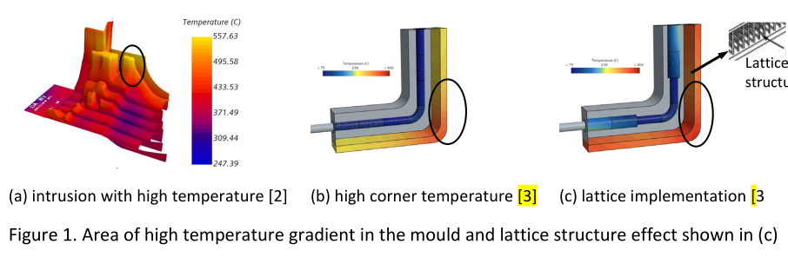

Methodology
The work of this PhD study will be conducted through three phases:

First phase: Understand the existing work, physics and models that have been developed during the previous work, and prepare and identify the different lattice structure mechanical and thermal properties and its mould implementation and limitations.

Second Phase: Develop the current model by introducing the thermal conductivity in the moule as a new variable for the adjoint optimisation model and connect that variable with the lattice structure geometry and size. Apply the adjoint method using simple geometry (Bubbler or Corners) and validate the model results using the existing experimental facilities, shown in Figure 2.

Third Phase: Apply the developed model to simulate the heat transfer and temperature distribution in an industrial mould and compare the result with the existing current CC moulds.
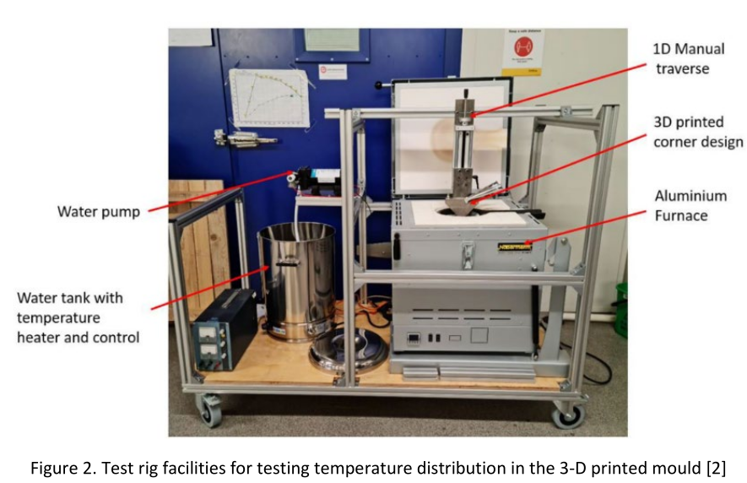
Further Reading: | 1- Feng, S.; Kamat, A. M.; Pei, Y., Design and fabrication of conformal cooling channels in molds: Review and progress updates. International Journal of Heat and Mass Transfer 2021, 171, 121082.  2- Zeng, T., Abo-Serie, E., Henry, M., & Jewkes, J., Cooling channel free surface optimisation for additively manufactured casting tools. The International Journal of Advanced Manufacturing Technology 2023, (127(3)), 1293-1315.  3- Abo-Serie, E.; Koranteng-Agyarko, S. K., Lattice Structure for Improving Cooling Uniformity in HPDC Mould Corners. Applied Sciences 2025, 15, (1), 427.

