University of Leicester
School of Engineering - Les Booth Studentship 2025

Project 5. AI-Driven Design of Metasurfaces for Enhanced Radiative Heat Transfer in High-Efficiency Solar-Thermal Photovoltaic Systems

Dr Muhammad Zubair - Muhammad.Zubair@leicester.ac.uk

Project Title | AI-Driven Design of Metasurfaces for Enhanced Radiative Heat Transfer in High-Efficiency Solar-Thermal Photovoltaic Systems
Project Highlights: | 1. | AI-driven inverse design tools for precise control of radiative heat transfer in solar-thermal systems will be delivered through optimization of metasurface geometries.
 | 2. | Functional metasurfaces for absorber–emitter pairs enabling selective spectral management and enhanced radiative heat exchange will be targeted for improved efficiency.
 | 3. | A scalable simulation-to-prototype workflow for metasurface-enhanced solar-thermal photovoltaic systems will be delivered, advancing next-generation energy solutions.
Project Overview
Solar energy holds the highest potential among renewable sources to meet global energy demands cost-effectively. However, conventional photovoltaic (PV) technologies remain constrained by the Shockley–Queisser limit due to spectral mismatch, where photon energy above or below the semiconductor bandgap leads to thermal and transmission losses. While tandem cells and III–V multijunction architectures offer improvements, they introduce significant complexity and cost. Solar thermophotovoltaic (STPV) systems offer a promising alternative, leveraging full-spectrum absorption and narrowband re-emission to PV cells, theoretically exceeding 85% efficiency under ideal conditions. Traditional STPV technologies face significant performance losses due to inefficient thermal management and limited spectral absorption, especially under low-light or fluctuating temperature conditions, common in UK environments. To realize the true potential of STPVs in practical settings, there is a critical need for material and structural innovation, especially in enhancing radiative heat transfer and thermal stability. This PhD project focuses on advancing STPV technology through the integration of photonic metasurfaces to enhance heat transfer and thermal management between the absorber, emitter, and PV cell. Metasurfaces, engineered nanostructures capable of precise control over light-matter interactions, offer a compact, efficient route to spectral and directional radiation control critical for STPV performance. Early studies predict that intelligently designed metasurfaces could improve energy capture efficiency by up to 18%, compared to standard STPV systems. The core novelty lies in the AI-driven inverse design methodology, which integrates deep learning with finite-difference time-domain (FDTD) simulations to explore complex geometries and material interactions. This will allow us to co-optimize spectral absorption, directional emission, and thermal conductance within the system. Materials such as TiN, AZO, and TiO₂ will be explored due to their spectral and thermal properties under high-flux conditions. Through systematic simulation, fabrication-aware optimization, and optical and thermal characterization, the PhD candidate will develop a library of high-performance metasurfaces. These designs will be tested for their ability to enhance radiation coupling, reduce thermal losses, and maintain operational temperature balance in practical STPV systems. The project addresses pressing energy sustainability goals while contributing to fundamental advances in radiative heat transfer.
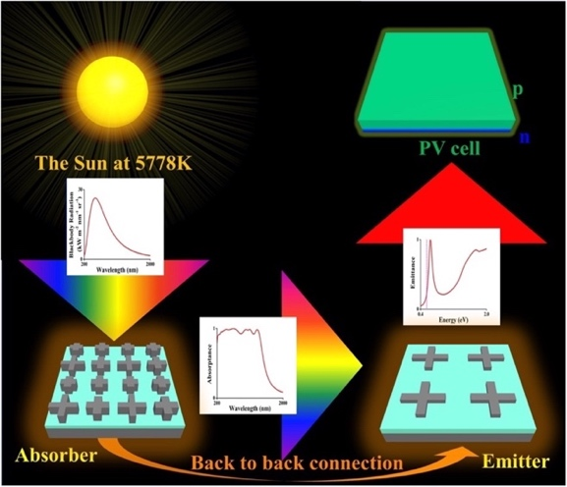
Schematic representation of complete metasurface-based STPV system design [showing (i) the sun and blackbody radiation spectrum, (ii) meta-absorber array and its absorptance, (iii) meta-emitter array and its emittance, and (iv) PV array]
Methodology
This project involves three integrated phases to realize high-efficiency STPV systems using metasurface engineering. First, a selection of refractory and plasmonic materials such as TiN, AZO, and TiO₂ will be assessed based on their dielectric functions, thermal resilience, and solar spectral response under varying illumination. Second, deep learning-assisted inverse design will be applied to optimize absorber and emitter metasurfaces, incorporating FDTD and CST simulations to fine-tune nanostructure geometries for spectral selectivity and impedance matching. Target absorber structures will employ MIM architectures with engineered supercells, enabling polarization- and angle-insensitive high absorption. Third, system-level optical and thermal validation will be carried out using OpticStudio and COMSOL, with fabrication-aware design leading to experimental prototyping in collaboration with nanofabrication labs. Emphasis will be placed on enhancing intermediate and overall system efficiency by balancing selective absorption, thermal emission control, and photonic field localization—thereby overcoming radiative and thermalization losses in real-world STPV operation.
Further Reading: | Ijaz, Sumbel, et al. "Metasurface Absorber–Emitter Pair-Integrated High-Efficiency Thermophotovoltaic System." ACS Photonics (2025). DOI: 10.1021/acsphotonics.5c00845  Li, Lin, et al. "Enhanced near-field thermophotovoltaics based on hyperbolic metasurface." Applied Thermal Engineering 262 (2025): 125272.  Noureen, Sadia, et al. "Deep-learning empowered unique and rapid optimization of meta-absorbers for solar thermophotovoltaics." Optical Materials Express 14.4 (2024): 1025-1038. DOI: 10.1364/OME.519077

