University of Leicester
School of Engineering - Les Booth Studentship 2025

Project 4. Thermal-Aware Decision-Making for Autonomous Low-Altitude Economy Systems
Dr. Xuefang Wang - xw259@leicester.ac.uk

Project Title | Thermal-Aware Decision-Making for Autonomous Low-Altitude Economy Systems
Project Highlights: | 1. | Develop a multi-layered heat-aware decision framework combing thermal modelling and low-level control to adapt flight behavior
 | 2. | Generate energy-efficient and safe low-altitude flight trajectories
 | 3. | Incorporate onboard heat-transfer modelling and sensing into the control architecture
Project Overview
The rapid growth of urban aerial logistics has made autonomous delivery drones a promising solution for last-mile transportation. Operating in low-altitude urban environments, these drones must navigate congested airspace, dynamic obstacles, and variable weather, all while ensuring energy efficiency and reliability. A critical yet often overlooked challenge in this setting is thermal management: sustained flight, frequent takeoffs/landings, and compact electronic systems generate significant heat, which can degrade performance or even lead to failure.

This project proposes a novel, thermally informed decision-making and control framework for autonomous aerial delivery vehicles. By integrating optimal control engineering with real-time heat transfer modeling, the framework enables drones to plan and execute delivery missions that are not only safe and efficient but also thermally sustainable.
Key elements of the project include:
- Heat-transfer modeling of critical UAV components (e.g., battery packs, propulsion units, embedded processors) based on urban thermal environments—factoring in solar radiation, building-induced wind tunnels, and ambient heat.
- A model predictive control (MPC) scheme that jointly optimizes trajectory, energy use, and thermal states over a delivery route.
- A decision-making module that evaluates trade-offs between flight duration, package weight, altitude, and expected thermal loads—guiding the drone to delay, reroute, or adjust speed for thermal safety.
- Integration of low-altitude economy metrics, such as energy-per-distance and thermally constrained mission range, into the decision logic to enhance delivery throughput without compromising system health.
This interdisciplinary project bridges heat-transfer physics, autonomous robotics, and optimal control theory to deliver a scalable solution for thermally aware urban air mobility. The results are expected to contribute to safer, longer-lasting, and more energy-conscious aerial delivery systems, paving the way for resilient drone operations in dense urban environments.
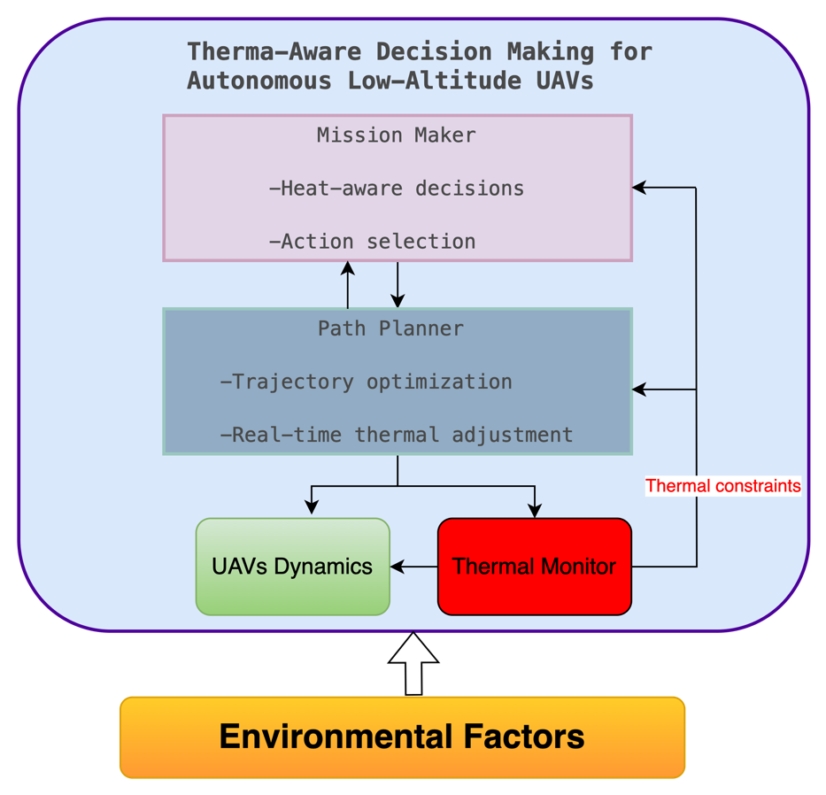
This diagram illustrates the hierarchical structure of a heat-aware autonomous UAV control system. At the top, a Mission Maker determines flight missions and selects thermally safe navigation strategies in uncertain environments. The generated decision is passed to a Path Planner, which computes optimal trajectories that balance energy consumption, safety, and thermal constraints
Methodology
The proposed framework integrates real-time thermal modeling with optimal control and decision-making for autonomous aerial vehicles. First, a lumped-parameter heat-transfer model is developed for key UAV components, capturing internal heat generation and environmental interactions during flight. Second, this model is embedded into a Model Predictive Control (MPC) scheme that jointly optimizes flight trajectory, energy efficiency, and thermal safety over a finite horizon. A decision-making layer employs a Markov Decision Process (MDP) or Reinforcement Learning (RL) to evaluate mission-level strategies under varying thermal and operational conditions. Moreover, simulations in realistic urban environments are conducted using a co-simulation platform combining MATLAB/Simulink, CFD-based heat maps, and UAV dynamics. Key performance metrics include mission success rate, thermal violations, and energy use. Finally, the framework will be validated through hardware-in-the-loop experiments using a quadrotor tested equipped with onboard thermal sensors.

Further Reading: | - D. Scott, S. G. Manyam, I. E. Weintraub, D. W. Casbeer and M. Kumar, “Noise Aware Path Planning and Power Management of Hybrid Fuel UAVs”, IEEE Transactions on Automation Science and Engineering, vol. 22, pp. 8227-8238, 2025. https://doi.org/10.1109/TASE.2024.3481998.  - Y. Wu, D. Wen, A. Zhao, H. Liu and K. Li, “Intelligent soaring and path planning for solar-powered unmanned aerial vehicles”, Aircraft Engineering and Aerospace Technology, vol. 96, no. 4, pp. 514-529. https://doi.org/10.1108/AEAT-05-2023-0138.  - C. T. Aksland, P. J. Tannous, M. J. Wagenmaker, H. C. Pangborn and A. G. Alleyne, “Hierarchical Predictive Control of an Unmanned Aerial Vehicle Integrated Power, Propulsion, and Thermal Management System”, IEEE Transactions on Control Systems Technology, vol. 31, no. 3, pp. 1280-1295, 2023. https://doi.org//10.1109/TCST.2022.3220913.

