University of Leicester
School of Engineering - Les Booth Studentship 2025

Project 3. Gas Turbine Blade Cooling: High-Fidelity Simulations and Bayesian Uncertainty Quantification of Low-Fidelity CFD Models

Dr. Ali Haghiri - ah794@leicester.ac.uk

Project Title | Gas Turbine Blade Cooling: High-Fidelity Simulations and Bayesian  Uncertainty Quantification of Low-Fidelity CFD Models
Project Highlights: | 1. | Gain fundamental insights into the complex mixing phenomena (turbulence and heat transfer) in gas turbine blade cooling using Direct Numerical Simulation (DNS).
 | 2. | Enhance the reliability of predictions by quantifying uncertainties in low-fidelity models (RANS/LES) through Bayesian inference for turbine blade cooling.
 | 3. | Optimise high pressure turbine cooling designs and enhance turbine efficiency and extend the turbine lifespan.
Project Overview
This research project focuses on gas turbine blade cooling, specifically targeting the blade trailing edge, where cooling air is expelled to mitigate thermal stresses and improve performance. Gas turbines are key components in aviation and energy generation, therefore optimising their performance is essential for reducing operational costs and emissions. The actively cooled trailing edge of turbine blades is a key design feature, as effective cooling significantly enhances the blade durability and performance.
To achieve this, the PhD candidate will use Direct Numerical Simulation (DNS), a high-fidelity computational fluid dynamics technique that resolves turbulent flow and heat transfer phenomena at the blade trailing edge. DNS captures intricate flow structures and mixing behaviours that are critical for understanding the cooling processes, providing fundamental insights beyond the ones by lower-fidelity numerical models. By employing DNS, the research aims to reach a comprehensive understanding of the mechanisms that govern the cooling performance of turbine blades.
Moreover, the project addresses the uncertainties associated with low-fidelity models, such as Reynolds-Averaged Navier-Stokes (RANS) and Large Eddy Simulation (LES). These models are used in preliminary design phases to speed up the industrial turbomachinery design process. To improve the reliability of these models, Bayesian inference techniques will be employed to quantify and reduce uncertainties, leading to enhanced predictive capabilities for turbine blade performance.
Ultimately, the findings of this research aim to inform the development of optimised blade trailing edge active cooling designs that not only improve the turbine isentropic efficiency but also extend the lifespan of turbine components. This work will have direct implications for the aviation and energy sectors, from the use of more durable, sustainable, and thermodynamically efficient gas turbines. By bridging the gap between high-fidelity simulations and lower-fidelity simulations used in industrial blade design practice, this project seeks to advance the state of knowledge in gas turbine blade cooling technologies.
Methodology
This research will employ the in-house high-fidelity CFD solver HiPSTAR to perform Direct Numerical Simulations (DNS) of turbulent flow and heat transfer in the trailing edge region of gas turbine blades. HiPSTAR is optimised for compressible flows and enables resolution of fine-scale turbulence features critical for understanding cooling performance. Initial efforts will focus on mesh generation, boundary condition setup, and validation against benchmark cases.
To complement the high-fidelity DNS, lower-fidelity models such as Reynolds-Averaged Navier-Stokes (RANS) and Large Eddy Simulation (LES) will be developed using OpenFOAM, an open-source CFD platform. These simulations will serve as a practical counterpart for engineering design applications.
Bayesian inference will be used to quantify and reduce the uncertainties in the RANS and LES predictions by calibrating them against DNS results. The project will proceed in three stages: DNS case setup and validation; RANS/LES modelling and uncertainty quantification; and design-oriented analysis of trailing-edge cooling strategies.
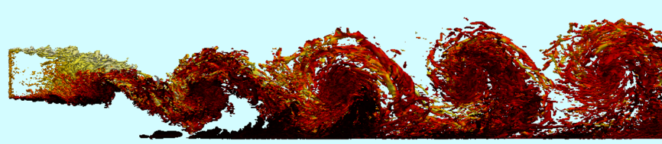
High-fidelity CFD simulation of a fundamental trailing-edge slot, used to study cooling effectiveness in turbine blades
Further Reading: | Haghiri, A. and Sandberg, R.D., 2020. Large eddy simulations of wall jets with coflow for the study of turbulent Prandtl number variations and data-driven modeling. Physical Review Fluids, 5(6), p.064501.  Sandberg, R.D. and Zhao, Y., 2022. Machine-learning for turbulence and heat-flux model development: A review of challenges associated with distinct physical phenomena and progress to date. International Journal of Heat and Fluid Flow, 95, p.108983.  Cheung, S.H., Oliver, T.A., Prudencio, E.E., Prudhomme, S. and Moser, R.D., 2011. Bayesian uncertainty analysis with applications to turbulence modeling. Reliability Engineering & System Safety, 96(9), pp.1137-1149.

