University of Leicester
School of Engineering - Les Booth Studentship 2025

Project 2. Analysis and Control of Aircraft Bleed Air Systems with Heat Dynamics

Dr Khaled Laib - kl314@leicester.ac.uk

Project Title | Analysis and Control of Aircraft Bleed Air Systems with Heat Dynamics
Project Highlights: | 1. | Integrated heat transfer modelling and robustness analysis
 | 2. | Advanced control design using LPV and LMI techniques
 | 3. | Collaborative research linking fundamental control theory and industry
Project Overview
This project aims to develop a robust modelling and control framework for aircraft bleed air systems, which are fundamental to the thermal management infrastructure of an aeroplane. These systems extract high-temperature, high-pressure air from the engine compressor stages and supply it to critical subsystems, including cabin pressurisation, environmental control units, and wing anti-icing. The behaviour of bleed air systems involves complex interactions among thermal, pneumatic, and mechanical domains, operating across a broad and uncertain range of flight conditions. Ensuring performance, safety, and efficiency under such variability requires rigorous modelling and advanced robust control strategies.

Heat transfer within major aircraft components—such as ducts, exchangers, valves, and fuselage panels—can be modelled using Partial Differential Equations (PDEs) that capture conduction, convection, and thermal inertia. To manage complexity and enable tractable theoretical analysis, spatial discretisation will be applied, resulting in a large-scale network of interconnected lumped-parameter subsystems. This modular representation supports scalable, component-level analysis. Integral Quadratic Constraints (IQCs) will serve as the primary tool to assess system stability and input–output performance under structured uncertainties and nonlinear effects.

To capture key operating conditions, the Linear Parameter Varying (LPV) approach will represent various components of the bleed air system, with scheduling variables such as altitude, engine spool speed, and bleed air demand, while also incorporating the refined thermal characteristics obtained from the heat transfer IQC analysis. Robust gain-scheduled controllers will be developed using Linear Matrix Inequality (LMI) methods to ensure performance and stability across the flight envelope. Beyond centralised control schemes, the component-based architecture of the bleed air system—comprising valves, heat exchangers, ducts, and sensors—is well-suited to distributed and hierarchical control strategies. These approaches enable local controllers to regulate individual components, while supervisory controllers coordinate system-wide objectives such as energy efficiency, thermal regulation, and fault resilience. This layered structure enhances modularity and aligns with certification and safety requirements in aerospace systems.

This project blends first-principles physical modelling with robust control methodologies to enable high-assurance, certifiable thermal management strategies. A newly established collaboration with Liebherr Aerospace will provide access to operational data and industrial expertise, ensuring the developed solutions are practical and industry-relevant.

Methodology
The project will combine system theory, convex optimisation, and simulation to develop robust control for aircraft bleed air systems. Heat transfer will be modelled by parabolic PDEs and converted into lumped-parameter networks via spatial discretisation. IQC theory will support robustness analysis under uncertainties and nonlinearities.

Operating conditions like altitude and engine speed will be captured with LPV state-space models. Robust gain-scheduled controllers will then be formulated using LMI convex optimization to ensure performance across the flight envelope.

Control architectures will include centralised, decentralised, and hierarchical schemes for scalability and fault tolerance. MATLAB and Simulink will be the main computational and simulation tools.

Model validation will use Liebherr Aerospace data, assessed by metrics such as RMSE and frequency response, iteratively from component to system level.

The project will run over three years: Year 1 for modelling and robustness analysis, Year 2 for control design, and Year 3 for validation and refinement.

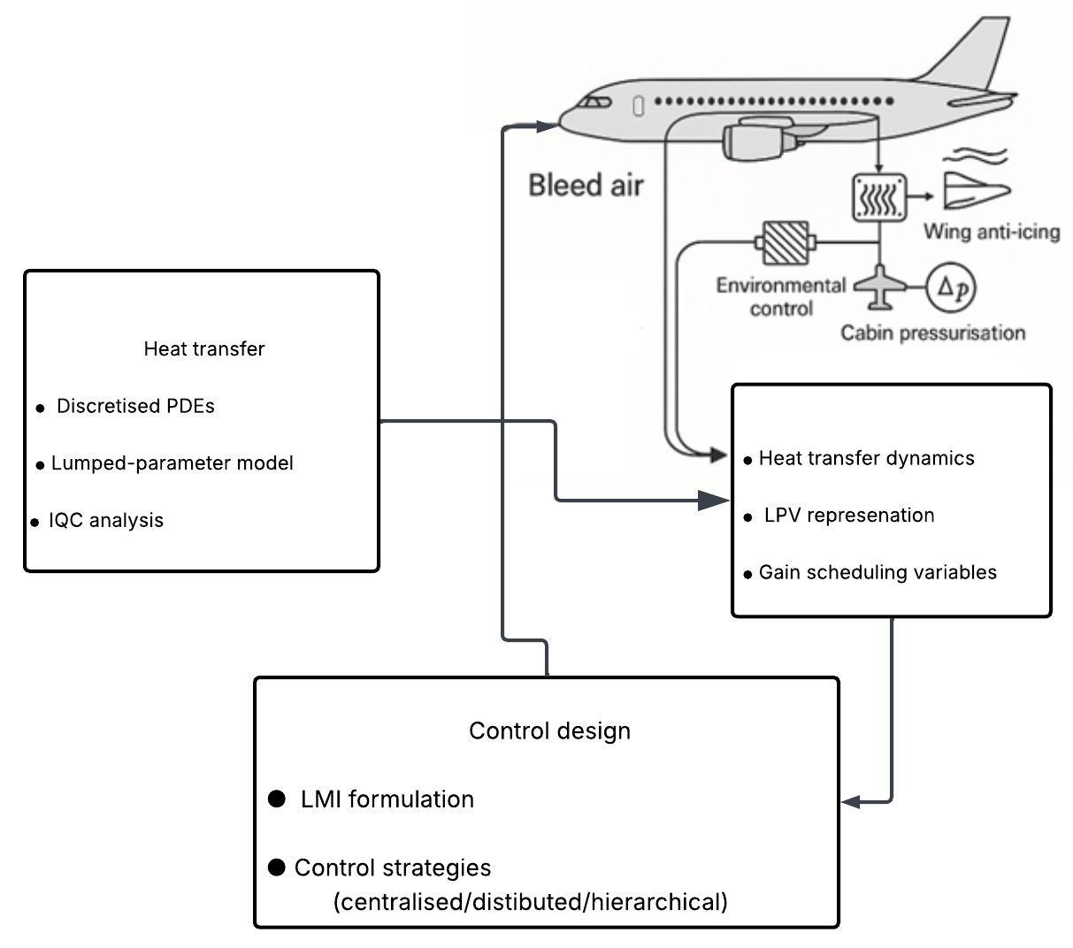
The diagram outlines a modelling and control framework for aircraft bleed air systems, with an emphasis on thermal management and control strategy development. Bleed air, extracted from the engine, is used to support critical functions such as environmental control, cabin pressurisation, and wing anti-icing. These subsystems require accurate modelling of heat transfer and effective regulation.

Further Reading: | - A. Pollok and F. Casella, "Comparison of control strategies for aircraft bleed-air systems," IFAC-PapersOnLine, vol. 50, no. 1, pp. 14194–14199, 2017, doi: 10.1016/j.ifacol.2017.08.2087.  - A. Megretski and A. Rantzer, "System analysis via integral quadratic constraints," IEEE Transactions on Automatic Control, vol. 42, no. 6, pp. 819–830, Jun. 1997, doi: 10.1109/9.588644.  - A. Packard and M. Kantner, "Gain scheduling the LPV way," in Proc. 35th IEEE Conf. Decision and Control, Kobe, Japan, 1996, vol. 4, pp. 3938–3941, doi: 10.1109/CDC.1996.577296.

