University of Leicester
School of Engineering - Les Booth Studentship 2025

Project 1. Resolvent analysis of supercritical fluids with heat transfer

Supervisor: Dr Benjamin Bugeat - bb283@le.ac.uk

Project Title | Resolvent analysis of supercritical fluids with heat transfer
Project Highlights: | 1. | Apply resolvent analysis to gain new physical insights into how heat transfer affects instabilities in supercritical fluids
 | 2. | Unravel the role of buoyancy, driven by temperature differences, in the dynamics of supercritical fluids
 | 3. | Develop new strategies to optimise heat transfer within the framework of resolvent analysis
Project Overview
Above certain conditions of temperature and pressure, fluids reach a supercritical state in which the distinction between liquid and gas no longer exists. Supercritical fluids are increasingly used in industrial applications such as power generation and rocket engines, in which they undergo significant heat transfer. Turbulence is usually desirable in these thermo-fluid systems as it promotes high heat transfer, which increases efficiency. Recent studies have shown that when a supercritical fluid is sufficiently heated, a new instability is observed (Ren 2019, Bugeat 2024).
This has opened exciting new perspectives for triggering turbulence in these fluids, but several fundamental questions remain open. A class of instabilities, called non-modal instabilities, is not fully understood: it is unclear which physical mechanisms are responsible for their growth and transition to turbulence. Furthermore, it is not known how buoyancy (the force resulting from temperature differences) affects their dynamics. Finally, no strategy has yet been proposed to leverage the unique dynamics of supercritical fluids in order to promote turbulence and high heat transfer.
This project will use resolvent analysis, a state-of-the-art computational technique, to address these questions. Resolvent analysis is based on linear analysis and identifies the optimal forcing and response that yield the largest energy growth in a flow. We propose to apply this method for the first time to a supercritical fluid in a flow where boundaries are maintained at different temperatures, thereby inducing heat transfer across the system. The structure of the optimal forcing and response will allow the prevailing mechanism to be identified. The role of buoyancy will be investigated by exploring a range of Richardson numbers.
Once these problems have been rationalised, a new formulation of resolvent analysis will be proposed in order to compute the optimal heat transfer rather than the optimal energy. Based on the very recent idea of Alben et al. (2024), this has the ground-breaking potential to identify novel optimal strategies to force a flow (e.g., determining the optimal location and shape of stirrers) that maximise heat transfer in a range of industrial flows.

Methodology
An in-house resolvent code, developed in a companion EPSRC project, will be readily available to the PhD candidate. This will allow the student to quickly obtain results and develop a strong grasp of the technique and the underlying physical mechanisms. The student will later adapt this code to address specific research questions. Three work packages are proposed:
WP1. The objective is to compute the optimal forcing and response in a supercritical fluid with varying heat input. Non-modal instabilities will be characterised by their energy growth across a range of frequencies, and new physics will be reported and analysed using mechanistic models.
WP2: The effect of buoyancy on the previously computed optimal perturbation will be analysed. It is expected, but remains to be proven, that streaks (a fundamental non-modal instability) will be significantly distorted.
WP3. A new mathematical framework (within resolvent analysis) that optimises heat transfer in flows will be proposed and tested.
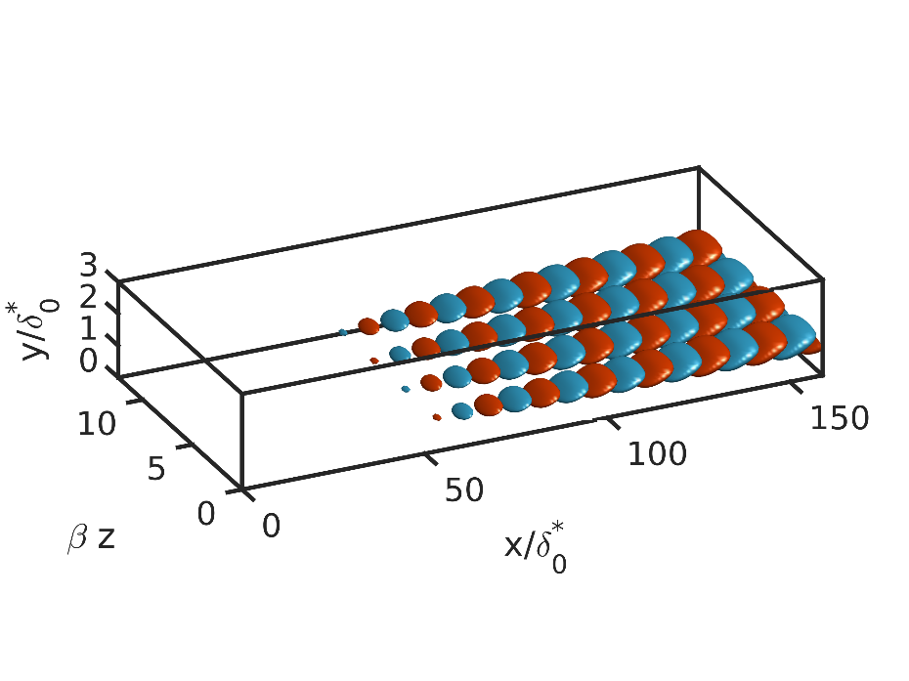
Three-dimensional optimal perturbations in a boundary layer obtained from resolvent analysis (Bugeat et al. 2019)
Further Reading: | Ren, J., Marxen, O., & Pecnik, R. (2019). Boundary-layer stability of supercritical fluids in the vicinity of the Widom line. Journal of Fluid Mechanics, 871, 831-864.  Bugeat, B., Boldini, P. C., Hasan, A. M., & Pecnik, R. (2024). Instability in strongly stratified plane Couette flow with application to supercritical fluids. Journal of fluid mechanics, 984, A31.  Alben, S., Prabala, S., & Godek, M. (2024). Enhancing heat transfer in a channel with unsteady flow perturbations. Physical Review Fluids, 9(12), 124503.

