Scheme: GTA

School of Chemistry PhD Project Proposal Form

First Supervisor | Dr Richard Hopkinson
School/Department/Institute | Chemistry
Email | Richard.hopkinson@leicester.ac.uk

Section 2 – Project Information

Project Title | Development of a novel cancer treatment strategy targeting reactive protein N-termini
Project Highlights: | 1. | Design and synthesise novel electrophilic drug-like small molecules (ESMs) that can react selectively with the nucleophilic N-termini of cancer-relevant proteins.
 | 2. | Validate the reactivity and inhibitory potential of ESMs with recombinantly expressed cancer-relevant proteins.
 | 3. | Identify anti-cancer activity for ESMs in human cancer cells.
Project Description
Background: Cancer remains one of the leading causes of death worldwide. Development of new cancer drugs is therefore urgently needed. However, a major limitation to the development of new cancer drugs is the lack of ‘druggable’ protein targets.
Our recent work has revealed that electrophiles can react with nucleophilic N-termini on proteins and regulate their functions.^{1,2} This is very exciting because many cancer-relevant proteins have nucleophilic N-termini. The reactivity of these N-termini is often important for their cancer-inducing or stimulating properties. This is the case of asparagine synthetase (ASNS), which uses its N-terminal cysteine residue to catalyse amino acid metabolism and to drive cancer progression.³
Our work has shown that electrophiles can inhibit ASNS activity and can consequently kill ASNS-dependent leukaemia cells.² This breakthrough discovery validates ASNS inhibition as a novel anti-cancer strategy and also implies that electrophilic drugs, if properly targeted, can be used to inhibit multiple cancer-relevant but previously undruggable proteins.
We therefore propose that electrophilic small molecules (ESMs) can be used to target cancer-relevant proteins. Reactions between the ESMs and protein N-termini will kill cancer cells.
Work in this project will develop ESMs that are selective for reaction with either ASNS, related N-terminal cysteine-containing proteins, or N-terminal proline-containing proteins that we have shown can react with electrophiles to form cyclic adducts.¹ Ultimately, the ESMs will be tested with recombinantly expressed proteins and in cancer cells to validate their on-target reactivity, inhibitory potential, and their efficacy as anti-cancer drugs.

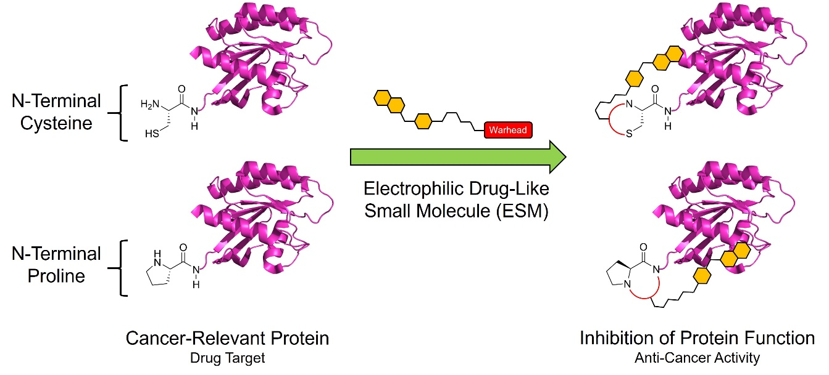
Figure 1. ESMs inhibit cancer-relevant proteins and induce cancer cell death.

Aim and Objectives: The overall aim of this project is to develop ESMs as novel N-terminal-targeting anti-cancer drugs. Specific objectives are:
1. Design and synthesise a library of ESMs that can react selectively with the nucleophilic N-termini of cancer-relevant proteins.
2. Determine the reaction kinetics, adduct structures and inhibitory potential of the ESMs with recombinantly expressed cancer-relevant proteins using NMR, mass spectrometry and fluorescence-based techniques.
3. Test the anti-cancer activity of the ESMs in human cancer cells both in isolation and in combination with other cancer drugs.
Methodology: Initial work will focus on designing and synthesising a library of ESMs. Library members will contain different electrophilic warheads that invoke selectivity for either N-terminal cysteine or proline residues. The design of these warheads will be informed by the literature⁴ and by our previous experience with electrophilic metabolites. In addition to the warheads, the ESMs will also incorporate subsidiary groups that will bind to protein-specific binding pockets near the N-terminal residue and will therefore enable selective targeting to particular proteins. The structures and relative positioning of the subsidiary groups will be informed by in silico modelling and by analysis of reported substrates.
After the ESM library has been prepared (>30 compounds), cancer-relevant N-terminal cysteine- or proline-containing proteins will be expressed (using a bacterial expression system) and purified for use in biochemical studies. Among these proteins (5-10) will be ASNS (N-terminal cysteine) and histone H2B (N-terminal proline), which we have previously shown to react with biologically relevant electrophiles. The purified proteins will then be incubated with the ESMs and the reaction rates, the sites of reaction (i.e. on the N-terminus or elsewhere on the protein), and the structures of the reaction products will be determined using NMR and protein mass spectrometry. ESM-induced inhibition of protein activity will then be tested in NMR- and fluorescence-based activity assays using recombinant protein and either natural or fluorescently labelled unnatural substrates.
Finally, inhibitory ESMs will be tested for their anti-cancer activity in human cancer cells using absorbance-based cytotoxicity assays. The ESMs will be tested in a variety of cell lines (thus profiling their on-target activity) and will also be tested in combination with current front-line cancer drug to assess whether they lead to synergistic anti-cancer activity (as we have previously observed with other electrophiles). Ultimately, these studies will confirm the anti-cancer potential of ESMs and will stimulate their progress into clinical trials.
The PhD student will receive hands-on training in all the required experimental methods, including in chemical synthesis, protein production, biochemical assays (e.g. using NMR, mass spectrometry and fluorescence imaging), and human cell culture.
References: [1] Commun. Chem., 2023, 6, 12. [2] Chem. Sci., 2024, 14, 2509. [3] Front. Oncol., 2020, 9, 2019. [4] J. Am. Chem. Soc., 2022, 144, 10396.

