Enabling Challenging Space Exploration: exploring 244Cm-based radioisotope power systems
- Radioisotope thermoelectric generators allow us to explore dark/distant locations in space e.g. Saturn, Icy Moons.  - This is an opportunity to research a new ²⁴⁴Cm based radioisotope “fuel” to enable space exploration.  - You will propose, make and assess the new fuel’s feasibility via experiments with non-radioactive simulants. | Level | PhD
 | First Supervisor | Dr Emily Jane Watkinson  ejw38@leicester.ac.uk
 | Second Supervisor | Prof Richard Ambrosi
 | Application Closing  Date | See web page
 | PhD Start date | September 2024

Project Details:

- Radioisotope power systems (RPS) are key for allowing us to explore some of the most challenging locations of our solar system that are not possible or are very challenging using solar array based electrical power supplies. Spacecraft need electrical power and onboard heating to operate. RPS generate heat via radioactive decay that can be used directly, or that can be converted into electrical power e.g. via thermoelectric generators. Some examples of missions enabled using RPS include various Apollo missions to the Moon, Mars 2020’s Perseverance rover, Cassini-Huygens spacecraft and probe to Saturn/Titan and New Horizons mission to Pluto. U.S. RPS utilise ²³⁸Pu as the radioisotope fuel.

- You will be supervised by experts who are actively developing ²⁴¹Am RPSs for European Space Agency in the School of Physics and Astronomy based at Space Park Leicester.

- This PhD will explore and propose new ²⁴⁴Cm based radioisotope “fuels”, which could open up new space science exploration mission opportunities. ²⁴⁴Cm has a shorter half-life than traditional radioisotopes at 18.1 years. You will assess the feasibility of the ²⁴⁴Cm based fuels.

- Your research will also contribute to knowledge relevant to nuclear power on Earth.
- You will:
  - make non-radioactive simulants of proposed ²⁴⁴Cm based fuel options, chemically.
  - develop laboratory analytical research skills to analyse the materials e.g., in scanning electron microscopy and X-ray diffraction.
  - develop the capability to consolidate the simulant “fuel” into a sintered pellet.
  - propose the clad/primary containment system for the fuel.
  - consider space science opportunities for using 244Cm based RPS e.g., operations and processes that require power in dark/distant locations and those that require higher power than what traditional radioisotope power systems offer.
- Beneficial skills: problem solving, interest and/or experience in experimental research, willingness to learn new experimental skills.

- Exploring dark and/or distant locations in our solar system is becoming ever timelier- the International Space Exploration Coordination Group (ISECG)’s “Space nuclear power & propulsion: a technology gap assessment” has highlighted the importance of radioisotope power systems to enabling robotic exploration of the Moon, Mars and the outer solar system.

References:

- An insight into the School of Physics and Astronomy’s Space Nuclear Power teams research into radioisotope power systems can be found here: https://www.era.ac.uk/projects/energy-for-space-exploration/

- Insight into past simulant fuels research and other research conducted by Watkinson et al. as part of the development of ²⁴¹Am radioisotope power systems can be found in the following paper:
R. M. Ambrosi, H. R. Williams, E. J. Watkinson, et al. European Radioisotope Thermoelectric Generators (RTGs) and Radioisotope Heater Units (RHUs) for Space Science and Exploration. Space Sci Rev 215, 55 (2019). https://doi.org/10.1007/s11214-019-0623-9

- The ISECG’s “Space nuclear power & propulsion: a technology gap assessment” can be found here: https://www.globalspaceexploration.org/. Last accessed 1st October 2023.

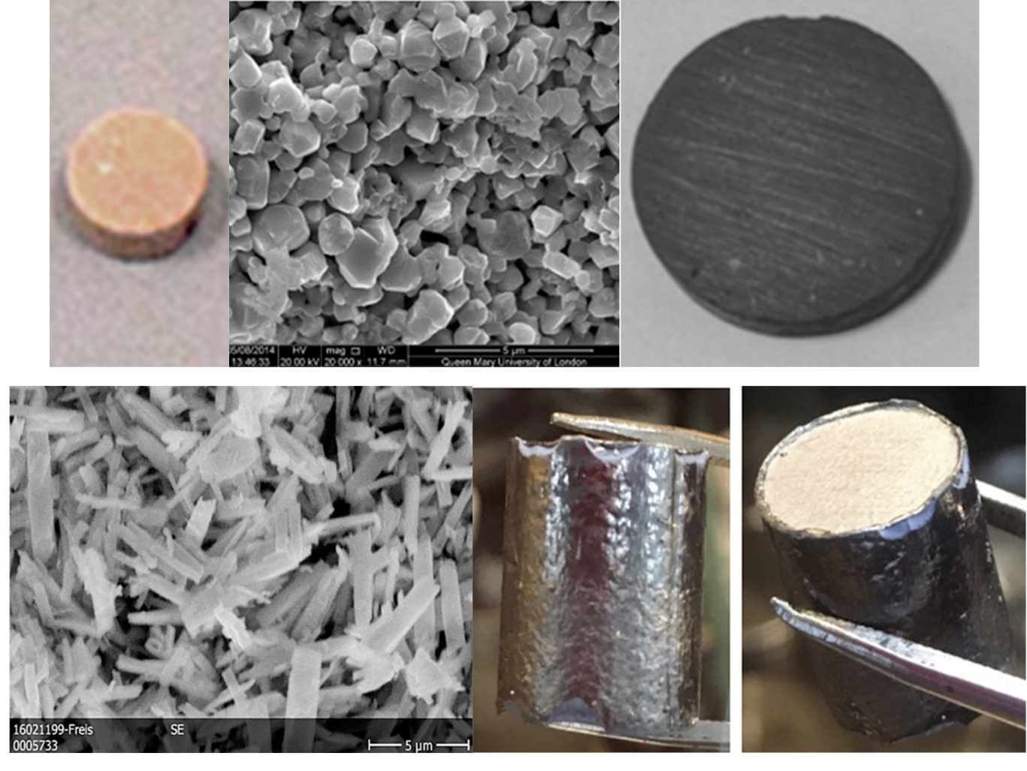

Cerium and neodymium oxide simulants were used for americium oxides in previous research. The raw material is shown in B and D and sintered discs are shown in A, C and E, Credit: E. J. Watkinson et al., 2017, https://doi.org/10.1016/j.jnucmat.2017.04.028 and Ambrosi et al., https://doi.org/10.1007/s11214-019-0623-9

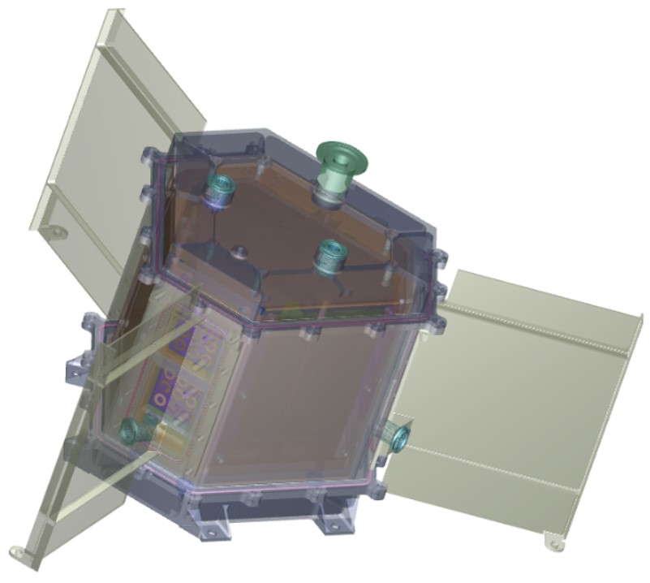

University of Leicester designed 241Am based RTG, Ambrosi et al., 2019, https://doi.org/10.1007/s11214-019-0623-9

Further information on how to apply and funding can be found at https://le.ac.uk/study/research-degrees/funded-opportunities/stfc

