Characterization of the Space Weather and radiation environment at Mars and the impacts on exploration.
- Complete characterization of the Mars’ radiation environment and its response to Space Weather activity  - Multi-spacecraft observations from surface to space covering more than 20 years of observations  - Impacts on technology and on future robotic and human exploration of Mars | Level | PhD
 | First Supervisor | Dr Beatriz Sanchez-Cano  bscmdr1@le.ac.uk
 | Second Supervisor | Dr Adrian Martindale
 | Application Closing  Date | See web page
 | PhD Start date | September 2024

Project Details:

The Sun continuously emits magnetic fields, particles and radiation that can interact with a planet’s upper atmosphere and surrounding magnetic environment to produce a myriad of effects, such as radio communications issues, which are typically referred as Space Weather. Decades of Earth observation have shown us the importance of real-time Space Weather forecasting in order to anticipate radiation hazard effects on technology (both at ground and space) and human tissues. We have an increasingly comprehensive understanding of solar activity and local interplanetary conditions impacting Earth’s environment. At Mars, however, this is a growing and crucial topic in part due to the large amount of critical infrastructure deployed, but also because of the upcoming likely human exploration either in orbit or on the surface (e.g., [2]).
Solar transient events (i.e., solar storms) are sources of very intense short-term variability, enhancing auroras, atmospheric escape, as well as creating large particle-radiation showers into the atmosphere that create technology disruptions, all of them major research topics in Mars’ exploration [5]. In order to mitigate those effects, particularly on technologies, a good knowledge of the Martian plasma system is needed, i.e., of the thermosphere (T)– ionosphere (I)– magnetosphere (M) – solar wind coupling. Mars-solar wind interaction is very complex, typically referred as a “hybrid magnetosphere”, with features of both induced and intrinsic magnetospheres [5]. This is mainly due to the presence of crustal magnetic fields in the equator and a region of the southern hemisphere, which rotate with the planet creating a complex and highly variable interaction where draped, closed and open magnetic field lines are present [1]. This interaction is even more complex when solar transients hit Mars as they enhance particle precipitation into the lower atmosphere, creating global auroras [6] as well as significant HF radio communication issues [4], which are significantly more intense on the nightside of Mars thanks to the complex magnetic topologies found in the Martian tail [3].
The aim of this PhD project is to provide the most complete characterization of the Martian radiation environment with special focus on the response of the Martian plasma system (M-I-T) to Space Weather activity, as well as to get a comprehensive evaluation of their impact on current technology at Mars. The following tasks are in principle foreseen:

- To investigate the impact of coronal mass ejections (CMEs) and solar energetic particles (SEPs) emitted from the Sun on the plasma and neutral environment of Mars during different levels of solar activity (i.e., different levels of ionization in the atmosphere). Near simultaneous observations from the surface of Mars to space.

- To characterise the response of the M-I-T system to SEPs/CMEs to estimate the level of atmospheric absorption produced under each circumstance, and how much radiation can reach the surface.

- Comprehensive evaluation of radiation/space weather impacts on current technology at Mars, via signal degradations and housekeeping observations, and how it informs on future payloads for the Martian environment.

This is a mainly data analysis project that will use data from all available assets at Mars, such as (but not limited to), Mars Express, MAVEN, MSL, or MRO. The full coverage of these missions expands near 20 years. Model-data comparisons of the ionosphere and magnetic fields are an additional value to this project.
The unique combination of multi-spacecraft datasets at Mars offers the potential for exciting new discoveries on the red planet. Successful PhD candidates would have some prior background in coding, as well as some prior knowledge of plasma physics and ionospheric science is desirable.
The supervisors of this project are involved on several missions in the Solar System, and in particular, are Co-Investigators of the MARSIS instrument on Mars Express and coordinators of the Mars Upper Atmosphere Network (MUAN), which will provide unique opportunities to the PhD candidate to collaborate with colleagues from different international institutions and missions. Moreover, Leicester’s current involvement in Mars’ exploration with Mars Express and ExoMars as well as on other planetary missions such as BepiColombo, SMILE, the Jupiter Icy Moons Explorer (JUICE), or the James Webb Space Telescope (JWST), offers a unique immersive experience on planetary research to the successful PhD candidate.

References:

- [1] DiBraccio, G. A., Luhmann, J. G., Curry, S. M., Espley, J. R., Xu, S., Mitchell, D. L., et al. (2018). The twisted configuration of the Martian magnetotail: MAVEN observations. Geophysical Research Letters, 45, 4559– 4568. https://doi.org/10.1029/2018GL077251
- [2] Lee, C.O., Sánchez-Cano, B., DiBraccio, G.A., Mayyasi, M., Xu, S., Chamberlin, P., et al. (2023). Heliophysics and space weather science at ∼1.5 AU: Knowledge gaps and need for space weather monitors at Mars. Front. Astron. Space Sci., Sec. Space Physics, 10. https://doi.org/10.3389/fspas.2023.1064208
- [3] Lester, M., Sanchez-Cano, B., Potts, D., Lillis, R., Cartacci, M., Bernardini, F., et al. (2022). The impact of energetic particles on the Martian ionosphere during a full solar cycle of radar observations: Radar blackouts. Journal of Geophysical Research: Space Physics, 127, e2021JA029535. https://doi.org/10.1029/2021JA029535
- [4] Sánchez–Cano, B., Blelly, P.-L., Lester, M., Witasse, O., Cartacci, M., Orosei, R., et al. (2019). Origin of the extended Mars radar blackout of September 2017. Journal of Geophysical Research: Space Physics, 124, 4556– 4568. https://doi.org/10.1029/2018JA026403
- [5] Sánchez-Cano, B., Lester, M., Andrews, D.J. et al. Mars’ plasma system. Scientific potential of coordinated multipoint missions: “The next generation”. Exp Astron 54, 641–676 (2022). https://doi.org/10.1007/s10686-021-09790-0
- [6] Schneider, N. M., Milby, Z., Jain, S. K., Gérard, J.-C., Soret, L., Brain, D. A., et al. (2021). Discrete aurora on Mars: Insights into their distribution and activity from MAVEN/IUVS observations. Journal of Geophysical Research: Space Physics, 126, e2021JA029428. https://doi.org/10.1029/2021JA029428
- [7] Lee, C. O., et al. (2017), MAVEN observations of the solar cycle 24 space weather conditions at Mars, J. Geophys. Res. Space Physics, 122, 2768– 2794, https://doi.org/10.1002/2016JA023495

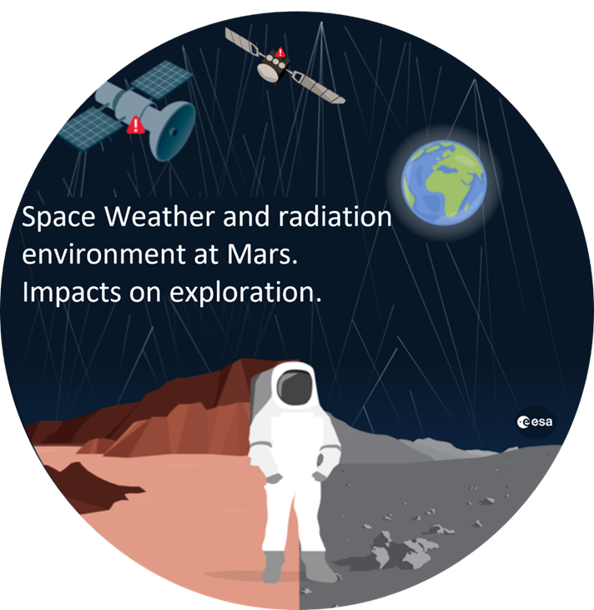

Mars and moon radiation environments as future landing sites for the humankind. Image adapted from ESA.

Further information on how to apply and funding can be found at https://le.ac.uk/study/research-degrees/funded-opportunities/stfc

