Exploring Giant Planet Atmospheres with JWST
- JWST has opened a new window for exploring our Solar System, providing unprecedented new data for the giant planets.  - Infrared spectral maps from NIRSpec and MIRI reveal the weather, dynamics, chemistry, and clouds in 3D.  - Learn how to use JWST, alongside ground-based observatories, to explore the origins and climate of other worlds. | Level | PhD
 | First Supervisor | Prof Leigh Fletcher  LNF2@le.ac.uk
 | Second Supervisor | Dr Henrik Melin
 | Application Closing  Date | See web page
 | PhD Start date | September 2024

Project Details:
Overview: In its first year of operations, the James Webb Space Telescope (JWST) has delivered astonishing new discoveries via infrared observations of the near and far universe. Planetary scientists at the University of Leicester have been leading a programme of exploration of the four giant planets in our own Solar System, capturing unprecedented new infrared observations of Jupiter, Saturn, Uranus, and Neptune. These can be used to explore the atmospheres, ionospheres, rings, and satellites of these enormous worlds. Specifically, infrared spectroscopy can be modelled to understand the three-dimensional temperatures, winds, gaseous composition, and clouds within a planetary atmosphere, from the turbulent cloudy layers, high into the rarefied upper atmosphere. These measurements provide insights onto the climate, dynamics, and chemistry shaping these diverse worlds. The planetary atmospheres team is searching for a new PhD student to help explore the riches of this JWST dataset, to pave the way for future missions to the giant planets.

JWST Observations: The key advance offered by JWST is the use of integral field unit spectroscopy, which acquires hundreds of spectra simultaneously across a small field of view, producing spectral maps of the target. Spectra contain the fingerprints of atmospheric gases and aerosols, which can be reproduced via a spectral retrieval code to diagnose the environmental conditions within an atmosphere. Our dataset from 2022-23 contains observations with both NIRSpec/IFU (1.6-5.3 µm) and MIRI/MRS (4.9-28.5 µm), providing spectral maps that span reflected sunlight (<6 µm), thermal emission (>4 µm), and ionospheric emission (3-5 µm). Specific datasets have targeted Jupiter’s Great Red Spot, polar auroras, and limb emissions; Saturn’s northern summertime and polar vortex; alongside global maps of the Ice Giants Uranus and Neptune. More data are being acquired in 2023-24. Dedicated data reduction tools have been developed in Python, and spectral inversion tools use an optimal-estimation retrieval algorithm (NEMESIS) written in Fortran. The new PhD student will therefore have access to world-leading new infrared data, coupled with mature and well-developed analysis tools, enabling new discoveries at the cutting edge of planetary science.

Science Themes: The initial aim for this PhD will be comparative planetology of the four planets, but this can be taken in multiple directions. For example, we might focus on the use of stratospheric chemicals to trace circulation patterns on Saturn and the Ice Giants, to understand how extreme seasonal differences influence the flow of air. Or we might compare and contrast the abundances of elements and isotopologues within each atmosphere, as a window onto the bulk composition of these worlds and the reservoirs of material accreted during their formation. Or we could perform a systematic study of aerosol differences between the four giant planets, as a precursor for the next generation of infrared instruments flying to Jupiter (e.g., ESA’s JUICE mission) and Uranus (e.g., NASA’s Uranus Orbiter and Probe). Each of these themes rely on the JWST data analysis and the development of expertise in spectral inversion and atmospheric physics. The project can evolve with time, as we discover new results in the JWST data, and as the PhD student develops their own interests within the field of planetary atmospheres.

Opportunities: This is a computationally intensive project making use of Leicester’s high-performance computing facility, so familiarity with Python (or an equivalent) is desirable, and some prior knowledge of atmospheric physics, astronomical observing, or planetary science would be welcome. There will be opportunities to become involved in ground-based observing (proposing observations, acquiring data from Hawaiian and Chilean observatories), and to contribute to the wider research of the planetary science group. With Leicester's current involvement in Juno, JWST, JUICE, and future involvement in missions to the Ice Giants, this PhD project offers the potential for exciting opportunities in planetary science.

References:

- Website for the JWST Giant Planets Programme: https://jwstgiantplanets.github.io/web/
- JWST: New Infrared Eye on the Solar System: https://www.europlanet-society.org/europlanet-magazine/issue-3/jwst-solar-system/
- Fletcher et al. (2023), Saturn's Atmosphere in Northern Summer Revealed by JWST/MIRI: https://doi.org/10.1029/2023JE007924
- Fletcher et al. (2021), The JWST Giant Planet Atmospheres Programme, https://doi.org/10.5194/epsc2021-39
- P.G.J. Irwin, Giant Planets of our Solar System, Springer-Praxis – for background in spectral modelling and giant planet atmospheres.

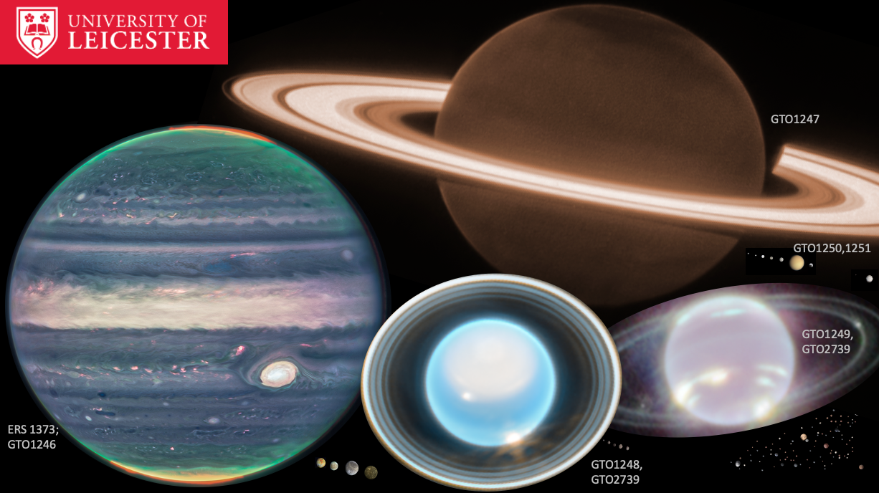

JWST NIRCAM views of the four giant planets in 2022-23, shown approximately to scale with their major satellites. Programme numbers are provided for the datasets, which include the NIRSpec and MIRI spectroscopy required for the planetary atmospheres research proposed here. Credit: NASA, ESA, STScI, compilation by L.N. Fletcher.

Further information on how to apply and funding can be found at
https://le.ac.uk/study/research-degrees/funded-opportunities/stfc

