Study of Broken up Primitive Asteroids to Understand early Solar System Evolution.
- Study of dark, primitive asteroids of the central and outer main belt.  - Follow a novel methodology to discover new asteroid families.  - Use an unprecedented dataset of Gaia asteroid spectra. | Level | PhD
 | First Supervisor | Dr Chrysa Avdellidou  c.avdellidou@le.ac.uk
 | Second Supervisor | Professor John Bridges
 | Application Closing  Date | See web page
 | PhD Start date | September 2024

Project Details:

Add new text
Scientific Context: The asteroid main belt, located between Mars and Jupiter, consists of over one million known asteroids with a plethora of compositions. Modern theories understand that the main belt resulted from different populations of primordial asteroids, the so-called planetesimals. One population is made of objects accreted in the main belt, while other populations formed in the terrestrial planet region or beyond Jupiter. It is understood that these planetesimals with the exogenous origin were transported and implanted into the main belt during dynamical processes that occurred at the early solar system. While in the main belt, collisions with other asteroids broke several planetesimals and created families of asteroid fragments. Studying the physical properties of families (e.g., composition) allows us to “look inside” the original planetesimals.
The study of the asteroid families and planetesimals of the central and outer main belt will help to understand the primitive population of small bodies. Even though this population accreted beyond Jupiter, due to dynamical processes they were spread into a large range of regions. In particular they populate Jupiter’s L4 and L5 Lagrange points (the Jupiter trojans), and all the asteroid main belt. Dark, primitive bodies have high probability to be hydrated, host volatiles and organic-rich material, and could have played a significant role for the emergence of life on Earth by providing life precursor compounds via impacts.
There are still important unknowns regarding the internal structure of asteroids. In the classical theory of planetesimal differentiation, a body would form an iron-rich core, an olivine-dominated mantle, and a pyroxene-rich basaltic crust. The detection of differentiated bodies in the current main belt will allow to get insights and study the very initial phases of planetesimal accretion and will constrain evolution models describing the early thermal evolution of their parent bodies and allow linking them to known meteorites. The study of iron meteorites has shown that the non-carbonaceous and the carbonaceous-rich planetesimals accreted contemporarily in two different locations in the solar system, which were separated by the “hard border” of growing Jupiter. Therefore, they should exist, but can we find any today? So far, the only proof of a non-carbonaceous differentiated planetesimal is asteroid (4) Vesta and its family. Are there any primitive, carbonaceous-rich, differentiated planetesimals?
The project: This is to study the primitive asteroid families of the central and outer main belt and comparing them with outer solar system bodies, such as the Jupiter Trojans. The PhD candidate will work on: (i) the characterisation of the physical properties (e.g., spectra, albedos, size distribution of the fragments) of the dark, primitive families, (ii) the re-assessment of the family members using their physical properties, (iii) the discovery of dark primitive families that escaped identification with the classical methods up to now. Other important results will be the detection of the first primitive differentiated family (our team has already a candidate) as well as the creation of the list of primitive planetesimals of the central and outer main belt that survive today.
Methodology: To fulfil the project, an interdisciplinary methodology will be followed. This will include the use of the unprecedented sample of asteroid spectra from ESA’s Gaia space mission Data Release 3 (2022) and Data Release 4 (2025) totalling in 100,000 spectra. A repository of some thousands of ground-based spectra and spectrophotometry will be also provided. Further physical properties will be retrieved from the Minor Planet Physical Properties Catalogue (mp3c.oca.eu). The PhD candidate will use and evolve a novel methodology to identify new and re-asses existing asteroid families. Our team has identified four very old asteroid families of different compositions. The co-supervisor has developed the mp3c.oca.eu database and he is responsible for the Gaia small body spectra production.
International context: There is a growing scientific interest to study this primitive population at different regions: NASA’s LUCY mission will flyby 7 of Jupiter Trojans, JAXA’s Martian Moon eXploration will orbit and sample Phobos, while United Emirates of Arabia will flyby one of the most primitive, large asteroids in the main belt, (269) Justitia. NASA will launch Psyche to visit the outer main belt asteroid Psyche, which is thought to be a metallic asteroid, probably an exposed core of a primitive differentiated planetesimal.
Further details on the project: The successful candidate is expected to have a knowledge of Python (or C++). In agreement with the School, the PhD candidate will spend time at the Observatoire de la Côte d’Azur, Nice, France, where can also be trained to small body observations using the 1m telescope at Calern astronomical station.

Further Reading:
- M. Delbo', K.J. Walsh, B.Bolin, C. Avdellidou, A. Morbidelli. Identification of a primordial asteroid family constrains the original planetesimal population. Science 357, Issue 6355, pp.1026-1029 (2017).
- M. Delbo', C. Avdellidou, A. Morbidelli. An ancient and a primordial collisional family as the main sources of X-type asteroids of the inner Main Belt. A&A 624, id. A69, 21 pp. (2019).
- S. Ferrone, M. Delbo, C. Avdellidou, R. Melikyan, A. Morbidelli, K. Walsh, and R. Deienno, Identification of 4.3 billion year old asteroid family and planetesimal population in the inner main belt. A&A 676, id.A5, 20 pp. (2023).
- C. Avdellidou, M. Delbo, A. Morbidelli, K. J. Walsh, E. Munaibari, J. Bourdelle de Micas, M. Devogele, S. Fornasier, M. Gounelle, G. van Belle, Athor asteroid family as the source of the EL enstatite meteorites. A&A 665, L9, 13pp. (2022).
- M. Delbo, C. Avdellidou, K. J. Walsh, Gaia view of primitive inner-belt asteroid families: Searching for the origins of asteroids Bennu and Ryugu. A&A in press (2023).
- https://mp3c.oca.eu

Images/Graphics:
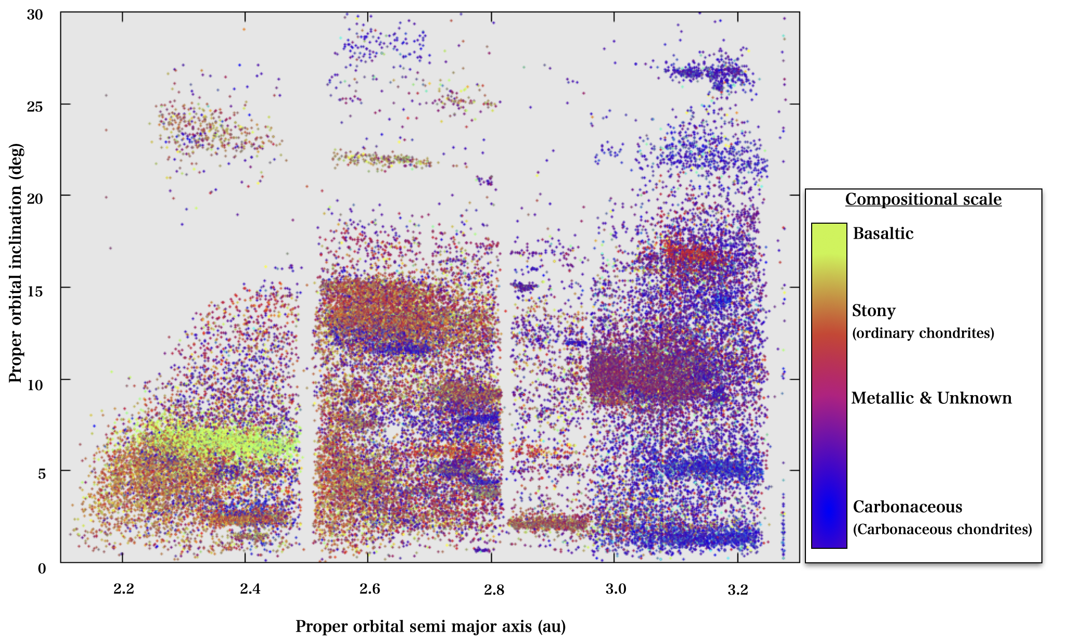
This is a view of the main belt, where each dot is an asteroid. Each asteroid is characterised by its orbit, its diameter, mass, rotation period, albedo, spectrum and many more parameters. In this plot each asteroid is painted with a different colour that is used it as a proxy for its composition, which varies throughout the belt. In the main belt co-exist dark carbonaceous bodies, which are the primitive ones and arrived in the asteroid belt from larger heliocentric distances and stony ones that represent objects that were formed in the inner solar system. The high-density regions correspond to the asteroids families that are generated after collisions between asteroids. Asteroid families appear as clusters of objects in the orbital element space, and this characteristic was used by traditional techniques to discover new families. However, old families have so diffused members in the orbital elements that escape the detection!

Further information on how to apply and funding can be found at https://le.ac.uk/study/research-degrees/funded-opportunities/stfc

