Project Reference | Physics Parker

First Supervisor | Dr Robert Parker
School/Department | School of Physics and Astronomy
Email | rjp23@le.ac.uk

Second Supervisor | Prof Heiko Balzter
School/Department | School of Geography, Geology and the Environment.
Email | hb91@le.ac.uk

Additional Supervisor | Dr Cristina Ruiz Villena, School of Physics and Astronomy, crv2@le.ac.uk  External:  Dr Toby Marthews, UK Centre for Ecology and Hydrology, tobmar@ceh.ac.uk

Section 2 – Project Information
Project Title | Understanding Changes in Tropical Wetlands With Remote Sensing, Machine Learning and Land Surface Modelling
Project Summary
Tropical wetlands are vitally important ecosystems, not only acting as major sources of biodiversity and home to human populations, but also playing a significant role in the global carbon cycle. Tropical peatlands and mangroves contain vast stores of organic carbon which are becoming increasingly susceptible to climate change. Changes in tropical wetland extent (e.g. due to increased precipitation and flooding) can have a devastating effect on the human population, as seen from recent disasters in Pakistan and Bangladesh. However, such changes in wetland extent can also have a significant and direct effect on climate.

Inundated wetland areas are the largest (and most uncertain) natural source of methane, one of the most important greenhouse gases. We know methane is produced in wetland areas by microbes but many questions remain on how this production is affected by factors such as temperature, water level and soil type. Importantly, we also do not know how large these methane-producing wetland areas are, as they continually change in size in response to rainfall and riverflow. Indeed, there is growing concern that the recent rapid and surprising increase in atmospheric methane is being driven by climate feedbacks on tropical wetlands. This response has the potential to become one of the most pressing questions in climate science and a better understanding of recent changes is vital. A significant step in addressing this would be to improve our capability to observe, model and predict wetland size and location, which would in turn allow us to better constrain current models and future climate predictions.

Satellites can provide unparalleled opportunities to monitor change in the Earth System and the volume of available high-resolution satellite imagery is increasing exponentially. This capability allows us to monitor across a range of scales, from local, to regional, to global and to better understand how the Earth System is responding to change. However, to deal with such large volumes of data, we must develop and apply new, more intelligent, methods. Machine learning methods potentially have a significant role to play, offering capabilities for image classification, clustering and anomaly detection. Recent machine-learning advances in computer vision (e.g. autoencoding transformers), are directly applicable to Earth Observation imagery and have the potential to be able transform our ability to analyse and interpret Earth Observation data.

The student will use high-resolution satellite imagery from the Sentinel-2 and Planet satellites and apply machine learning methods to detect and classify wetland areas and monitor their changes over time.

With co-supervision from the UK Centre for Ecology and Hydrology, the student will perform state-of-the-art simulations of wetland inundation with the JULES-CaMa-Flood land surface model. We will use specific tropical wetland regions as case studies, for example the Sudd wetlands in South Sudan and the Mekong River Basin wetlands in Cambodia, working closely with scientists in those areas. We will combine high-resolution satellite data along with a range of additional parameters derived from Earth Observation (e.g. land surface temperature, soil moisture, etc) to understand and better constrain our ability to model wetland inundation.

A PhD is intended to train you to become a scientist and this project offers ample training opportunities across a range of areas. There will be the opportunity to receive training at UKCEH related to using and analysing the JULES land-surface model for simulation of wetland inundation. We will provide training on using the Python programming language, the Earth System Model Evaluation Tool (ESMValTool) and data processing on the ALICE (Leicester) and JASMIN (NERC) HPC facilities. The student will be affiliated to the UK National Centre for Earth observation (NCEO) who will provide access to its Researcher Forum, staff conferences/workshops and national-level training.

Any interested candidates are welcome to get in touch (rjp23@le.ac.uk) for an informal chat prior to submitting their application.

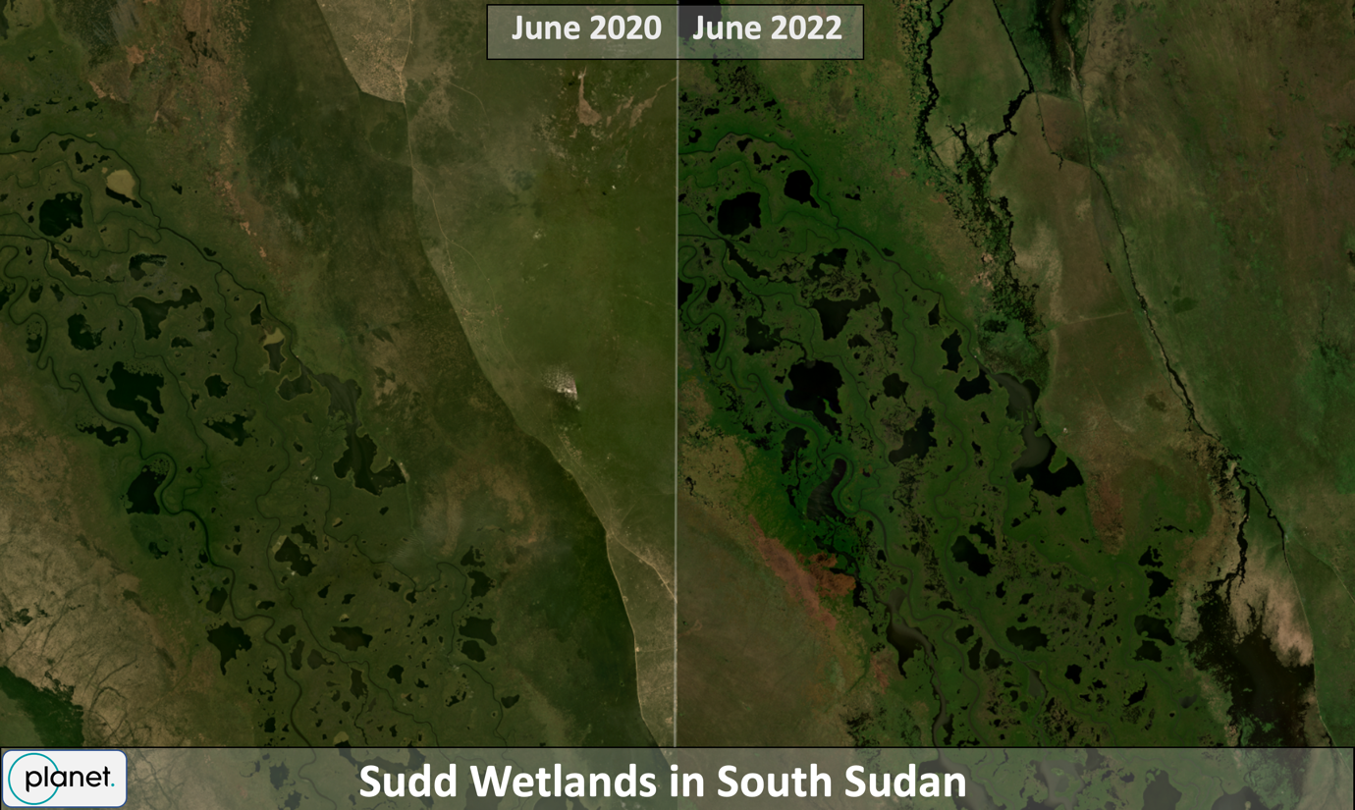
High-resolution Planet satellite imagery showing change in wetlands in South Sudan between June 2020 and June 2022

References
Feng, L., Palmer, P.I., Zhu, S., Parker, R.J., Liu, Y, Tropical methane emissions explain large fraction of recent changes in global atmospheric methane growth rate. Nat Commun 13, 1378 (2022). https://doi.org/10.1038/s41467-022-28989-z

Saunois, M., et al, The Global Methane Budget 2000–2017, Earth Syst. Sci. Data, 12, 1561–1623, https://doi.org/10.5194/essd-12-1561-2020, 2020.

Gedney, N., Cox, P. M., and Huntingford, C. (2004), Climate feedback from wetland methane emissions, Geophys. Res. Lett., 31, L20503, https://doi.org/10.1029/2004GL020919.

Marthews, T. R., Dadson, S. J., Clark, D. B., Blyth, E. M., Hayman, G. D., Yamazaki, D., Becher, O. R. E., Martínez-de la Torre, A., Prigent, C., and Jiménez, C.: Inundation prediction in tropical wetlands from JULES-CaMa-Flood global land surface simulations, Hydrol. Earth Syst. Sci., 26, 3151–3175, https://doi.org/10.5194/hess-26-3151-2022, 2022.

