University of Leicester PhD studentship
Funding Source: CENTA DTP
Proposed start date: 23rd September 2024
Closing date for applications: See our web page
Eligibility: UK/International
Department/School: Geology
Supervisors: PI: Prof Simon Gill, University of Leicester, spg3@leicester.ac.uk
Co-I: Dr Catherine Greenfield, University of Leicester
Project Title: Pore fabric controls on rock strength and fracture growth.

Project Description :
Project Highlights:
- Develop expertise in finite element modelling
- Contribute to our understanding of fracture behaviour in enhanced geothermal reservoirs and sites for mineral storage of CO₂
- Gain experience in geomechanics laboratory work and XCT scans
Overview:
Rock fractures are known to decrease rock strength and increase rock permeability, with significant impact on both at all scales. Fracture formation and properties are therefore critical in a number of resource industries, including geothermal and carbon capture & storage (CCS). Volcanic rocks are a common target in these industries and yet the fracture behaviour of these rocks has been relatively understudied compared to sedimentary rocks. This is particularly true of rocks that contain millimetre- to centimetre- scale bubbles, known as vesicles or pores, as they are extremely challenging to study in laboratory experiments. Numerical computer modelling offers an alternative to relying solely on laboratory experiments and will be used to make advances in our understanding.
It is well established that spherical pores in rocks reduce strength and increase the potential for rock failure during applied loading. Estimates of these reduced rock strength values feature prominently in upscaled calculations of bulk rock strength, from fluid reservoir models to volcano stability models. Recent work has shown that rocks containing anisotropic pore fabrics that are shaped as aligned flattened discs show a large departure from predicted spherical-pore rock strength. The degree of departure from predicted is dependent on the direction in which the rock is compressed. Fracture behaviour, distribution, and resulting permeability can therefore also vary with direction.
This project will use numerical modelling with the commercial software COMSOL to expand our understanding of the effects of anisotropic pore fabrics in controlling rock fracture. It will quantitatively relate pore fabrics to anisotropic rock strength and fracture behaviour by running numerical simulations at the pore-scale, using both idealised pore fabrics and natural pore fabrics from X-ray computer tomography scans of rocks captured between stepped uniaxial compression experiments in a geomechanics laboratory.
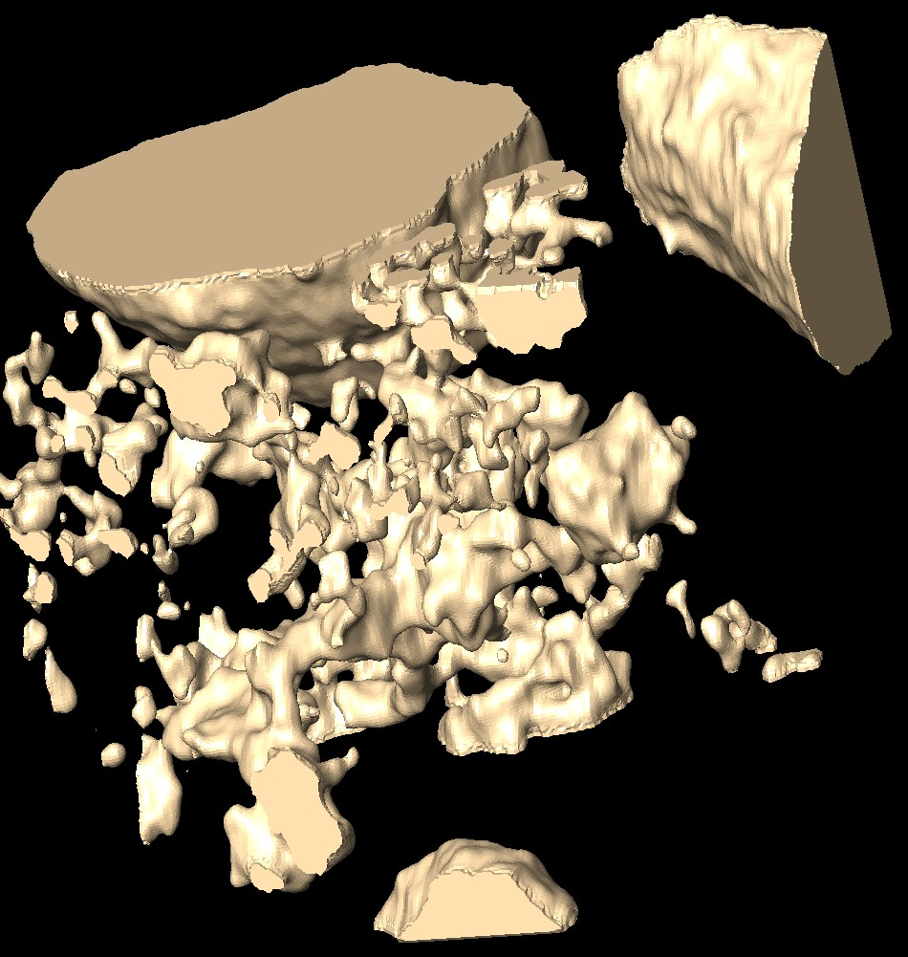
Figure 1: Finite Element mesh rendered from XCT scan of pore space in vesicular basalt.
Alt text: Computer generated 3D illustration of pore spaces within a rock

Methodology:
The successful student will perform stepped uniaxial compressive tests on basalt rock cores and produce x-ray computer tomographic scans of the cores at each compressive step. The scan data will be processed and analysed in image processing software to extract a visualisation of the pore space and location of brittle damage growth. The pore visualisations will then be used to create finite element meshes suitable for import into COMSOL. The COMSOL software will be programmed to model the predicted damage growth and the results compared with the experimental compressive test data to validate the COMSOL code. Once validated, the code will be run on a suite of pore fabrics of known statistical distributions to gain insight into the role of pore fabric in rock fracture behaviour.

References:

Bubeck, A., Walker, R.J., Healy, D., Dobbs, M. and Holwell, D.A., 2017. Pore geometry as a control on rock strength. Earth and Planetary Science Letters, 457, pp.38-48.
Gill, S.P., 2021. A damage model for the frictional shear failure of brittle materials in compression. Computer Methods in Applied Mechanics and Engineering, 385, p.114048.
Griffiths, L., Heap, M.J., Xu, T., Chen, C. & Baud, P., 2017. The influence of pore geometry and orientation on the strength and stiffness of porous rock. Journal of Structural Geology, 96, 149-160.
Healy, D., Jones, R.R. and Holdsworth, R.E., 2006. Three-dimensional brittle shear fracturing by tensile crack interaction. Nature, 439(7072), pp.64-67.

Funding details:
NERC CENTA studentships are for 3.5 years and are funded by NERC. In addition to the full payment of your tuition fees, you will receive the following financial support:
- Annual stipend, currently set at £18,622 (2023/4 – new figures to be confirmed spring 2024)
- Research training support grant £8,000 (RTSG)
If you are not eligible for UK Fees the University of Leicester will fund the difference between UK and International fees for the duration of your studies
For more details of the CENTA consortium please see the CENTA website: www.centa.org.uk.
Entry requirements:
Applicants are required to hold/or expect to obtain a UK Bachelor Degree 2:1 or better in a relevant subject.
The University of Leicester English language requirements apply where applicable.

Application advice:
To apply please refer to our web page for further information and read carefully the How to Apply section before submitting your application
https://le.ac.uk/study/research-degrees/funded-opportunities/centa-phd-studentships

In the funding section please specify that you wish to be considered for Ref CENTA2-SGGE7-GILL

In the proposal section please provide the name of the supervisors and project title (a proposal is not required)

Project / Funding Enquiries to: CENTA@le.ac.uk or cat.greenfield@leicester.ac.uk
Application enquiries to pgradmissions@le.ac.uk

