University of Leicester PhD studentship
Funding Source: CENTA DTP
Proposed start date: 23rd September 2024
Closing date for applications: See our web page
Eligibility: UK/International
Department/School: Geography
Supervisors: PI: Mick Whelan (mjw72@leicester.ac.uk) University of Leicester
Co-I: Jens Zinke (jz262@leicester.ac.uk) University of Leicester
Co-I: Sue Page (sep5@leicester.ac.uk) University of Leicester
Co-I: Sarah Cook (sarah.cook4@warwick.ac.uk) University of Warwick
Project Title: Tracing Land-to-Ocean Dissolved Organic Carbon Fluxes from Catchment to Coral Reefs.

Project Description :
Project Highlights:
- Contributing novel insights into riverine carbon dynamics and shedding light on the environmental consequences of land use change in Southeast Asia.
- Providing evidence to inform decision-makers, benefiting conservation efforts and sustainable land management practices.
- Employing a comprehensive methodology that combines laboratory and field-based measurements, optical sensing and real-time data to provide a detailed understanding of riverine carbon dynamics.
Overview:
Coastal systems annually receive 0.4-0.5 Pg of organic carbon from terrestrial sources, transported via rivers (Ciais et al., 2013). Dissolved organic carbon (DOC) is a vital component of the global carbon cycle, impacting coastal ecosystems by influencing light availability for photosynthesis and contributing to seawater acidification. Human disturbances like deforestation can enhance land-to-ocean DOC export.
Southeast Asia's tropical peatlands have experienced extensive land-use changes, converting over 90% of peatland into agricultural land in three decades (Miettinen et al., 2016; Figure 1). This rapid transformation, among the highest globally, profoundly affects coastal DOC export. One example is northwestern Borneo's Baram River catchment, which has seen substantial land-use changes associated with oil palm plantation expansion (Naciri et al., 2023). Recent satellite data analysis has revealed a 30% rise in coastal terrigenous DOC fluxes between 2002 and 2021, directly linked to the conversion of 69% of regional peatland into non-forest land (Sanwlani et al., 2022). Field studies in Sarawak confirm substantial terrigenous DOC inputs to coastal waters, much of which is likely to mineralise to CO₂ (Martin et al., 2018).
Borneo's peatland-draining rivers exhibit exceptionally high DOC concentrations, up to 66 mg C L⁻¹, surpassing most global rivers. However, Southeast Asia lacks research on quantifying DOC fluxes from these rivers, with limited studies on rivers and estuaries. Only one known study, by Martin et al. (2018), specifically explored DOC transport beyond coastal waters, focusing on Sarawak's Rajang and Maludam Rivers.
This study aims to quantify DOC fluxes from Sarawak's Baram River, the region's second-longest river. This represents an important carbon transport pathway from land to the ocean which appears to be influencing the Miri-Sibuti coral reef marine park. The research will contribute to understanding the environmental consequences of land-use changes and human activities on riverine carbon dynamics, providing critical insights into freshwater and marine ecosystem health and resilience.
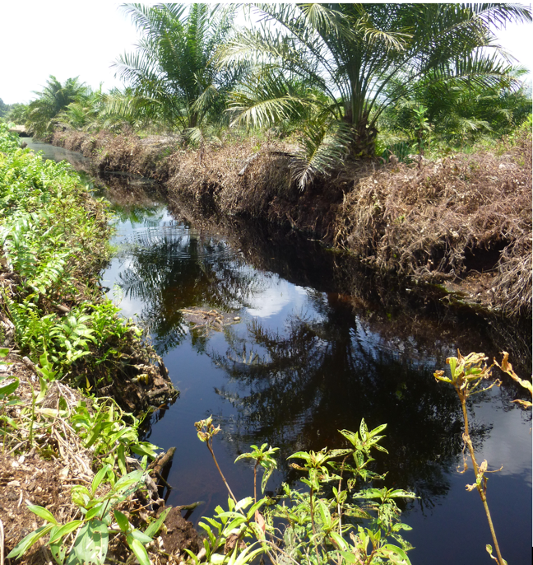

Figure 1 Artificial drainage channel in a tropical peatland oil palm plantation exporting dissolved organic carbon into a nearby river. Sarawak, Malaysia.
Methodology:
Existing data on discharge and water quality will be collated and analysed along with remotely sensed imagery which will be used to quantify land use change. River and sea water samples will be collected seasonally and analysed for DOC concentrations using a combination of laboratory and field-based (spectrophotometric) measurements. Field measurements will be carried out at various locations to capture spatial variation in DOC concentrations and properties. Optical methods including Specific Ultraviolet Absorbance (SUVA) will be used to provide proxy composition metrics on the bulk DOC pool. Discharge data at existing gauging stations will be checked and, if necessary supplemented by instrumentation giving real-time data. Hydrological and biogeochemical models will be developed to give insights into the relationships between hydrological response and water quality, seasonally and in response to land use change .
The student will also use remote sensing data of chromophoric DOC (CDOM) in sea water and assess the extent to which this correlated with coral luminescence coring data (available for the last 100 years). This will allow us to estimate long-term trends in organic carbon fluxes (Kaushal et al., 2021).

References:

Ciais, P., C. Sabine, G. Bala, L. Bopp, V. Brovkin, J. Canadell, A. Chhabra, R. DeFries, J. Galloway, M. Heimann, C. Jones, C. Le Quéré, R.B. Myneni, S. Piao and P. Thornton, 2013: Carbon and Other Biogeochemical Cycles. In: Climate Change 2013: The Physical Science Basis. Contribution of Working Group I to the Fifth Assessment Report of the Intergovernmental Panel on Climate Change [Stocker, T.F., D. Qin, G.-K. Plattner, M. Tignor, S.K. Allen, J. Boschung, A. Nauels, Y. Xia, V. Bex and P.M. Midgley (eds.)]. Cambridge University Press, Cambridge, United Kingdom and New York, NY, USA.
Kaushal, N., Sanwlani, N., Tanzil, J. T. I., Cherukuru, N., Sahar, S., Müller, M., et al. (2021). Coral skeletal luminescence records changes in terrestrial chromophoric dissolved organic matter in tropical coastal waters. Geophysical Research Letters, 48, e2020GL092130.
Martin, P., Cherukuru, N., Tan, A. S. Y., Sanwlani, N., Mujahid, A., and Müller, M.: Distribution and cycling of terrigenous dissolved organic carbon in peatland-draining rivers and coastal waters of Sarawak, Borneo, Biogeosciences, 15, 6847–6865, https://doi.org/10.5194/bg-15-6847-2018, 2018.
Miettinen, J., Shi, C., and Liew, S. C.: Land cover distribution in the peatlands of Peninsular Malaysia, Sumatra and Borneo in 2015 with changes since 1990, Glob. Ecol. Conserv., 6, 67–78, https://doi.org/10.1016/j.gecco.2016.02.004, 2016.
Naciri, W., Boom, A., Payne, M., Browne, N., Evans, N.J., Holdship, P., Rankenburg, K., Nagarajan, R., McDonald, B.J., McIlwain, J., Zinke, J., 2023. Massive corals record deforestation in Malaysian Borneo through sediments in river discharge. Biogeosciences 20, 1587–1604. https://doi.org/10.5194/bg-20-1587-2023
Sanwlani, N., Evans, C.D., Müller, M., Cherukuru, N., Martin, P., 2022. Rising dissolved organic carbon concentrations in coastal waters of northwestern Borneo related to tropical peatland conversion. Sci. Adv. 8, eabi5688. https://doi.org/10.1126/sciadv.abi5688

Funding details:
NERC CENTA studentships are for 3.5 years and are funded by NERC. In addition to the full payment of your tuition fees, you will receive the following financial support:
- Annual stipend, currently set at £18,622 (2023/4 – new figures to be confirmed spring 2024)
- Research training support grant £8,000 (RTSG)
If you are not eligible for UK Fees the University of Leicester will fund the difference between UK and International fees for the duration of your studies
For more details of the CENTA consortium please see the CENTA website: www.centa.org.uk.
Entry requirements:
Applicants are required to hold/or expect to obtain a UK Bachelor Degree 2:1 or better in a relevant subject.
The University of Leicester English language requirements apply where applicable.

Application advice:
To apply please refer to our web page for further information and read carefully the How to Apply section before submitting your application
https://le.ac.uk/study/research-degrees/funded-opportunities/centa-phd-studentships

In the funding section please specify that you wish to be considered for Ref CENTA2-SGGE6-WHEL

In the proposal section please provide the name of the supervisors and project title (a proposal is not required)

Project / Funding Enquiries to: CENTA@le.ac.uk or mjw72@leicester.ac.uk
Application enquiries to pgradmissions@le.ac.uk

