University of Leicester PhD studentship
Funding Source: CENTA DTP
Proposed start date: 23rd September 2024
Closing date for applications: See our web page
Eligibility: UK/International
Department/School: Geography
Supervisors: PI: Prof Mark Williams (Leicester) mri@leicester.ac.uk
Co-I: Dr James Borrell (Kew)
Co-I: Prof Robin Allaby (Warwick)
Co-I: Dr Juan Carlos Berrio (Leicester)
Project Title: Understanding the origins of agriculture to guide future climate adaptation.

Project Description:
Project Highlights:
- Agriculture arose independently in many regions of the world, and that pattern may hold clues to identifying the resilient agriculture of the near-future, in a rapidly changing world.

- Climate change will radically shift crop distributions in the coming century and in order to adapt to this future we must learn from the past.

- Identifying agrobiodiversity hotspots and conserving them as libraries of crop diversity is key to delivering resilient and sustainable food security.

Overview
Around 12,000 years ago 99% of the human population were hunter gatherers, but by 5000 years ago 99% were farmers (Weisdorf, 2005). This characterises one of the most fundamental transitions in our species’ history, dramatically altering our relationship with nature. After 300,000 years of modern Homo sapiens’, agriculture arose rapidly and independently in as many as 11 separate regions – termed the Neolithic Revolution (Harlan, 1971; Meyer et al., 2012). What precipitated this radical change? Was it driven by growing population, increasing cultural and technological sophistication, over exploitation of natural resources or environmental change? In the coming century of climate change, global agriculture will be forced to undergo another rapid change. Crop distributions will shift to keep pace with suitable climate envelopes and new or underutilised species may form an increasingly important part of our food system (Borrell et al., 2020; Rampersad et al., 2023). What can early agriculture teach us about the potential to adapt?
This project will investigate the rapid, but asynchronous origins of agriculture in a number of discrete regions at the end of the last ice age, and the highly heterogeneous distribution of 'centres of domestication' that do not necessarily align with broader global biodiversity gradients (Pironon et al., 2020). This is important, because we face a twin biodiversity crisis, whereby the decline of wild biodiversity is mirrored by a decline in the diversity of crops we use. Indeed, over recent decades our global food system has become increasingly uniform (Khoury et al., 2014). Despite evidence that humans have consumed more than 7000 species of plants, more than half of global calories are derived from just three species - rice, wheat and maize (SOTWPF, 2020). Understanding what drove and maintained hotspots of agrobiodiversity will be the key to conserving them and their associated indigenous knowledge for a sustainable and resilient future food system.

This project supports our broader goal of area-based conservation for agrobiodiversity. By identifying agrobiodiversity hotspots we can support countries to meet the Global Biodiversity Framework 30x30 target, and avoid loss of the biodiversity on which we are most dependent.

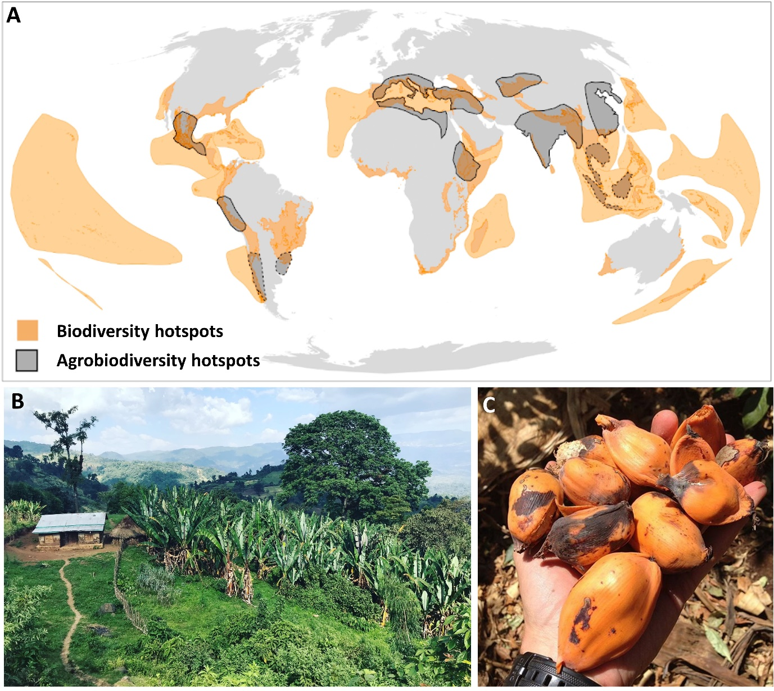
Figure 1: A) The global distribution of biodiversity and agrobiodiversity hotspots. Biodiversity and agrobiodiversity hotspots do not always overlap, suggesting they may be driven by different processes. B) A smallholder farm in the Ethiopian Highlands, an area of exceptionally high biodiversity where Kew is working to support crop conservation. C) Fruits of enset, a crop endemic to Ethiopia that provides the staple food for 20 million people.
Alt text: A map showing biodiversity and agrobiodiversity hotspots, with examples of the landscape and crops in Ethiopia.

Methodology:
This project is timely because of multiple newly available datasets and increasingly accessible analysis techniques employing Google Earth Engine. In the first phase, the student will collate archaeobotanical and socio-cultural data on the origins of global crop species. We will then integrate high-resolution global palaeoclimate layers (e.g. http://www.paleoclim.org/) across the Greenlandian, Northgrippian and Meghalayan data to understand the environmental conditions and sociocultural context associated with asynchronous adoption of agriculture and domestication of diverse crops. The multiple independent origins of agriculture over a several thousand-year period, together with heterogeneous global climate trends provide a means to examine and test hypotheses for the drivers of agriculture.
A major feature of this proposal is the use of interdisciplinary methods. The student will be trained to integrate diverse archaeological evidence of past land-use change, to generate alternative lines of evidence with analytical modelling approaches including redundancy and geographically weighted path analysis.

References:

Antonelli, A., Smith, R.J., Fry, C., Simmonds, M.S.J., Kersey, P.J., Pritchard, H.W., Abbo, M.S., Acedo, C., Adams, J., 2020. State of the World’s Plants and Fungi. https://doi.org/10.34885/172
Borrell, J.S., Dodsworth, S., Forest, F., Pérez-Escobar, O.A., Lee, M.A., Mattana, E., Stevenson, P.C., Howes, M.-J.R., Pritchard, H.W., Ballesteros, D., Kusumoto, B., Ondo, I., Moat, J., Milliken, W., Ryan, P., Ulian, T., Pironon, S., 2020. The climatic challenge: Which plants will people use in the next century? Environmental and Experimental Botany, The climatic challenge: learning from past survivors and present outliers 170, 103872. https://doi.org/10.1016/j.envexpbot.2019.103872
Harlan, J.R., 1971. Agricultural Origins: Centers and Noncenters: Agriculture may originate in discrete centers or evolve over vast areas without definable centers. Science 174, 468–474. https://doi.org/10.1126/science.174.4008.468
Khoury, C.K., Bjorkman, A.D., Dempewolf, H., Ramirez-Villegas, J., Guarino, L., Jarvis, A., Rieseberg, L.H., Struik, P.C., 2014. Increasing homogeneity in global food supplies and the implications for food security. Proc. Natl. Acad. Sci. U.S.A. 111, 4001–4006. https://doi.org/10.1073/pnas.1313490111
Meyer, R.S., DuVal, A.E., Jensen, H.R., 2012. Patterns and processes in crop domestication: an historical review and quantitative analysis of 203 global food crops. New Phytologist 196, 29–48. https://doi.org/10.1111/j.1469-8137.2012.04253.x
Milla, R., 2020. Crop Origins and Phylo Food: A database and a phylogenetic tree to stimulate comparative analyses on the origins of food crops. Global Ecol Biogeogr 29, 606–614. https://doi.org/10.1111/geb.13057
Pacheco Coelho, M.T., Pereira, E.B., Haynie, H.J., Rangel, T.F., Kavanagh, P., Kirby, K.R., Greenhill, S.J., Bowern, C., Gray, R.D., Colwell, R.K., Evans, N., Gavin, M.C., 2019. Drivers of geographical patterns of North American language diversity. Proc. R. Soc. B. 286, 20190242. https://doi.org/10.1098/rspb.2019.0242
Pironon, S., Borrell, J.S., Ondo, I., Douglas, R., Phillips, C., Khoury, C.K., Kantar, M.B., Fumia, N., Soto Gomez, M., Viruel, J., Govaerts, R., Forest, F., Antonelli, A., 2020. Toward Unifying Global Hotspots of Wild and Domesticated Biodiversity. Plants 9, 1128. https://doi.org/10.3390/plants9091128
Rampersad, C., Geto, T., Samuel, T., Abebe, M., Gomez, M.S., Pironon, S., Büchi, L., Haggar, J., Stocks, J., Ryan, P., Buggs, R.J.A., Demissew, S., Wilkin, P., Abebe, W.M., Borrell, J.S., 2023. Indigenous crop diversity maintained despite the introduction of major global crops in an African centre of agrobiodiversity. Plants People Planet ppp3.10407. https://doi.org/10.1002/ppp3.10407
Smith, B.D., 2006. Eastern North America as an independent center of plant domestication. Proc. Natl. Acad. Sci. U.S.A. 103, 12223–12228. https://doi.org/10.1073/pnas.0604335103
Weisdorf, J.L., 2005. From Foraging To Farming: Explaining The Neolithic Revolution. J Economic Surveys 19, 561–586. https://doi.org/10.1111/j.0950-0804.2005.00259.x

Funding details:
NERC CENTA studentships are for 3.5 years and are funded by NERC. In addition to the full payment of your tuition fees, you will receive the following financial support:
- Annual stipend, currently set at £18,622 (2023/4 – new figures to be confirmed spring 2024)
- Research training support grant £8,000 (RTSG)
If you are not eligible for UK Fees the University of Leicester will fund the difference between UK and International fees for the duration of your studies
For more details of the CENTA consortium please see the CENTA website: www.centa.org.uk.
Entry requirements:
Applicants are required to hold/or expect to obtain a UK Bachelor Degree 2:1 or better in a relevant subject.
The University of Leicester English language requirements apply where applicable.

Application advice:
To apply
To apply please refer to our web page for further information and read carefully the How to Apply section before submitting your application
https://le.ac.uk/study/research-degrees/funded-opportunities/centa-phd-studentships

In the funding section please specify that you wish to be considered for Ref CENTA2-SGGE5-WILL

In the proposal section please provide the name of the supervisors and project title (a proposal is not required)

Project / Funding Enquiries to: CENTA@le.ac.uk or mri@leicester.ac.uk
Application enquiries to pgradmissions@le.ac.uk

