University of Leicester PhD studentship
Funding Source: CENTA DTP
Proposed start date: 23rd September 2024
Closing date for applications: See our web page
Eligibility: UK/International
Department/School: Geology
Supervisors: PI: Prof Gawen Jenkin, University of Leicester (grtj1@le.ac.uk)
Co-I: Dr Phil Bird, DESCYCLE and University of Leicester
Project Title: Promoting pyrometallurgical slags as a critical metal resource: Geometallurgy and leaching behaviour with environmentally benign solvents.

Project Description:
Project Highlights:
- Develop skills in mineralogy and solvometallurgy and apply them to sustainably recover metals for the green transition from waste products instead of mining.
- Opportunity to work with Industrial Partner Descycle www.descycle.com to develop real impact from your research.
- Be part of the Centre for Sustainable Resource extraction to deliver vital solutions to the security of supply of metals for the 21st century.
Overview:
Pyrometallurgical slags are the solidified waste products from the smelting of metals. These are dominantly composed of finely crystalline or glassy silicate and oxide minerals but contain small blebs of native metals or metal sulfides which reflect the original ore being smelted, such as Sn, Cu, Pb or Ag. Subsequent weathering may form new secondary oxide and carbonate minerals. Historically generated slags produced by inefficient smelting and slag separation often contain high contents of metals which may be a few % to sometimes >10% of base metals and 10s-100s ppm of silver or gold. These values well above modern ore values - and thus a potentially valuable metal resource if they can be recovered. Little is known about the critical metal content of slags but given that historical smelters used less “clean” ore than modern smelters, there is likely significant amounts of critical metals (e.g. Sb, Bi, Te) also contained in some historical slags.
Slag reprocessing is therefore tempting, but is challenging for a number of reasons: Poor knowledge of metal-bearing phases, variable oxidation of metal particles, some metals (such as Zn) partition to the silicate phase. Pyrometallurgical reprocessing is one option but has a high energy consumption and a smelter may no longer exist in the area. Alternatively, hydrometallurgy may use solvents such as sulfuric acid, although this may be inhibited by gelation of some slags and may not recover silicate-hosted metals.
This project aims to develop a fresh approach to reprocessing of historical slags. You will develop a geometallurgical workflow for characterising the mineralogy of target metals (including critical metals where they occur) using SEM-based automated mineralogy. This will be combined with the use of novel solvents, such as Deep Eutectic Solvents to selectively leach and recover the target metals in an environmentally friendly and low energy process, building on the extensive experience in this field at Leicester within the Centre for Sustainable Resource Extraction. This project will equip you for a career in mineral resource metallurgy.
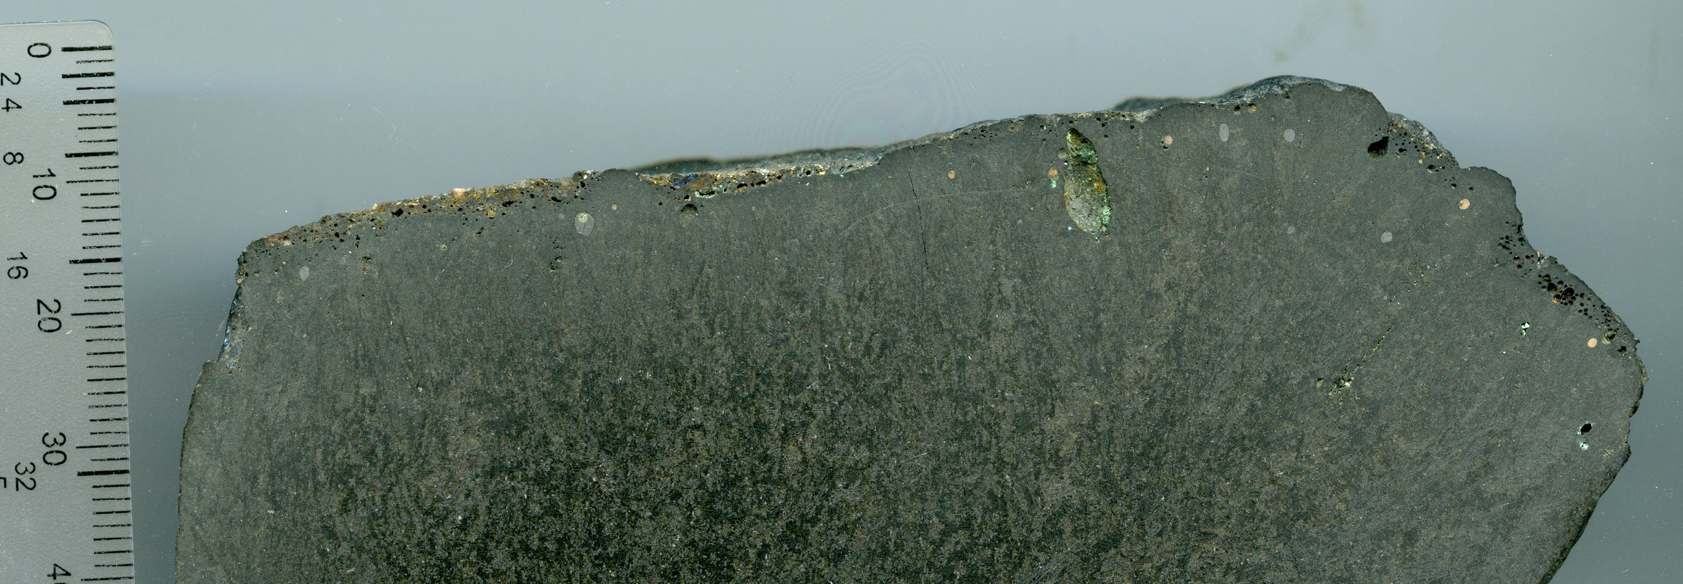
Figure 1: Sample of historical copper slag from Cornwall, showing blebs of unrecovered metal. Could we sustainably reprocess these as a metal resource, and what critical metals are present?
Alt text: Information: Sample of historical copper slag – silicate matrix contains small blebs (<2 mm) of metals.
Methodology:
Samples of slag will be collected from known localities in the UK (e.g. Cornwall) and material from abroad donated by Descycle and their partner companies. These samples will be mineralogically and texturally characterised using transmitted and reflected light microscopy together with SEM-based automated mineralogy (Zeiss Mineralogic software). This will be augmented by other microbeam techniques such as µ-XRF and laser ablation ICP-MS where necessary to understand the mineralogical setting of critical elements.
The leaching behaviour of the metal-bearing target minerals with novel solvents will be assessed using both in situ and bulk leach techniques. For the latter leachates will be characterised by ICP-MS and solid residues by XRF and ICP-MS. You will work to optimise solvents to efficiently extract target metals and leave a non-hazardous waste.

References:

Jenkin GRT, Al-Bassam AZM, Harris RC, Abbott AP, Smith DJ, Holwell DA, Chapman RJ, Stanley CJ (2016). The application of deep eutectic solvent ionic liquids for environmentally-friendly dissolution and recovery of precious metals. Minerals Engineering, 87, 18-24. DOI: 10.1016/j.mineng.2015.09.026.
Gorai B, Jana RK, Premchand, (2003). Characteristics and utilisation of copper slag – a review. Resources, Conservation and Recycling, 39, 299-313. doi:10.1016/S0921-3449(02)00171-4.
Abbott AP, Al-Bassam AZM, Goddard A, Harris RC, Jenkin GRT, Nisbett F & Wieland M (2017). Dissolution of Pyrite and other Fe-S-As minerals using Deep Eutectic Solvents. Green Chemistry, 19, 2225-2233. DOI: 10.1039/c7gc00334j

Funding details:
NERC CENTA studentships are for 3.5 years and are funded by NERC. In addition to the full payment of your tuition fees, you will receive the following financial support:
- Annual stipend, currently set at £18,622 (2023/4 – new figures to be confirmed spring 2024)
- Research training support grant £8,000 (RTSG)
If you are not eligible for UK Fees the University of Leicester will fund the difference between UK and International fees for the duration of your studies
For more details of the CENTA consortium please see the CENTA website: www.centa.org.uk.
Entry requirements:
Applicants are required to hold/or expect to obtain a UK Bachelor Degree 2:1 or better in a relevant subject.
The University of Leicester English language requirements apply where applicable.

Application advice:
To apply please refer to our web page for further information and read carefully the How to Apply section before submitting your application
https://le.ac.uk/study/research-degrees/funded-opportunities/centa-phd-studentships

In the funding section please specify that you wish to be considered for Ref CENTA2-SGGE4-JENK

In the proposal section please provide the name of the supervisors and project title (a proposal is not required)

Project / Funding Enquiries to: CENTA@le.ac.uk or grtj1@le.ac.uk
Application enquiries to pgradmissions@le.ac.uk

