University of Leicester PhD studentship
Funding Source: CENTA DTP
Proposed start date: 23rd September 2024
Closing date for applications: See our web page
Eligibility: UK/International
Department/School: Geology
Supervisors: PI: Dr Andrew Miles (ajm131@le.ac.uk)
Co-I: Prof Mike Branney (University of Leicester)
Co-I: Dr Cees-Jan de Hoog (University of Edinburgh)
Project Title: Tracking volatile evolution in explosive alkaline eruptions.

Project Description :
Project Highlights:
- An opportunity to research one of the best exposed volcanic sequences on Earth.
- Contribute to understanding one of the principal controls on volcanic eruptions, their deposits and volcanic hazards.
- Develop expertise in a variety of field and laboratory techniques to resolve the evolution of volatile elements in volcanic systems
Overview:
Volatiles like H₂O, CO₂, S, F and Cl are key components of magmas and are inherited from their source regions. Their ability to dissolve in magmas changes during magma ascent due to changes in pressure and temperature. When volatiles saturate, exsolved fluids and bubble expansion can change the physical properties (e.g. viscosity) of a magma, and in some cases may even help to remobilise stagnant, crystal-rich mushes and trigger explosive eruptions. In addition to controlling the eruption of a magma, volatiles are also likely to play an important part in controlling the nature of their deposits. Ignimbrites are the deposits formed by pyroclastic density currents, but the controls on whether these deposits remain unconsolidated or weld during deposition may also in part depend on the volatile content of the magma being erupted. Gaining a complete picture of volatile evolution from magma mush, to eruption, to surface deposit is therefore critical for understanding the most hazardous components of explosive volcanoes.
Melt inclusion studies currently represent the state-of-the-art in reconstructing pre-eruptive magmatic volatile contents. However, melt inclusions are affected by a number of post-entrapment processes that can modify or reset their volatile contents on timescales of hours to years (e.g. Hartley et al., 2014). Recent studies have highlighted the potential of the mineral apatite as an alternative proxy for tracking volatiles in magmas (e.g. Stock et al., 2016). The apatite crystal structure can host a range of volatile species that are important for understanding volatile budgets. Apatite is more retentive of these elements than many silicate minerals and glasses, and it can preserve a record of magmatic volatile contents even where the glass is largely degassed. Apatite also hosts other trace and redox-sensitive elements that can be used to build a detailed picture of pre-eruptive magma storage conditions (Miles et al., 2013). However, the benefits of apatite are often offset by its small grain size, which can hinder detailed analytical study of its rich volatile record.
By contrast, haüyne is rare, but often large S-rich mineral found in highly Si-undersaturated magmas. It has received comparatively little attention as a monitor of volatile evolution and excess degassing, but its size enables a detailed examination of its chemical and textural characteristics. Early studies have shown a fascinating range of textural varieties that have tentatively been shown to reflect episodes of volatile sparging during magma accumulation (Cooper et al., 2015).
This project is the first to propose examining how apatite and haüyne can be used in tandem to provide a detailed and complementary record of volatile evolution leading up to a Plinian eruption. The project will focus on the 668ka Arico ignimbrite - a rare welded ignimbrite formed from the eruption of the Las Cañadas volcano, Tenerife. State-of-the-art analytical techniques (SEM, EPMA, LA-ICP-MS and SIMS) will be used to carry out in situ textural and chemical analyses of both crystal types. This combination provides an unrivalled opportunity to track the lead up to one of the most significant eruptions of the Las Cañadas volcano and the circumstances that led to the welding of its pyroclastic density current deposits. Understanding how volatile elements behave in magmas has important implications beyond unravelling the events that led up to eruptions, including the formation of hydrothermal ore deposits that are commonly found in association with many volatile-saturated, S-rich volcanic centres.
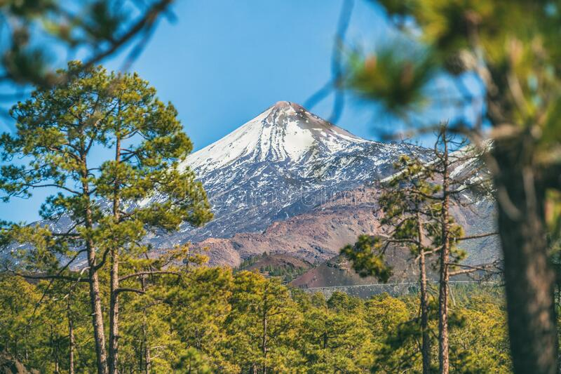
Figure 1: The modern-day Teide volcano, Tenerife. Teide sits on top of the much larger Las Cañadas volcano from which the Arico ignimbrite formed 668 ka.
Methodology:
The successful student will be accompanied in the field to gather juvenile pumice samples from the Arico ignimbrite, Tenerife. These samples will supplement an existing collection gathered by the PIs. Quantitative textural and compositional characterisation will be carried out at the University of Leicester using a scanning electron microscope (SEM) coupled with Zeiss’ Minerlogic software and laser ablation mass spectrometry. Crystals will be analysed in situ from thin section or mineral separates, with major and some volatile elements determined by a combination of SEM and electron microprobe. Volatile elements will also be measured by secondary ionisation mass spectrometry (SIMS) at the University of Edinburgh following a grant application to the facility.

References:

Cooper, L.B., Bachmann, O., Huber, C., 2015. Volatile budget of Tenerife phonolites inferred from textural zonation of S-rich haüyne. Geology. 43, 423-426.
Hartley, M.E., Bali, E., Mclennan, J., Neave, D., Halldorsson, S.A., Melt inclusion constrains on petrogensis of the 2014-2015 Holuhraun eruption, Iceland. Contributions to Mineralogy and Petrology, 173:10.
Miles, A.J., Graham, C.M., Hawkesworth, C.J., Gillespie, M.R., Hinton, R.W., EIMF, 2013, Evidence for distinct stages of magma history recorded by the compositions of accessory apatite and zircon: Contributions to Mineralogy and Petrology, v. 166, p. 1-19.
Stock, M.J., Humphreys, M.C.S., Smith, V.C., Isaia, R., and Pyle, D.M., 2016, ‘Late-stage volatile saturation as a potential trigger for explosive volcanic eruptions’. Nature Geoscience, 9, 243. 1-2

Funding details:
NERC CENTA studentships are for 3.5 years and are funded by NERC. In addition to the full payment of your tuition fees, you will receive the following financial support:
- Annual stipend, currently set at £18,622 (2023/4 – new figures to be confirmed spring 2024)
- Research training support grant £8,000 (RTSG)
If you are not eligible for UK Fees the University of Leicester will fund the difference between UK and International fees for the duration of your studies
For more details of the CENTA consortium please see the CENTA website: www.centa.org.uk.
Entry requirements:
Applicants are required to hold/or expect to obtain a UK Bachelor Degree 2:1 or better in a relevant subject.
The University of Leicester English language requirements apply where applicable.
Application advice:
To apply please refer to our web page for further information and read carefully the How to Apply section before submitting your application
https://le.ac.uk/study/research-degrees/funded-opportunities/centa-phd-studentships
In the funding section please specify that you wish to be considered for Ref CENTA2-SGGE1-MILE

In the proposal section please provide the name of the supervisors and project title (a proposal is not required)

Project / Funding Enquiries to: CENTA@le.ac.uk or ajm131@le.ac.uk
Application enquiries to pgradmissions@le.ac.uk

